Lampiran 1/3 ( CV + Foto )


DAFTAR RIWAYAT HIDUP

Data Pribadi
Nama : Nova Nur Achmad
Tempat / Tanggal Lahir : Jakarta, 30 November 1985
Jenis Kelamin : Laki-Laki
Agama : Islam
Status : Belum Menikah
Alamat : Jl.Beringin II A21/23 PCI Jatibening Pondok
Gede Bekasi, 17412
Pendidikan
2006-2011 AMIK BSI
2001-2004 SMA YP.KAPIN Jakarta
1998-2001 SMPN 7 Bekasi
1992-1998 SDN Cikunir 3 Bekasi

Pengalaman Kerja
- 2008-2009 Admin at INSOMNIA.NET ( GAME ONLINE SERVER )- Bekasi
- 2009-2010 Sales at PT. BAHANA NADA GEMILANG dist.- Jakarta Barat
- 2010-2012 Freelance – Surveyor Interviewer at AC.NIELSEN INDONESIA.- Jakarta Selatan
- 2012-2014 Admin Marketing at CV.FIRST GALAXY PROPERTY.- Bekasi

Pengalaman Entertainment
- 2005 s/d 2006 : HomeBand @Hotel Mulia Jakarta (as Pianist)
- 2006 s/d Sekarang : Wedding Singers (as Pianist / Keyboardist)
- 2009 s/d 2010 : - Best 25 of 250 Band @PIC Organizer Event (as Keyboardist)
- Guest Star @BNN Event (as Keyboardist)
- Guest Star @ABNON JAKTIM 2011 Event (as Keyboardist)

Bekasi, 20 Oktober 2014

Nova Nur Achmad

Lampiran 2/3 ( Scan Ijazah D3)
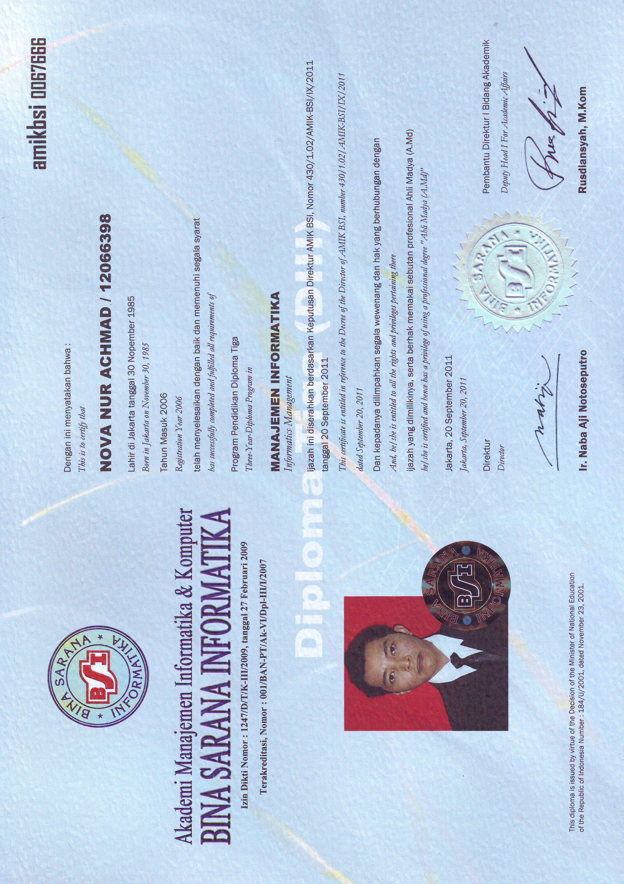

Lampiran 3/3 ( Scan Transkript Akademik )



