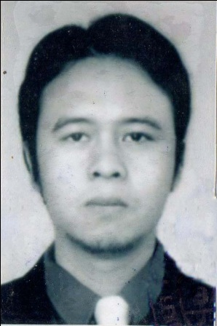
CURRICULUM VITAE

I. PERSONAL DETAILS
Name : Irfan Rifana
Mailing Address : Kp.Nangkabongkok RT/RW 01/06 Desa.Gandamekar
Kec.Kadungora Kabupaten.Garut 44153
Email : irfan.rifana@yahoo.com
Contact Number : 085320658076 / 0262 456540
Place, Date of Birth : Garut, August 4, 1983
Sex : Male
Marital Status : Married
Religion : Islam
Nationality : Indonesian

II. EDUCATION DETAILS
1. 1989 – 1995 SDN Lembur Kuring- Garut
2. 1995 – 1998 SMPN 1 Kadungora -Garut
3. 1998 – 2001 SMU Negeri 1 Tarogong- Garut
4. 2001 – 2006 Sekolah Tinggi Teknologi Tekstil Majoring Teknik Tekstil-Bandung
GPA = 2.85 (scale 4)
PREDICATE = Very Good

III. Jobs Experience
December 2006 – July 2007 QA Supervisor at PT.Hansae Indonesia -Jakarta
(Garment manufacture)
August 2007 –August 2010 Supervisor at PT.Kwalram Indonesia - Bandung
(Textile manufacture)
August – December 2010 IE Staff at PT.Trigolden Wisesa - Karawang
(Garment Manufacture)
January 2011- December 2013 PPC at PT.Superbetex - Bandung
(Textile manufacture)

IV. COMPUTER ABILITY
Microsoft Word, Microsoft Excel, Microsoft Access, Microsoft Power Point.

This is to state that above information is true and provided here by me, all in good faith.

Sincerely yours,

Irfan Rifana, S.ST

