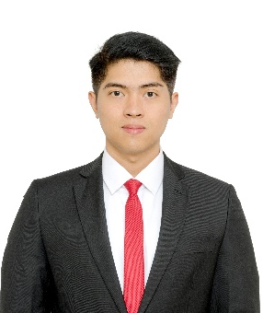
Firman Adi Prastowo

Mobile: (+62) 81223431513 ● Email: firmanprastowo@gmail.com

Place, Date of Birth: Jakarta, July 15th, 1992 ● Blood type: O

Short Profile:
Introvert, Intuitive, Thinking, Judging
Perfectionist, hard-working, think strategically, highly dicipline, and driven by confidence to achieve goals

EDUCATION

Institut Teknologi Bandung (ITB), Indonesia
Meteorology Major, Faculty of Earth Science and Technology (GPA 3,48)
Graduate on October 2015th

Marsudirini Bekasi Senior Highschool, Indonesia
Natural Science Degree
Graduate on July 2010th

ACHIEVEMENTS

Faculty of Earth Science and Technology, ITB Dean List Awards (3rd, 4th, 5th, and 7th Semester)
Award for Faculty of Earth Science and Technology students with GPA above 3,5 at related semester.
2012-2015

Winner of Marsudirini (Jabodetabek) Band Competition
Band competition held by Marsudirini Bogor for all Marsudirini Senior High School in Jabodetabek.
December 2008th

ACADEMICAL ACTIVITIES

Lecturer Assistant
Assistant in meteorology subjects taught by Drs. Zadrach L. Dupe including: Climate Change, Introduction to Meteorology and Climatology, Atmosphere Teledetection.
2013-2015

Jury of Olimpiade Sains Nasional (Kebumian)
Surveyed test places, guided practical tests, checked written and practical test results, determined winning sequence.
2013, 2014, 2015

PROFESSIONAL EXPERIENCE

P3TKEBTKE, Kementrian ESDM, Practical Work (Functional Office Group)
Verify and validate weather model results to the observed data and determine whether model results are appropriate with observed data.
Finished on July 2014th

PT. Encirclo Nusa Integra (Business Networking Company)
Co-founder and Chief Growth Officer
Ongoing

ORGANIZATIONAL EXPERIENCE

Head of HMME “Atmosphaira” ITB Internal Department
Led Kinship Division and Secretary Division to create comfortable environment in HMME, both in physical or nonphysical aspects.
2014-2015

Bandung Region Coordinator for Himpunan Mahasiswa Meteorologi Indonesia (HMMI)
Technical manager for HMMI events in Bandung.
2013-2014

LANGUAGES AND SKILLS

Language
Excellent in Bahasa and good in English.

Computer Skill
Competent in Microsoft Office, Fortran90, SPSS Statistics, Matlab, and ArcGIS.

Marketing
Digital marketing and startup growth.

Writing
Blog, content creating, newsletter

