portofolio
  - Michael (www.michaelfromage.com)
iOS

KLN (Kapanlaginetwork)
KLN adalah sebuah aplikasi berita bersumber dari KapanLagiNetwork.
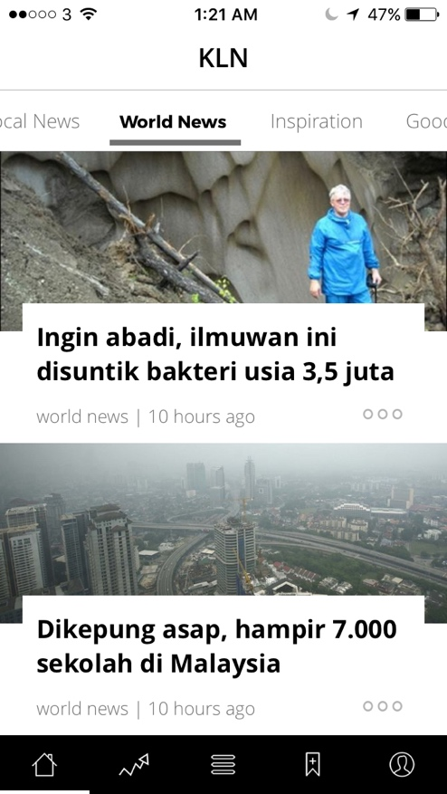
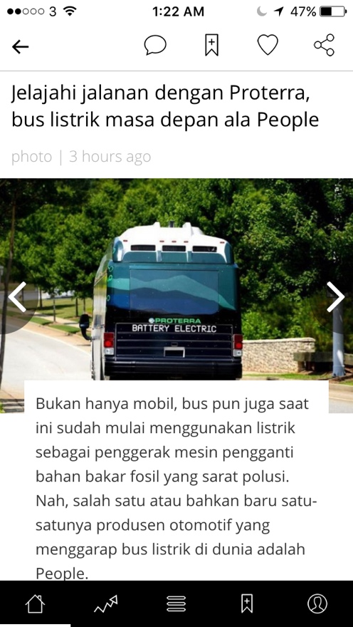

Feature:
- NewsFeed
- Comment
- Category
- Bookmark
- Sign in by Social Media (Facebook, Twitter, Google+)

iOS

Indonesia flight
Indonesia Flight is a plane ticket booking application that is fast, easy and reliable. Indonesia Flight is established on 2012. On this project I redesign on iOS platform
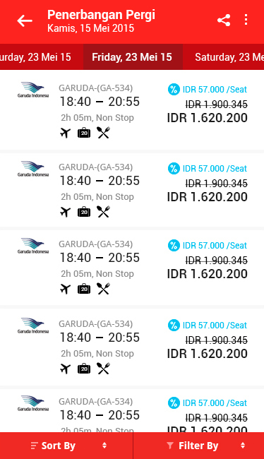
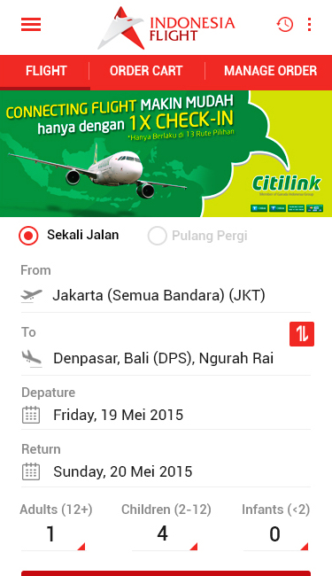

iOS

Share Faith
Share Faith is a motivation social media. Share Faith provide user to share their testimony to God that can motivate the others.
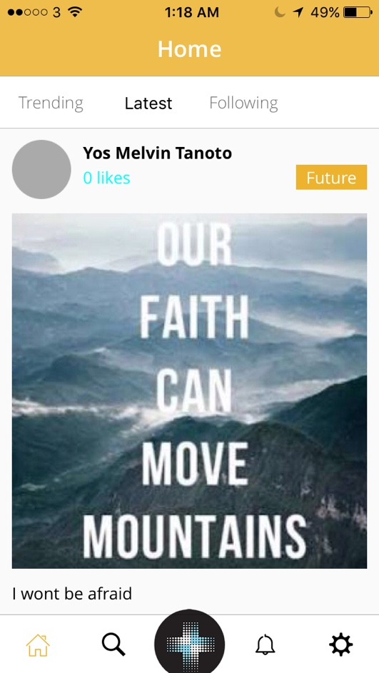
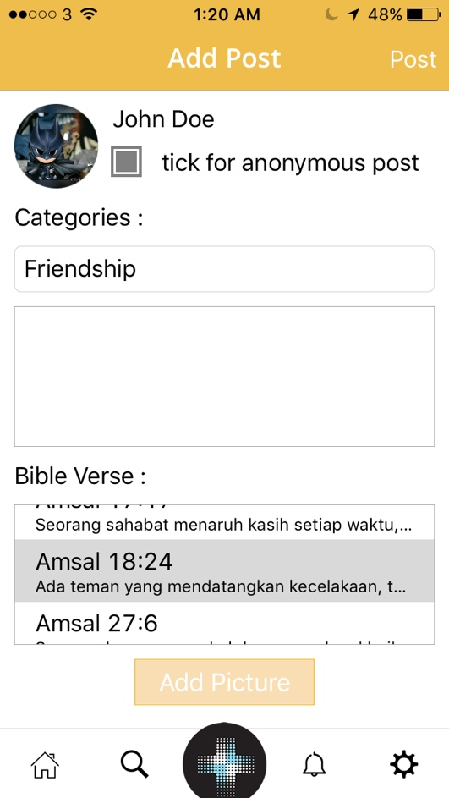

Feature:
- Add Testimony
- Comment
- Search Testimony
- Notification

