CURRICULUM VITAE (CV)
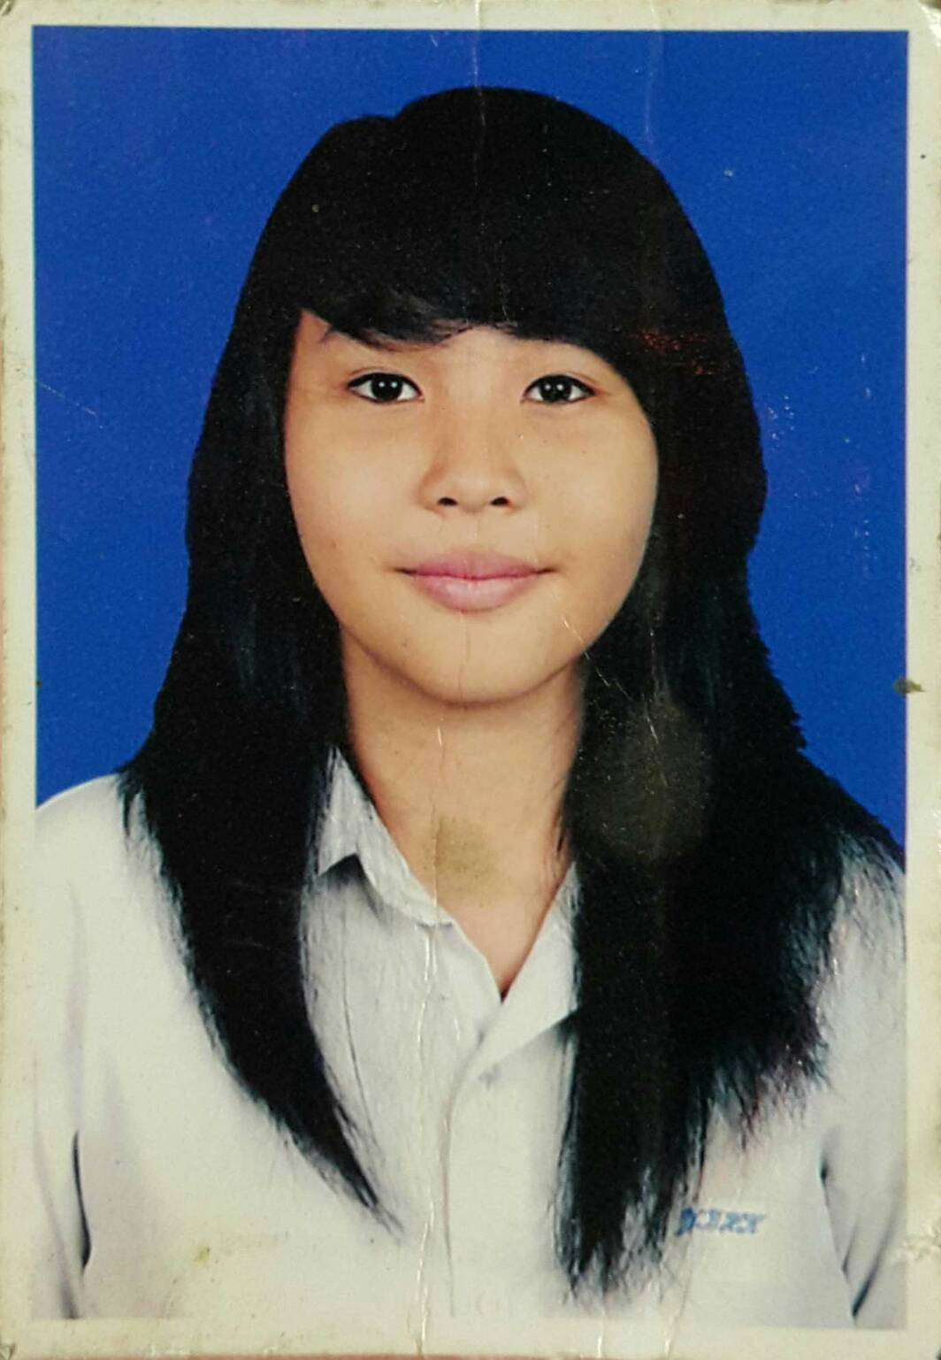

PHOTO
- PERSONAL INFORMATION
- Name : Michelle Josephina
- Gender : Female
- Place / DoB : Jakarta / June 3rd, 1994
- Nationality : Indonesia
- Marital Status : Single
- Religion : Catholic
- Address : Jalan Batu Tulis Raya No. 4
RT 003/002
Kel. Kebon Kelapa – Kec. Gambir
Jakarta Pusat - 10120
- Mobile : +62821 1013 1300
- E-mail : michellejosephinaa@gmail.com

- EDUCATIONAL BACKGROUND
- 1998 – 2000 TK Santa Maria
- 2000 - 2006 SD Santa Maria
- 2006 – 2009 SMP Santa Maria
- 2009 – 2012 SMA Tarsisius 1
- 2012 – 2014 UNIKA Atma Jaya
Economy - Accounting
- 2014 - Now BINUS University
School of Design – Interior Design

- ORGANIZATIONAL EXPERIENCE
- UKM Oasis Unika Atma Jaya 2012-2014 – Member
- UKM Badminton Unika Atma Jaya 2012-2014 – Member
- Himpunan Mahasiswa Desain Interior (HIMDI) 2014 – Now – Activist
- Sanmar Cup 2008 - Volley & Badminton Division
- Penerimaan Anggota Baru UKM Oasis 2013
- Malam Keakraban (MaKrab) Desain Interior 2014 – PR Division (External)
- Buddy Coordinator Freshmen Enrichment Program Penerimaan Binusian 2019
- Buddy Coordinator Freshmen Enrichment Program Penerimaan Binusian 2020

- INFORMAL EDUCATION BACKGROUND (COURSE)
- 2010 – 2013 Kursus Bahasa Belanda - Erasmus Huis

- COMPUTER SKILL/SPECIAL SKILL
- Auto Cad
- SketchUp + VRay
- 3Ds Max (on Progress)

- LANGUAGES SKILL
- Indonesia (Native)
- English (Good)
- Dutch (Beginner)

- PERSONALITY TEST

