CURRICULUM VITAE
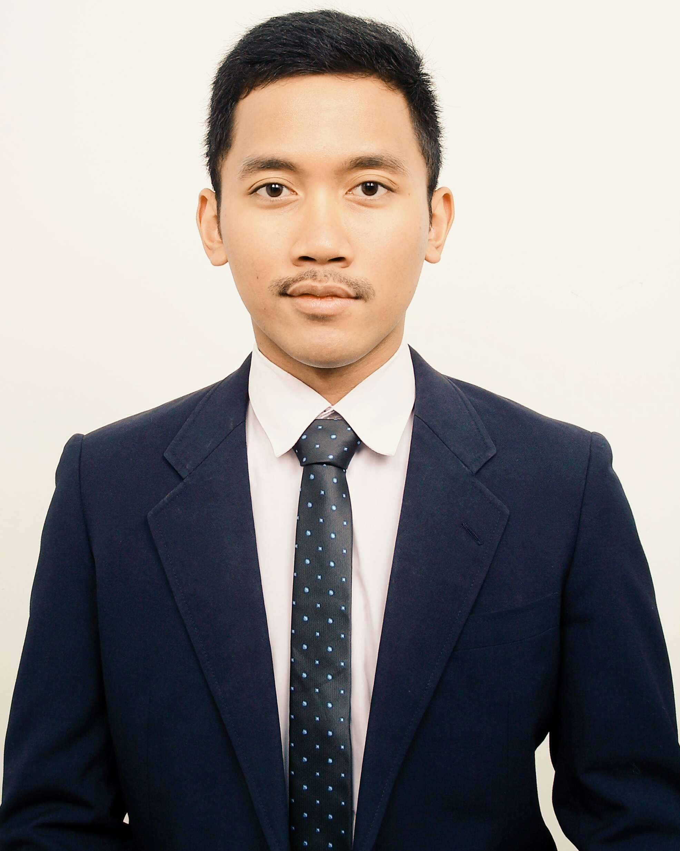

NAME: ANGGRAHA PUTRA
DATE OF BIRTH: 12TH JANUARY 1992
PLACE OF BIRTH: JAKARTA, INDONESIA
CURRENT LOCATION: JAKARTA, INDONESIA

ID NO. (KTP): 3271061201920004
PASSPORT NO.: A5749893
NATIONALITY: INDONESIAN
CONTACT NO.: +6287782497116
E-MAIL ADDRESS: ANGGRAHAPUTRA@GMAIL.COM

GENDER: MALE
MARITAL STATUS: SINGLE
FIRST LANGUAGE: BAHASA INDONESIA
OTHER SPOKEN LANGUAGE: ENGLISH, BAHASA MELAYU

DRIVING LICENCE: A & C (INDONESIAN), D (MALAYSIAN)

PERSONAL QUALITIES: FAST LEARNER / APPROACHABLE / LOVE REACHING OUT TO THE PUBLIC / TEAM-FOCUSED / PASSIONATE

MY HIGHER + HIGHEST EDUCATION:



1. BA (HONS.) BROADCASTING AND JOURNALISM
LIMKOKWING UNIVERSITY OF CREATIVE TECHNOLOGY
MALAYSIA
MARCH 2012 – DECEMBER 2013



2. DIPLOMA IN MASS COMMUNICATION
SEGi UNIVERISTY
MALAYSIA
SEPTEMBER 2009 – NOVEMBER 2011

MY PRACTICAL SKILLS:

WRITING (8/10)
REPORTING (8/10)
BROADCASTING (8/10)
V/O (8/10)
VIDEOGRAPHY & PHOTOGRAPHY (7/10)
MICROSOFT WORD/POWERPOINT/EXCEL (7/10)
ADOBE PHOTOSHOP (5/10)
FINAL CUT PRO (5/10)

PROFESSIONAL EXPERIENCE:

- MAJALAH MOBILMOTOR
NOVEMBER 2014 – NOW

- ROLE: JUNIOR REPORTER
- INDONESIA’S LONGEST RUNNING LOCAL AUTOMOTIVE MAGAZINE

I. FLYTIMES PUBLICATION AND PRODUCTION
AUGUST 2012 – JULY 2013

- ROLE: WRITER/REPORTER/NEWS PRESENTER + FOUNDING MEMBER
- LIMKOKWING’S FIRST UNIVERSITY NEWS PUBLICATION AND PRODUCTION
- DAILY TASK WAS TO LOOK FOR NEWS AND EVENTS, WHERE IT WOULD BE THEN PRODUCED AS PRINTED NEWSPAPERS AND ELECTRONIC NEWS (VIDEO)
- ORGANIZED AS WEEKLY PRINT AND RECORDED SEGMENT

II. MERAH PUTIH CLUB
JUNE 2012 – JUNE 2013

- ROLE: PUBLIC RELATION + SOCIAL MEDIA OFFICER
- LIMKOKWING’S ESTABLISHED INDONESIAN STUDENTS SOCIETY
-

III. TOPGEAR MALAYSIA
DECEMBER 2012 – MARCH 2013

- ROLE: INTERN
- DAILY TASK: TO UPDATE THE WEBSITE DATABASE
- OTHER TASKS: PROCESSED PRESS RELEASES INTO SHORT NEWS ARTICLES, ATTENDED NEW CAR & MOTORBIKE LAUNCHES AS WELL AS MEDIA DRIVES, COMPLETE WITH PHOTOGRAPHS

IV. WINGS RADIO LIMKOKWING UNIVERSITY
MARCH 2012 – JUNE 2012

- WORKED AS RADIO SHOW HOST

MY OTHER EXPERIENCE & ACHIEVEMENTS:

1. “LOG OUT, GO OUT” AWARENESS CAMPAIGN PROJECT, SEGi UNIVERSITY

2. “DEAN’S LIST” AWARD, SEGi UNIVERSITY

3. “PIXIE LOTT LIVE IN KUALA LUMPUR” PRESS MEET FOR WINGS RADIO (2012)

4. HOST/EMCEE FOR THREE MERAH PUTIH EVENTS: “MALAM AKRAB 2012”, “MONOPHONE 2013” AND “ELECTION 2013”

5. CONTRIBUTED A WRITING TO TRIBUN PONTIANAK REGARDING MALAYSIA’S 2013 GENERAL ELECTION (LINK: http://pontianak.tribunnews.com/2013/05/04/kontroversi-spanduk-barisan-nasional)

6. CONTRIBUTED A WRITING TO TRIBUN PONTIANAK ON INDONESIA’S 2014 PRESIDENTIAL ELECTION IN KUALA LUMPUR (LINK: http://pontianak.tribunnews.com/2014/07/06/pemuda-indonesia-di-kuala-lumpur-cenderung-ke-jokowi-jk)

7. MEDIA TEAM FOR WORLD YOUTH FOUNDATION’S “INTERNATIONAL CONFERENCE ON HUMAN TRAFFICKING ON YOUNG WOMEN AND CHILDREN” (2nd – 9th SEPTEMBER 2013)

8. TWO WRITINGS MADE INTO PRINT FOR TOPGEAR MALAYSIA, “MITSUBISHI MIRAGE MEDIA DRIVE” AND “GOSB DRIVE TO KEDAH”, PUBLISHED ON FEBRUARY 2013 AND APRIL 2013 ISSUES RESPECTIVELY

9. PRODUCTION WORKS: “BEAUTY AND PERCEPTION: SKIN TANNING” (DOCUMENTARY), “COOLBLOG” (CORPORATE DOCUMENTARY), “THE RESIDENT” (PROPERTY DOCUMENTARY)

FIND ME ON:

LINKEDIN: my.linkedin.com/pub/anggraha-putra/51/872/777/
FACEBOOK: ANGGRAHA PUTRA TRIGUNADI
TWITTER: @ANGGRHPTR
INSTAGRAM: @ANGGRHPTR

FOR YOUR REFERENCES:

DEWIGAH NATARAJAH
HEAD FACULTY OF COMMUNICATION, MEDIA AND BROADCASTING
LIMKOKWING UNIVERSITY OF CREATIVE TECHNOLOGY
E-MAIL: dewigah.natarajah@limkokwing.edu.my / MOBILE: +6 012 272 5783

HEZERI SAMSURI
EDITOR
TOPGEAR MALAYSIA
E-MAIL: editor@topgear-malaysia.com / MOBILE: +6 012 304 3634

SHEHZANA SHAIK HASSAN
FACILITY AND PROGRAM CO-ORDINATOR
WINGS RADIO LIMKOKWING UNIVERSITY
E-MAIL: shehzana.shaik@limkokwing.edu.my / MOBILE: +6 012 640 3427

ANTONIA TIMMERMAN
PRESIDENT (2012 – 2013)
MERAH PUTIH CLUB
E-MAIL: timmerman.antonia@gmail.com / MOBILE: +62 878 7168 5836

