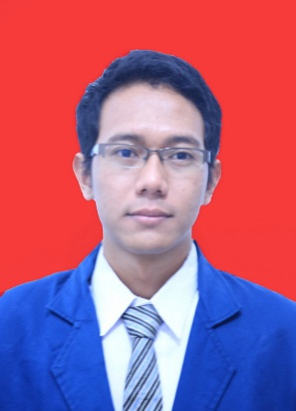
Fahrudin Afendy, S.Hum
Date of Birth : Pati, 07 Juni 1989
Gender : Man
Marital Status : Single
Religion : Islam
Height / Weight : 178 cm / 63 kg
Address : Jl. Nusa Indah RT 01 Rw 04 Growong Kidul, Kec. Juwana Kab. Pati
Phone / E-mail : +6285 680 076 86 / af_fendy@yahoo.co.id

Formal Education
2009-2013 Diponeoro University majoring English Department
Studying Literature and Culture especially from English and America including the history and issues around both countries.
2005-2008 SMK N 2 Pati
Vocational school for factory machinery program.
2002-2005 Madrasah Tsanawiyah Raudlatul Ulum Guyangan, Trangkil
Junior high school level for Islamic school.
1995-2001 Mi Raudlatul Ulum Guyangan, Trangkil

Formal Training (Certified)
2009 Latihan Keterampilan Manajemen Mahasiswa (LKMM) Tingkat Dasar Universitas Diponegoro.
2011 Seminar Nasional Indonesia Mengajar
2012 Pelatihan Pengajaran Bahasa Inggris bagi Anggota HMJ S1 Sastra Inggris (EDSA).
2012 International Seminar on Culture Across Perspectives Contestation Among Global, Nation And Local Cultures.
2014 In House Training First Aid and CPR.

Organization Experience
2009 – 2010 Wapeala Staff ( Mahasiswa Pecinta Alam) Diponegoro University
2010 – 2011 HMJ Staff , Student Department.
2010 – 2011 BEM Staff, Social Service Department.

Qualification
Computer Literate
English (written and oral)
Hospitality
Marketing

Work Experience

Informal Sector
2011 - 2013 Independent Freelance translator.
Translate documents from many dicplines program such as fishery, economic and legal from other college deparment.
2012 – 2013 Barista at coffee shop
Making beverages especially local Indonesian coffee.

Formal Sector
No. | Period | Institution | Position | Job Description
1 | 2008 - 2009 | PT. Laser Metal Mandiri | Machine Operator | - Make items as drawn by engineer using cutting, bending and welding machines
2 | 2010 - 2011 | El-Fifa Course | English Trainer | - Teach the children in English  - Develop fun learning system
3 | 2014 - 2014 | PT. Island Connection International | Customer Engagement Expert | - Responsible for the guests’ request and queries from pre, during and after their stay  - Explain the detail information about the resort  - Assisting site manager for arranging activities, canteen goods and administration  - Escort and guide the guests for special activity  - Ensure guests’ satifaction
4 | 2015 - 2016 | PT. Solid Gold Berjangka | Business Consultant (Marketing) | - Make appointment with investor  - Promote and dealt business proposal to new investor  - Give service in online trading such as advises and strategy about market condition for taking opportunity  - Develop the team

