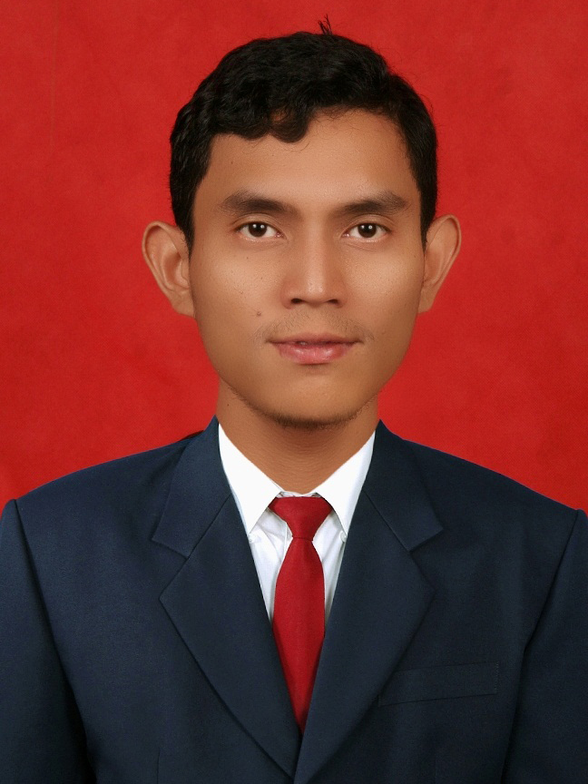
Curiculum Vitae

PERSONAL INFORMATION
Full Name : Taufan Afandi, S.H.,
Place/ Date of Birth : Jakarta / June 30th, 1990
Sex : Male
Religion : Christian
Nationality : Indonesian
Marital Status : Single
Height and Weight : 175 cm, 69 kg
Home Addres : Jl. Cibubur 2 No.10b Rt.008/Rw.010 Blok Duku Cibubur Ciracas Jakarta Timur
Code post : 13720
Mobile Phone : +62 821 1292 5693
Email : taufanafandi00@gmail.com
Hobi : Sport (Futsal,Bike), Reading, Traveling, Listen Music,
Watch Film, and Play Computer.
Educational Qualification
- Elementary School at SDK Permata Bunda, Depok, 1996 – 2002.
- Junior High School at SMPK IGN. Slamet Riyadi, Cijantung , 2002 – 2005.
- Senior High School at SMAN 99, East Jakarta, 2005 – 2008.
- Faculty of Law at University of Pancasila, Jakarta 2008 -2012,
GPA : 3,17 (Scale 4.00)

Summary of Qualification
- Good communication and interpersonal Skill.
- Good in english both writen and oral.
- Quick learner, discipline, able to work under pressure and work effectively (independent and in a team)
- Realiable, strong analytical skill and inovative
- High motivated and responsible able to work as individual or part of a team
- Able to work with societies that has variably of etnic and culture

Capability of Language

Specification | Reading | Writing | Speaking | Listening
English | Good | Good | Good | Good
Indonesian | Fluent | Fluent | Fluent | Fluent

Informal Education
- 2007 Computer Training (Office I) in Mutiara Computer Education
- 2005-2007 English Course in LIA

Job Experiences
- Working in Bank Rakyat Indonesia as a back office
Period : July 08 2013- August 25 2014
Description : Monitor standard quality of service from CS, Teller, and Satpam
and give a value for Customer Service, Teller, and satpam did.

Organization Experiences
- Member of Eunterpreneur University 2010 – 2011
- Member of Peradilan Semu University of Pancasila 2009 – 2010
- Secretary of Liga Mahasiswa Nasional untuk demokrasi 2008 - 2009

Computer Skill
- Microsoft Office (Word, Excel, Power Point), Internet Explorer

Seminar dan Training
Specification | Location | Years
Study Pengenalan Profesi Hukum  - Seminar | Law Faculty of University Of Pancasila, Jakarta | 2009
Business Plan Competition  - Seminar | Economy Faculty of University Of Pancasila, Jakarta | 2009
Trading Forex  – Seminar | Wisma BNI 46 by Mr. Leo | 2010
Pancasila sebagai Ideologi Bangsa  – Seminar | Law Faculty of University Of Pancasila, Jakarta | 2011
Pendidikan Khusus Profesi Advokat  - Training | University of Indonesia, Depok | 2015
Paper
- Minithesis with title “Upaya Pencegahan Penyalahgunaan Alat Pembayaran Non Tunai berupa Cek Travel (Traveler Cheque) menurut Undang-Undang No.8 Tahun 2010 tentang Tindak Pidana Pencucian Uang”. - 2012
With this I affirm that data described in Curriculum Vitae is true.
Jakarta, Mei 2015

(Taufan Afandi, S.H.,)

