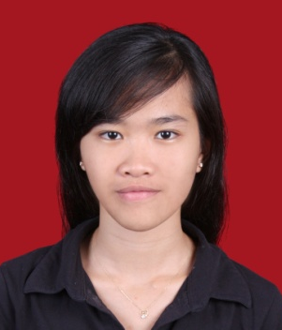

CURRICULUM VITAE

PERSONAL  INFORMATION | Name : Ria Riana  Place, Date of Birth : Jakarta, 13 July 1985  Address : Komp. Reni Jaya Blok AA 14 No.10, Pamulang, TangSel  Phone : (021)7493505, 081315166747  Email : rheya99@gmail.com
FORMAL EDUCATION | Inha University, Incheon, South Korea (2009-2013)  BA in Korean Language and Literature  National University, Pasar Minggu, Jakarta (2004-2007)  AMd in Korean Language
INFORMAL EDUCATION | Korea University, International Foreign Language School  (July 2008-January 2009) Korean Language Course
EXPERIENCE | Deposit Dept. at Bank Woori Saudara (January-August 2015)  Corporate Planning Dept. at Bank Woori Saudara (August 2015-January 2016)  International Trade and Business Dept. at Woori Bank Korea (April 2013-October 2014)  Planning Dept. at PT. Inni Ceragem Indonesia (November 2007-June 2008)
QUALIFICATION | Energetic and mature; eager to learn something new; challenging person and ready to do something creative.  Dynamic personality; able to work individually as well as a team; persistent  Good computer skill (Ms.Office and internet)  Fluency in Indonesia, English and Intermediate-Advance level for Korean Language

