Elzara Maharani
- elzara3006@gmail.com
- +62852-6183-4982
- +62852-6183-4982
- elzaramaharani
- Elzara Maharani

Jalan Letjend Jamin Ginting NO G6A
Komplek Pamen
Padang Bulan
Medan, 20155

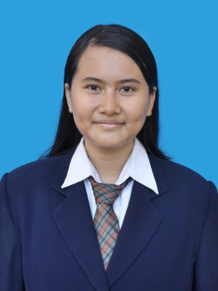

Date of Birth
30 June 1996

Personal Details
I am respectful, enthusiastic, responsible, self-initiated, able to work in team and independently. Like to learn new things, focus and serious in work. Based on my education background, so here I am apply for internship position that related to my background.

Education

2001-2002

2002-2005

2005-2008

2008-2011

2011-2014

2014-now

Organizations

TK BHAYANGKARI-13 PADANGSIDIMPUAN

SDN 15 PADANGSIDIMPUAN

SD SWASTA KEMALA BHAYANGKARI RANTAU PRAPAT

SMPN 1 RANTAU UTARA

SMK TELKOM SANDHY PUTRA MEDAN
Switching Engineering (Telecommunication)

UNIVERSITY OF NORTH SUMATERA
Science Communisation– Advertising Concentration

2009-2011 PRAMUKA SMPN 1 GUDEP 06031-06032

2011-2014 PASKOMDA (PASKIBRA SMK TELKOM MEDAN)

ROHIS SMK TELKOM SANDHY PUTRA MEDAN

2012-2013 OSIS SMK TELKOM SANDHY PUTRA MEDAN

Bendahara 2

2015-now UKM BADMINTON USU
Member
2016 SPIRIT ART ADVERTISING (SPARTA)
Member

Elzara Maharani – Resume

Work Experience
2013 POLISI DAERAH SUMATERA UTARA (POLDASU)
Internship

Training and Conference

2012 CISCO Networking Academy

2013 Blogger Telkom

Medan

2015 Pelatihan Jurnalistik Tingkat Dasar SUARA USU
Medan
2016 Kampus KOMPAS TV USU
Medan
2016 Personal Appearance and Branding Workshop
Medan

Computerliterate
Microsoft Office (MS word, excel , power point)
Adobe (Photoshop, Premiere)
Corel Draw

Interesting & Hobbies
Korean Drama, Writing, Reading, Badminton, Swimming, Cooking, Fotografi and Games

