C U R R I C U L U M V I T A E
FIRSTA ANGGA YULIANRA SUBIAKTO

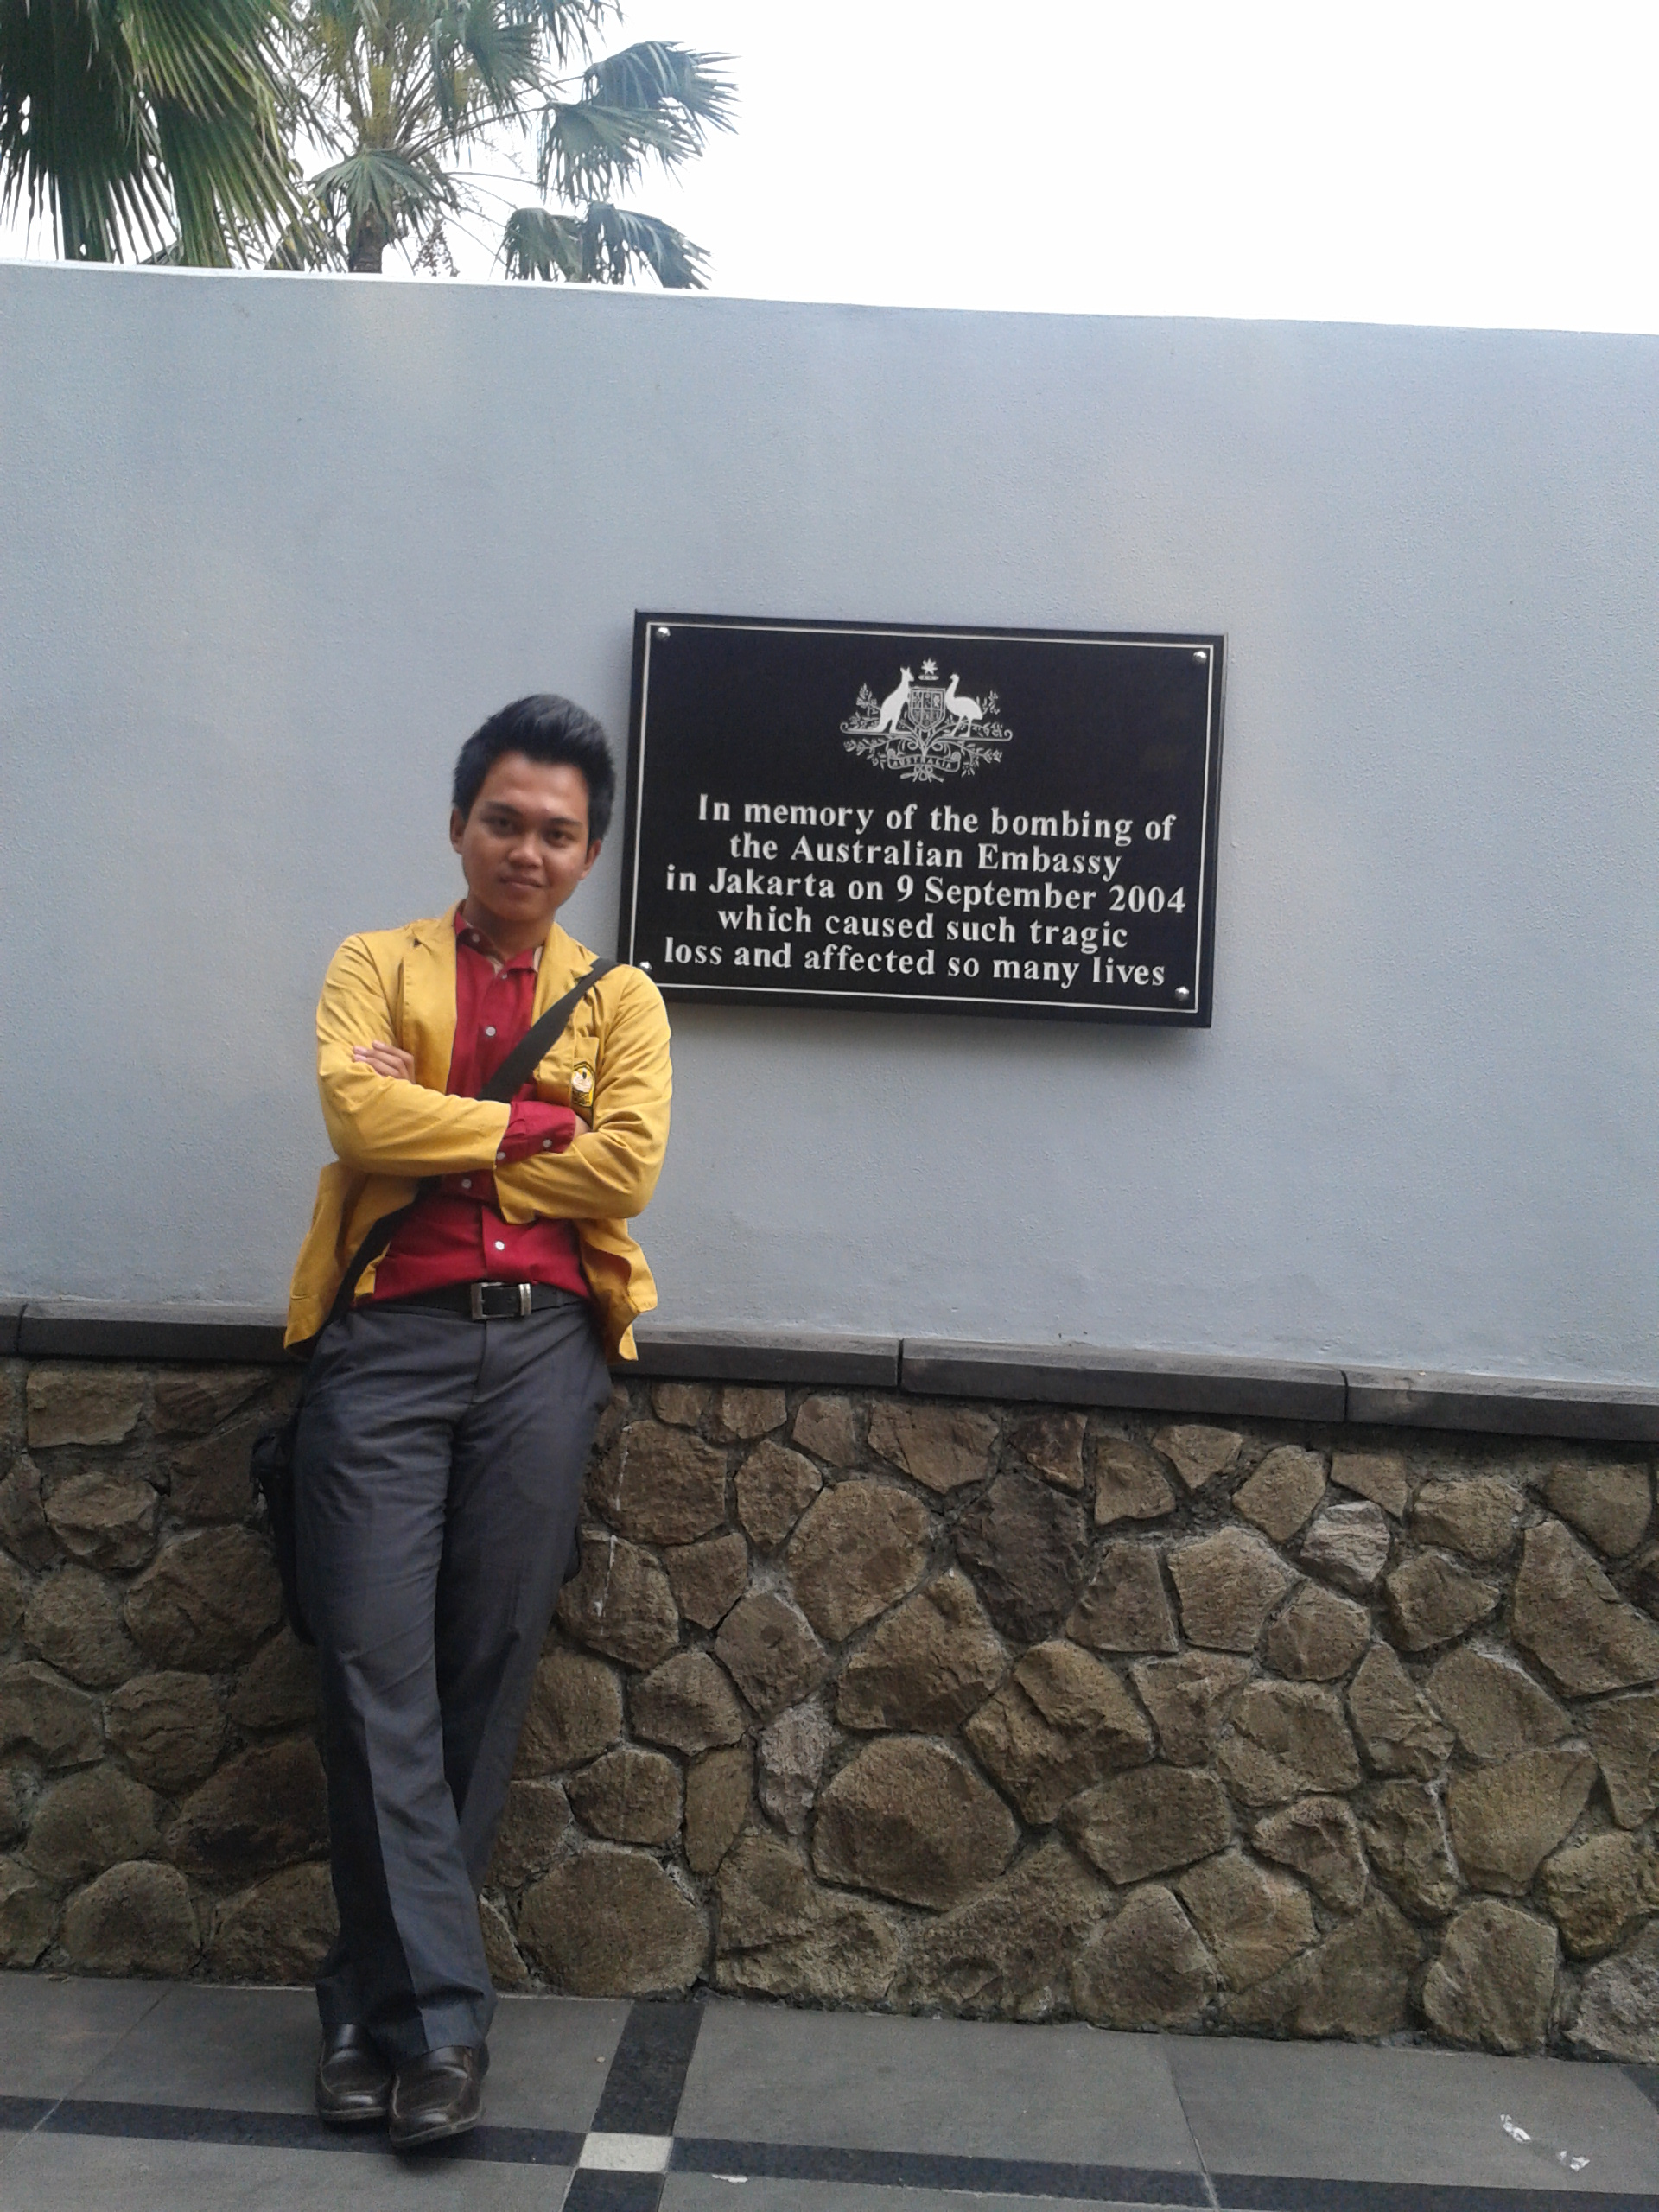

PERSONAL DETAILS

Full Name : Firsta Angga Yulianra Subiakto
Nick Name : Angga
Place, Date of Birth : Bekasi, July 1st, 1992
Sex : Male
Religion : Moslem
Weight :170 cm
Height :70 kg
Current Address : Madrani Street, Gg. Nakula, Harmony Boarding House, Room: 202, Urban village : Grendeng / Subdistrict : North Purwokerto, Zip Code : 53122

Permanent Address : Mangun Jaya Indah II, C2 No. 21, Merak Raya Street, Tambun/Bekasi, Zip Code: 17510

Mobile Phone : 085747307000
E-mail / Facebook : agayzjr@gmail.com / firsta.thetranslator@gmail.com
/Firsta Angga
Twitter : @FirstaAnggaYS

Hobbies : Playing computer games, programming, teaching, reading, playing guitar, and swimming

EDUCATIONAL
BACKGROUND

2010 – Now : Universitas Jenderal Soedirman, English Literature Study Program, Faculty of Humanities
2007 – 2010 : SMAN 01 Bekasi, Science Program (Senior High School )
2004 – 2007 : SMPN 01 Tambun (Junior High School )
1998 – 2004 : SDN 01 Setia Dharma Tambun (Elementary School )

ORGANIZATION/ COMMITTEE
EXPERIENCE

2014- Now : Staff of Public Relations Department, Promotion and Information Division of SEF (Student English Forum) UNSOED

2013 : Vice Project Officer of 5th Jenderal Soedirman Debating Championship
2013 : Staff of Public Relations Department, Promotion Division of SEF Unsoed

2013 : Announcer of SEF Indisc (Radio program), cooperated with Dian Swara 98,2 FM

2012 : Chief of English Literature Familiarity Night 2012 with the theme “PROMISE”

2012 : Coordinator of Equipment Division in IFDC (Inter Faculty Debating Championship) and JSDC (Jenderal Soedirman Debating Championship)

2012 : Staff of Student’s Welfare of HMSI (Himpunan Mahasiswa Sastra Inggris)

2012 : Manager of SEF Broadcasting Management cooperated with Dian Swara 98.2 FM
2012 : Journalist of VOSEF Magazine

2011 : Coordinator of Escort Commission of Student’s Orientation 2011 with the theme “KRISTAL”

2010 : Staff of Fund Rising Division of FISIP Social Service in Kubangan Village, Cilongok

TEACHING EXPERIENCE

2014- 2015 : English Instructor in SPEC Purwokerto

2013 : English Instructor of Regular Class of SEF Unsoed, Lower-Intermediate Level
2012 : English Instructor of MIN Purwokerto, 6th Grade Student, Elementary Level
2012 : English Instructor of Regular Class of SEF Unsoed, Basic Level

COMPETITION
EXPERIENCE

2014 : UNSOED delegates of Speech Contest of AEO in BINUS.
2013 : Debater of JOVED (Java Overland Varsities English Debate) in Universitas Brawijaya, Malang, East Java
2013 : Debater of EASA in STAIN Purwokerto
2013 : Panelist Adjudicator of ALSA UGM Debate Competition in Yogyakarta
2012 : Panelist Adjudicator of IFDC (Inter Faculty Debating Championship) UNSOED
2011 : Swing Team of IFDC UNSOED

ONGOING PROJECT

- Thesis entitled “The Effectiveness of Using C.A.L.L Spaced Repetition System In Autonomous Learning Of Spoken English (Experimental Study In SMAN 3 Purwokerto)
- English Instructor and Translator in RuangBahasa.com
- Web programmer and administrator of RuangBahasa.Com
- Web Web programmer and administrator of uptbahasa.unsoed.ac.id
- Software F.A.Y.S. Sm@rtEnglish Acceleration Advanced Version (Learning English by Software )
- Software FAYS Point Of Sales (Sales/Cashier Software)
- Software FAYSTASTIC WORLD (Learning English by RPG Game in Computer)

REFERENCES

- Drs. Agus Sapto Nugroho M.Ed TESOL(Chief of Unsoed Language Service Unit)
Phone Number: 085865244404
- Agus Subiakto, SE (My Father), Phone Number: 0811156751

ONGOING PROJECT

ORGANIZATION EXPERIENCES

T M

