DAFTAR RIWAYAT HIDUP

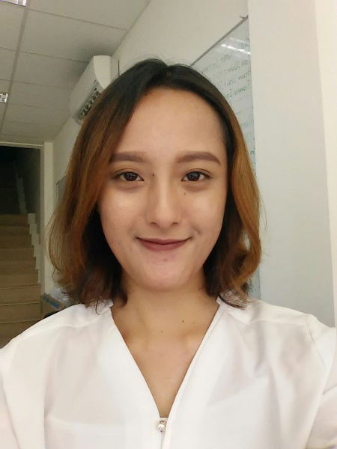

Data Pribadi

Nama : Dina Lathifa Horman
Tempat/Tanggal Lahir : Jakarta, 26 Desember 1993
Alamat : Bojong Gede Indah, Blok G/11
RT01/17, Bojong Gede, Bogor, 16320
Telepon : (021)8782798 (rumah)/
087770816023 (Hp)
E-mail : dinalathifahorman@gmail.com
Jenis Kelamin :Perempuan
Tinggi/berat badan : 158 cm/45 kg
Agama : Islam
Kewarganegaraan : Indonesia

Latar Belakang Pendidikan Formal

1999-2005 : SD Muhammadiyah Bojong Gede
2005-2008 : SMPN 7 Bogor
2008-2011 : SMAN 9 Bogor
2011-2014 : D-3 Penerbitan-Jurnalistik, Jurusan Teknik Grafika
dan Penerbitan, Politeknik Negeri Jakarta, IPK 3,51 (skala 4)

Latar Belakang Pendidikan Nonformal

2012-2014 : Student of LIA-Depok in Conversation Class

Pengalaman Kerja/Magang

November 2013-Desember 2013 : Magang sebagai proofreader pada Penerbit
AsmaNadia Publishing House (ANPH) November 2014-Januari 2016 : Freelance sebagai website content writer
pada Media Online Chirpstory.com
(Chirpstory.com/id/Dina16Bahri)
Januari 2015-Februari 2016 : Content Writer pada website KelasCinta.com
(http://kelascinta.com/author/dina-lathifa)
Februari 2016-Sekarang : Blogger di Halo Robotics
(http://blog.halo-robotics.com/author/dina-lathifa/)
Pengalaman Organisasi

Sekretaris Umum OSIS SMPN 7 Bogor periode 2006/2007
Anggota MPK SMAN 9 Bogor periode 2008/2009
Wakil Presiden 2 Polytechnic Radio Station (Poros) FM periode 2011/2012
Sekretaris Umum Polytechnic Radio Station (Poros) FM periode 2012/2013

Keahlian

Content Marketing
Social Media
Blogging
Translating
Handling customer

Software Skills

Microsoft Word Microsoft Power Point Wordpress
CRM (newsletter & live chat)
Magento (basic dan edit html)
Adobe Photoshop dan Adobe Dreamweaver (basic)
Hootsuite
Facebook Bussiness Manager

Kepribadian

Fleksible
Fast-learner
Hard-working
Curious

Resume Jobdesc Terkini

- Responsible for publishing blogpost on company's blog.
- Providing content description for products on e-commerce website.
- Providing content to be use for digital campaign.
- Responsible for planning, designing, and scheduling newsletter every week or any special occasion(s).
- Handling customer service through live chat, phone, email.
- Handling social media's company and brands, as well manage Facebook ads.

In additional:
- Design graphics to be use in digital campaign or blogpost.
- Help web developer to maintain website from back-end system (edit html).
- Help sales team by track online sales on e-commerce site through back-end system (familiar with magento).

Find me on

Instagram
Twitter
Facebook
LinkedIn

Demikian daftar riwayat hidup ini saya buat dengan sebenarnya.

Hormat saya,

Dina Lathifa Horman

