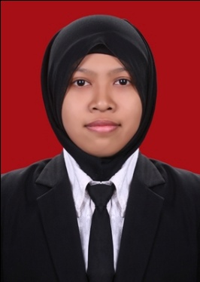
CURRICULUM VITAE
PERSONAL DETAILS
Name : Syifaul Lathifah
Place of Birth : Pati
Date of Birth : December, 6th 1993
Gender : Female
Height : 152
Marital Status : Single
Nationality : Indonesian
ID Number : 3318064612930002
Address : Jalan Pete Raya No. 28, Sekaran, Gunungpati, Semarang
Phone Number : 082221218960
Email Address : syifaullathif69@gmail.com
GPA : 3.49/4

FORMAL EDUCATION
2011 – 2015 English Education and Literature, Semarang State University
2008 – 2011 SMAN 2 Pati
2005 – 2008 SMPN 1 Jaken
1999 – 2005 SD Sriwedari 1, Jaken, Pati

SKILLS
Computer : Microsoft Office application (Word, Excel, Power point)
Languages : Excellent in Indonesian, good in English

WORKING EXPERIENCES
August – Sept 2014 Internship at SMPN 1 Karangtengah, Demak
Feb 2016– Present Tentor at Cendekia Course
Freelance English translator

Sincerely yours,

Syifaul lathifah

