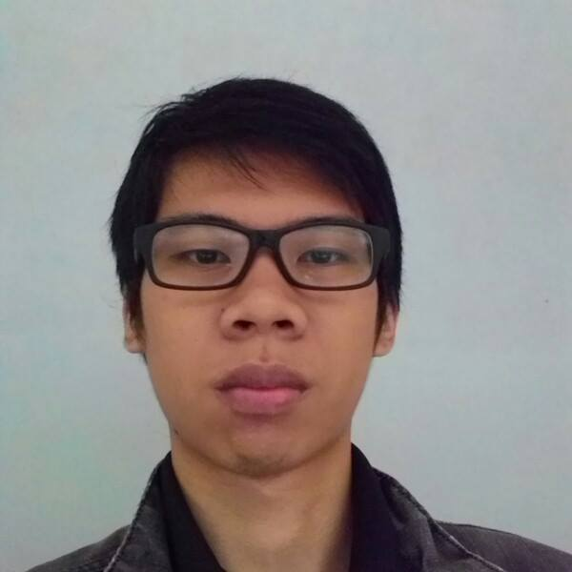
‍‍Andrew Jason
Muara Karang Blok F5 Utara no. 6, Pluit, Penjaringan, Jakarta Utara | 082122306474 | forte_nos@yahoo.com
Basic Profile
- Just an ordinary dude with some inventions in Unity Engine.
Education
Formal Education
Sekolah Dasar | Graduated: 2007 | SD Tarakanita 4
Sekolah menengah pertama | graduated: 2010 | Smp Tarakanita 2
Sekolah menengah akhir | graduated: 2013 | Sma Tarakanita 2

Special courses
Mandarin course | VMGP Mandarin class
FROM 2002 uNTIL 2011, iNTERMEDIATE GRADE
Japanese course | Evergreen
2013, BASIC 2 GRADE
mANDARIN course | BNMC
2014, Intermediate grade
Study abroad programme | South China University of technology
September 2015 until jANUARY 2016
Skills & Abilities
Android
- Just basics, still stuck on database and network
3D MODELING
- Sketchup, Blender, and house modelling
Programming (Java, Unity, C#, C++, Web, Android)
- Sometimes in my spare time I always make some small unity project for VR and AR
- Website with only CSS and HTML (Front End)
Leadership
- Can lead a group of 3-5 people for a small project or a big project.
Experience
Content Programmer | Mazel Hazel | fEBRUARY 2015 UNTIL aUGUST 2015
- Accomplish 3 contents on VR development which is developed with Unity Engine and Unreal Engine
eDUCATION cOORDINATOR | binus game development club | aPRIL 2014 UNTIL AUGUST 2015
- Handles some of tutorial classes on game development and handle some events like workshop or seminar for the members of BGDC and Binusian.
IT Developer | Elixir | February 2016 until aUGUST 2016
- Handle website and some apps for the company
IT Developer | sUGA | aUGUST 2016 Until present
- Handle Point of Sales App for the company
PART-TIME Android Developer | lazato | march 2016 Until may 2016
- Developing some Android Apps
Komti / Head prefect class | September 2013 UNTIL January 2015 AND PRESENT
- Handle class, and also as the lecturer assistant to help the lecturer for his/her needs, for example: going to AOC room, and attendance verification
committee of tarq cup (Radio division)| 2012
- As the DJ and giving some information for when the competition of TarQ cup
committee of tarq cup (Consumption division)| 2012
- Preparing food for guest stars and host for the closing night of TarQ cup.

Achievements and Participations
- 1st PLACE Story Telling Competition, 2010 Swiss German University
- 1st Place, Start Up 1st Business Plan Competition 2013
- Participated in ALSA UI 2015 E-comp for story telling completion
- Participated in ALSA UNPAD 2015 E-comp for story telling completion
- Participated in ALSA UNPAD 2016 E-comp for story telling completion
- Participated in AEO 2015 story telling completion
- Participated in AEO 2016 story telling completion
- Participated in UNTAR The ICON 2015 E-comp for story telling completion
- Participated in Binus ECOM 2016 Story Telling Competition

