Resume (July 2014)
Elymariani
Malaysia Address:
Savanna Condominium
Block A-13A-07, Jalan Bukit Jalil 1/155A
Bukit Jalil (57000),
Kuala Lumpur, Malaysia
(+60) 10-2456-903
E-mail: Fang_yiz@hotmail.com
Personal Information
Date of Birth: 01 April 1991
Passport Number: A7255908
Gender: Female
Nationality: Indonesian
Religion: Buddhist Female feFemale Buddish
Marital Status: Single Single Indonesian
Expected Salary: MYR 3000 - 3500 (NEGOTIABLE)
Notice Period: Able to start at March i

Career Objective
Seeking a challenge career with entry level IT related job at company that provides opportunities to become professional and personal growth.

Profile Summary
An enthusiastic self-starter: Willingness to hardworking and learn with fast: highly flexible and adaptable performer: Ability to work in under pressure with minimum supervisor and work in team: adaptable at multi-tasking and delivering numerous time of project: Have a high of responsibility and loves a challenge.
Working Experience
Business Development Executive in Exabytes Network SDN.BHD 2014 (Feb – May)
Responsibilities:
- Develop relationships with potential and existing customers via emails and online community involvement
- Gathering market trend and customer information to promote hosting solutions to prospects
- New business leads penetration & business opportunity evaluation
- Actively get new customers and new sales
- Increase the yield per client
- Prepare quotations competently
- Process new orders proficiently
- Follow-ups with the customers consistently
- Formulate and document product positioning and go-to-market plans
- Develop and implement management processes and reporting
- Develop and document business and / or sales marketing plan
- Assist in any ad-hoc-projects as assigned
Internet Marketing Executive in Exabytes Network SDN.BHD 2014 (June – Current)
Responsibilities:
- Assist in planning, executing and evaluating marketing campaigns.
- Plan and run advertising campaigns
- Engage and strengthen relationship with customers / partners / bloggers through different channels such as web, blog and social media network.
- Build up brand awareness among blogging community.
- New business leads penetration and business opportunity evaluation.
- Do market research and competitor analysis
- Handle and follow up sales enquires.
- Create knowledgebase articles and tips

Education Background
Bachelor of Computing 2009-2012
Asia Pacific University of Technology and Innovation (APU) Under Staffordshire University (UK) program
Major: Web Development
Honors: 2nd Class (Upper)
CGPA: 3.3

Senior High School 2006-2009
Holy Word Christian High School
Major: Science
Skills
- Programming Skill HTML5, C#, ASP.NET, PHP, CSS3, Java Scripts and Action Scripts.
- Familiar with database technology including MS SQL Server and MS Access.
- Familiar with software Microsoft Visual Studio, Web Expression, Adobe Dream Weaver, Adobe Flash, Adobe Photoshop, Web Design, UX Design and Word Press
- Familiar with Microsoft Office (Word, Excel, Visio, PowerPoint and Project).
- Excellent Communication Skill.

Other Details
- Willing to be interviewed for further discussions.
- Willing travel mobility and relocation.
- Languages Spoken: English, Chinese, Hokkien, Indonesian Language, and Bahasa Melayu.
- Languages Written: English, Indonesian Language, and Bahasa Melayu.

Portfolio
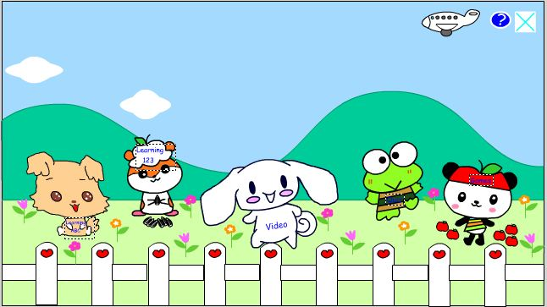

Kids E-Learning Animated Application

Kid’s E-Learning Animated Application about how developer uses the Adobe Flash to develop a multimedia system for kids aged between 3 to 5 years old. This application will teach the kids to learn the alphabets and basic numeric.

Kids E-Learning Animated Application included some quizzes to let the kids do the test about alphabets and numeric after they were finish learned from application. The quizzes can test the IQ of kids and help the kids to quickly remember and memorize the alphabets and numeric.

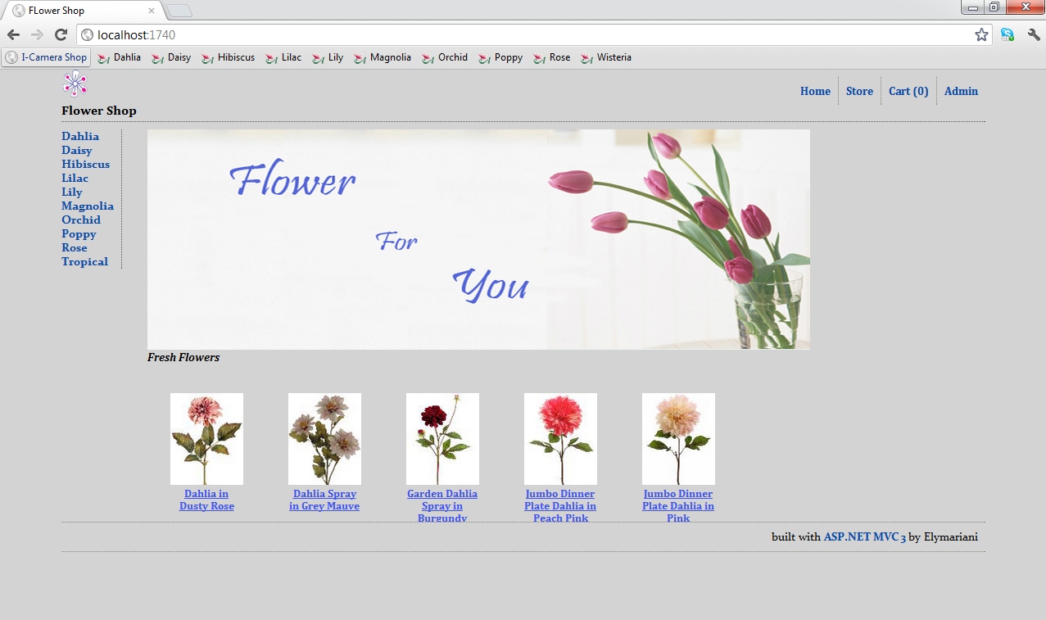
Ecommerce Online Flower Shop Website

Ecommerce Online Flower Shop Website about how developer uses the ASP.NET MVC to develop for online shopping website. User is able to purchased the flowers. Online Flower Shop website users be able to login, registration, browse products, view, delete, add, update shopping cart and make payment.

The administrator is be able to modify the products such as create new products include the details information and products picture. The administrator also can edit the products details and delete the products when the products are out of stock.

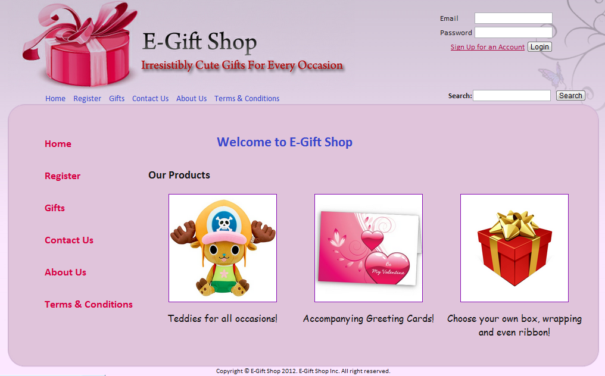
Ecommerce E-Gift Shop Website

Ecommerce E-Gift Shop Website about how developer uses the Microsoft Studio 2010 to develop for online shopping website. User is able to purchased the Gift such as teddy bears, customization greeting cards, select wrapping, ribbon, gift box and bag.

Online E-Gift Shop website users be able to login, registration, edit profile, change password, browse, search products, view, delete, add, update shopping cart, view order history, view order delivery info, view orders status and make payment.

The administrator be able to product management such as browse, view, create new products include the details information and products picture. The administrator also can edit the products details and delete the products when the products are out of stock.

Additional functions administrator able to manage the orders such as view pending, view-completed orders, view orders status, view members detail, approval, and reject orders.

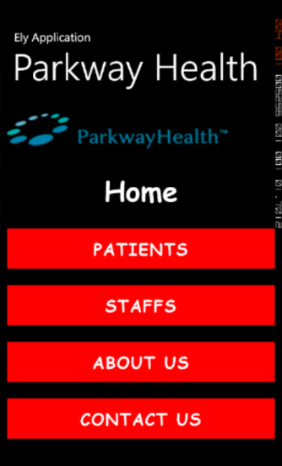
Parkway Hospital Application

Parkway Hospital Application about how developer uses the Microsoft Studio 2010 to develop for online Hospital Application. This Hospital Application also support for hotline call system.

Online Hospital Application patients be able to login, registration, make, view appointment, and view prescription information.

The doctors be able to login, view appointment information, view, add prescription, patients records, view doctors and nurses location.

The nurses are able to login, view appointment information, patient’s record, view nurses and doctors location.

