 | Reza Pradipta Maulana
7/1/2016 | Personal Information:
Nationality: Indonesia
Date of Birth: March 5, 1992
Birthplace: Bandung
Address: Jl. Cibogo Bawah No.23 RT04 RW07
Phone Number: 081546824299 (WhatsApp/Line)/085721332927
E-mail: rezapradiptamaulana@gmail.com
Facebook: http://facebook.com/rezapradiptamaulana
Twiter: @re_zapperation

Professional Profile
- Hard – Working and adapting easily to new life and working environment.
- Fast learning behaviour in self and knowledge development.
- Open minded toward new knowledge.
- Capable work in a team as well as independently

Education and Qualifications
Degree  2010 – 2013 | Diploma of English Linguistics  Politeknik Negeri Bandung (POLBAN)
2007 – 2010 | 15 Senior High School
2004 – 2007  1998 – 2004 | 26 Junior High School  Sarijadi Selatan I Elementary School
professional Experience
Manual Author | PT.Dirgantara Indonesia
August 2013 – November 2014
- Responsible for proof-reading and verifiy any aero plane instrument manual
- Coordinate with the Illustration and Assembly Division team on verifying manuals, customer feedbacks and problems
- Responsible for re-evaluate archives and documents concerning letters of import, invoices, customer’s feedback, etc.

Non – formal Education and organization
2014 – 2015  2012 – 2013  2010 – 2012  2008 – 2009  2004 – 2007 | E-PLC Speaking Class  Ieduc General and Toeic ( English Course )  Purwacaraka Music School  Bandung Beatles Community  Kharisma Badminton Club

skills
- Microsoft Word, Excel, Point, etc
- Adobe Photoshop
- CorelDraw
- AutoCAD

transkrip nilai

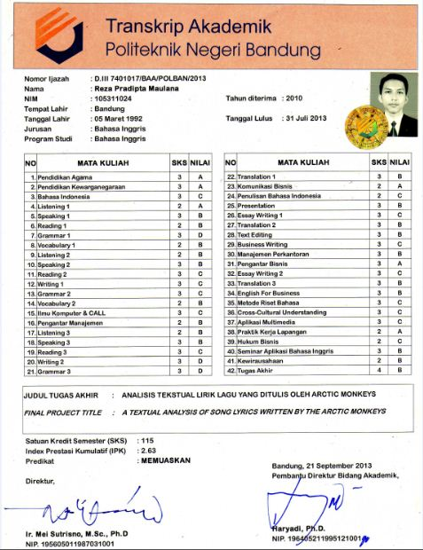

Ijazah

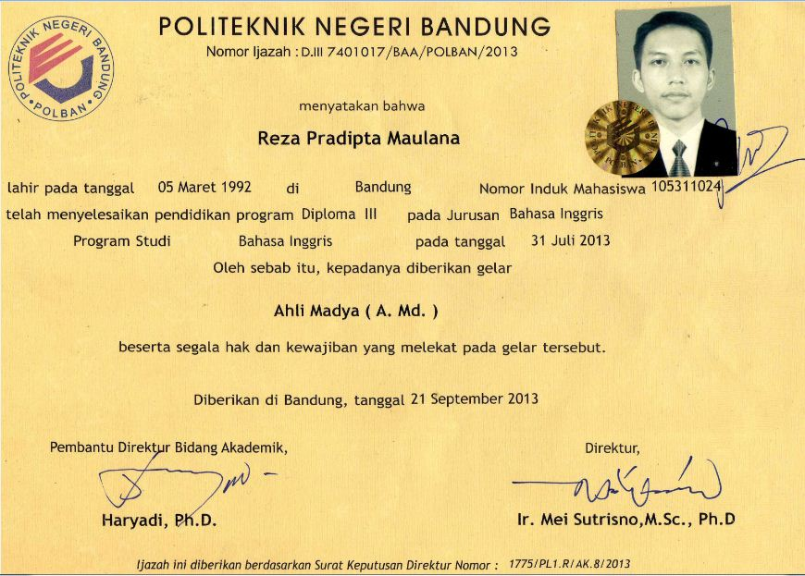

ktp
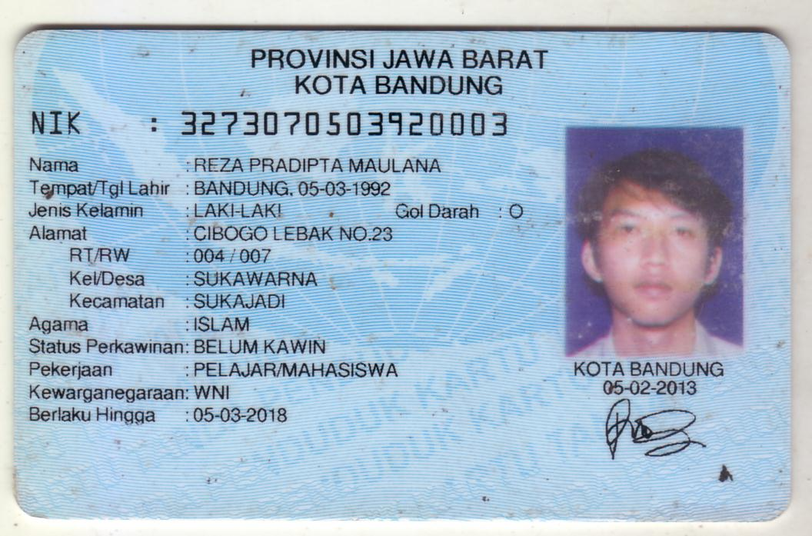
TOEIC

