CURRICULLUM VITAE

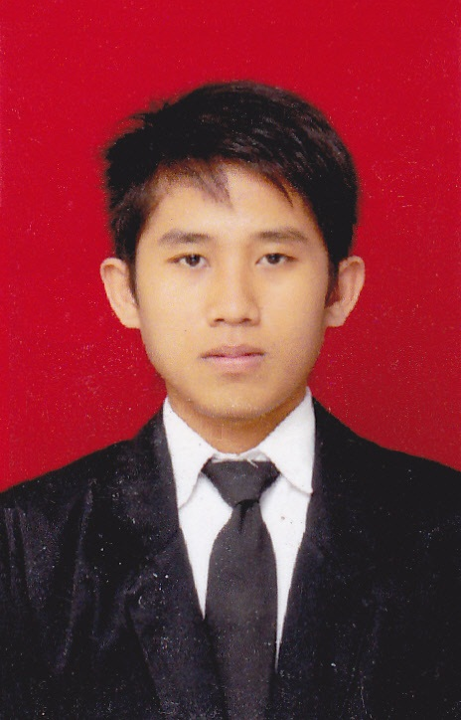

MUHAMMAD IRWAN
Jl. Kranggan, Kebonsari RT. 01/RW. 03
Pekalongan 51174
Phone: 0858-7655-3126
Email : muhammadirwan228@gmail.com

PERSONAL DATA

Nick Name : Irwan
Place, Date of Birth : Pekalongan, Agustus 20th, 1993
Gender : Male
Marital Status : Single
Religion : Moslem
Career Objective

To seek further challenges as BSS Engineer, BSS Team Isntaller, Junior Staffor other related position where a diverse background and proven technical expertise will be utilized and advanced
SuMMARY OF QUALIFICATION

Able to adapt situation, learn quickly, attractive, hard working, discipline, honest and loyal, enjoy teamwork but able to work independently, self motivated, willing to learn everything, good inter-personal skills, ability to maintain a good relationship with clients
FORMAL EDUCATION

2011 – 2015 : Program Study D₃Manajemen Informatika
PolytechnicMuhammadiyah Pekalongan, IPK : 3.13
2008 – 2011 : SMK GATRA PRAJA Pekalongan
2005 – 2008 : MtsSS Proto Karangdadap, Pekalongan
1999 – 2005 : SD N 02 Kebonsari Karangdadap, Pekalongan

computer skills

Operating System | - Windows (XP, Win 7 & 8)
Desktop Aplication | - Adobe Photoshop  - Corel Draw  - Ms. Office (Word, Excel & Power Point)
Web Aplication Builder | - Adobe Dreamweaver
Desktop Aplication Builder | - Visual Basic 6.0
Computer Software Maintenace | - Reinstall OS  - Error Troubleshooting
WORKING EXPERIENCE

- Update Detail Progress from field with email service day to day
- Controll Progress with Ms. Excel.

