Curriculum Vitae
Personal Information
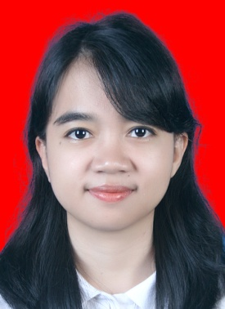

Name : Dike Nabila Trivinggar
Place/ Date of Birth : Bandung, January 23rd 1992
Nationality : Indonesia
Sex : Female
Marital Status : Single
Address : Panghegar Permai, Jl. Panyawangan VI/16, Bandung, Indonesia
Mobile Phone : +6285695665700
E-mail : dike.trivinggar@gmail.com
Translation Language
- Engli

- English - Indonesian (Mother Tongue)
Educational Background

2010 - 2015 : International Relations Department, Faculty of Social and Political Science, Universitas Indonesia, Depok (Performed 5 semesters before exiting the program)
2015 - : Intermedia Visual Arts Department, Faculty of Creative Industries, Telkom University, Bandung

Organizational Experiences

2014 : Liaison Officer in Festival Management Division in UI Film Festival 2014

Working and Internship Experience

2013 : Private Bahasa Indonesia Tutor for Foreign Students, University of Indonesia
During my study years in University of Indonesia, I worked as a part-time private Bahasa Indonesia Tutor for foreign students in University of Indonesia.
January-
February 2014: Book Translator at Mizan Publishing House, Bandung
Mizan is an Indonesian publishing company based in Bandung, West Java. I joined the company as an intern for foreign novel translator position. The book I translated with team during my internship period, titled “The Lost Files: Secret Histories” which is part of “I Am Number Four” series written by author Pittacus Lore, has been published nationwide in February 2015.

Skills

- Translating - Editing

