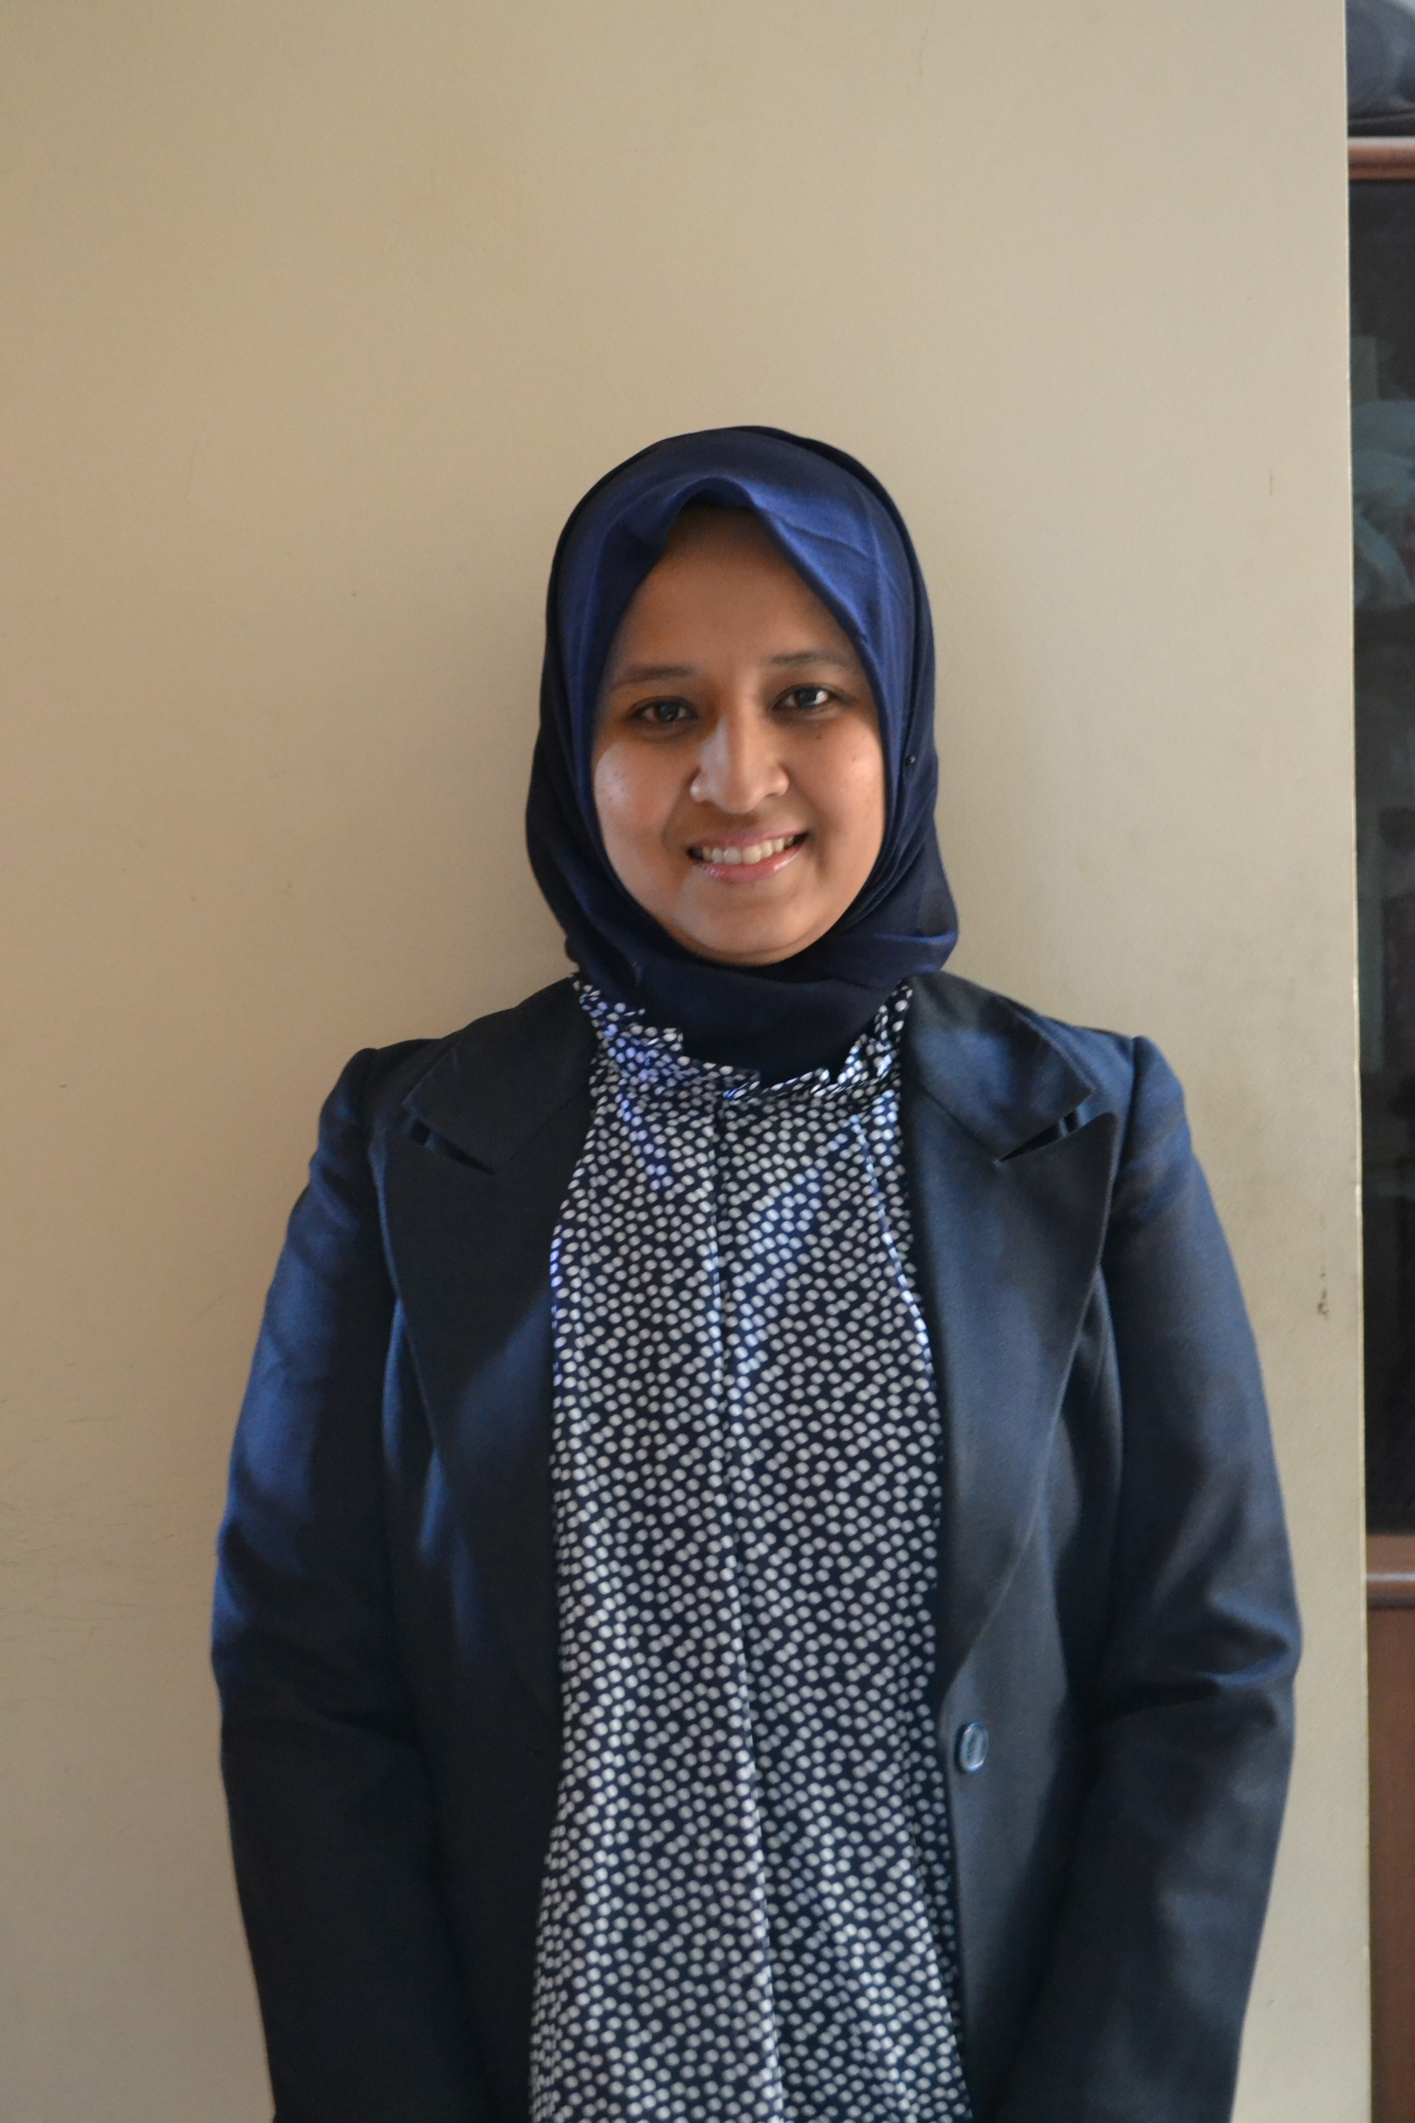
ESTU PRASTIWI
- Jln. Wadassari II No. 38 RT 007 RW 02
Pondok Betung - Pondok Aren - Tangerang 15221
  - icetwo29@yahoo.com
 0815 8767 326 (Cell Phone)
 0878 8950 9398 (Cell Phone)

OBJECTIVE

To pursue a challenging position which will use the knowledge I have gained built on my experiences in progressive and reputable company.

PROFILE

- A loyal, trustworthy, and dependable person
- A good communicator who enjoys new challenges with an objective and responsible approach to work
- An enthusiastic and adaptable person who works well as part of a team or individual
- Familiar with independent correspondence (Indonesian and English)
- Tactful in handling confidential matters
- Welcome to a position offering career progression and an opportunity to develop present skills

PERSONAL Details

Place/date of birth : Jakarta, October 29, 1984
Sex : Female
Religion : Moslem
Marital Status : Married
Nationality : Indonesian
Interest : Music and Reading

EDUCATIONAL BACKGROUND

Formal:
No | Name of Institution | Year of Graduation | Remarks
1 | Gunadarma University, Faculty of Letters | 2007 | Bachelor (S1) majoring in English Literature
2 | SMUN 87 Bintaro | 2002 | Senior High School
3 | SLTPN 177 Bintaro | 1999 | Junior High School
4 | SD Hanjuang | 1996 | Elementary School
5 | TK Hanjuang | 1990 | Kindergaten

Informal:

No | Name of Training | Time | Place
1 | Office Secretary | 2008 | Interstudi Secretarial College, Jakarta
2 | English Course (Basic Level) | 2001 | LIA, Bintaro

TRAINING/WorkSHOP

No | Name of Training | Time | Place
1 | TOEFL Preparation Course | 2006 | Gunadarma University, Depok
2 | Internet for Literature and Linguistics | 2005 | Gunadarma University, Depok

SKILLS

Languages Bahasa and English
Computer Windows OS, Ms.Office (Word, Excel, PowerPoint), and Internet Explorer

Working experience

- HUMAN RESOURCES ADMINISTRATIVE to HUMAN RESOURCES MANAGER Nov 2008 – Sept 2015
PT. Saripari Pertiwi Abadi – Indonesia
Drilling and Workover Rig Services
- Manpower
- Assisted the group in fulfilling client manpower requirements
  - Managed job postings
  - Received, compiled and summarized applicant CVs
  - Arranged interviews
- Monitored flow of manpower request documents
- Arranged employment agreements issued.
- Personnel Database & Daily/Monthly HR Job
  - Updated & maintained personnel data through the HR On-line system
  - Prepare necessary documentations on employee’s employment
  - Maintain accurate & timely updates of leave records and attendance report in order to calculate the attendance allowance
  - Handle Jamsostek (BPJS Ketenagakerjaan) for project employee
  - Handle Employee Health Insurance
- Support other HR-related function general administration duties
  - Performed and Manage routine day to day or monthly HR operational matters such as:
- Handle HR Correspondence (Ingoing and Outgoing letter or emails).
- Making duty letter for employee who will perform duty travel on our project or other business trip for the Manager and various department staff
- Arranged ticket and hotel for duty travel or other business trip for HR Manager and Supervisor

- Marketing and Tender Staff July – November 2008
PT. Saripari Geosains – Indonesia
Survey and Geophysical Services

- Looking for the tender in Seismic Operation in order to carry as a company strategic plan.
- Perform a control check against the tender documents to be submitted
- Monitoring running Tender and that will come
- Creating an improvement plan to the entire tender process to obtain added value
- Monitoring and implementing progress tenders that have been submitted to the customer.
- Prepare, review, evaluate and monitor a document that has been included in the tender
- Help and try to give solutions to the discrepancy or the dissatisfaction of the customer.
- Monitor corporate formalities associated with government regulatory standards
- Organized Marketing Division activities
- Assisted the Marketing Manager in daily activities
- Spread the information about company capacity and capability by various information media.
- Made and propose the budget for marketing activities.

