CURRICULUM VITAE

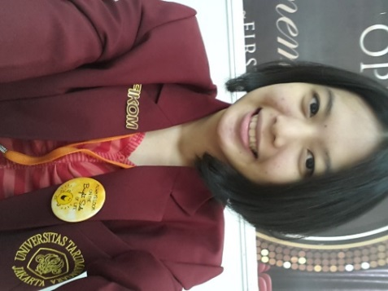
Personal Information
Nama : Michelle Alexandrea
Address : Muara Karang Blok W 5 Utara No.5,
Jakarta Utara
Telephone : (+62) 8981308848
Email : Alexandrea.michelle@yahoo.com
Date of Birth : March 11th, 1995
Religion : Catholic
Nationality : Indonesian
Sex : Female
Marital Status : Single
Height, Weight : 166 cm, 45 kg
Education
Studied Faculty of Communication at Universitas Tarumanagara (from 2013 until now)
Work Experience
- SPG FitActive at Tribeca Central Park (Event Dance Out Loud 22-24 Juni 2012).
- SPG Smoothie at ITC Kuningan (3 Juli 2012).
- SPG Teh Walini at PRJ JiExpo Kemayoran (6 Juni 2013- 7 Juli 2013).
- SPG Oxone at Mall Artha Gading (27 Januari 2014 – 9 Februari 2014).
- SPG Lotte Koala’s March at Carrefour Emporium Pluit (21 Februari 2014 – 23 Maret 2014).
- SPG Balmut at (JCC Gelar Batik Nusantara 24 Juni 2015 – 28 Juni 2015).
Languages
Language | Speaking | Writing
Indonesian | Excellent | Excellent
English | Good | Good

Other Skills
Computer Literature : Microsoft Office, Microsoft Power Point and Microsoft Excel
Social Media : Facebook, Twitter, Instagram, Line
Interests
Singing, Teaching English, Playing Computer
Strenght Point
My principle is “Be Yourself and Believe in GOD.”
Weakness Point
I do something seriously, but sometimes forget to take a rest for a while.

