Curriculum Vitae

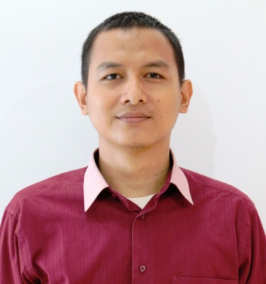

I. Personal Details
Name : Muhamad Imam Alfi
Address : Perum. Bumi Sindang Asri Blok A-A1, Cibarusah, West Java 17340
Phone Number : 089654087481
Place & Date of Birth : Bekasi, July 29 1989
Gender : Male
Marital Status : Married
Religion : Islam
Nationality : Indonesia
II. Educational Background
1. 1995 – 2001 SDN Karang Asih 03/ Elementary School, Cikarang
2. 2001 – 2004 SMP Syi’arul Islam / Junior High School,Cikarang
3. 2004 – 2007 SMK Negeri 1 Karawang / Senior High School, Karawang
III. Job Experiences
Mar 2013 - Present  (1 year 5 months ) | Mechanical Designer  PT. Tetra Pak Stainless Equipment | Jakarta Raya, Indonesia
Nov 2012 - Feb 2013  (3 months ) | Drafter  Pt. Trustindo Mekatronic Mulya | Jawa Barat, Indonesia
Aug 2012 - Nov 2012  (3 months ) | Drafter  PT. Harapan Semangat Bersama | Jawa Barat, Indonesia
Jun 2008 - Jul 2011  (3 years 1 month ) | Production Engineering (Jr. Technician)  PT. Mah Sing Indonesia | Jawa Barat, Indonesia

IV. Computer Skills
- Autodesk Inventor
- Autodesk Vault
- Solidwork
- Autocad
- Microsoft Office
V. PERSONALITY
Good attitude, communicative, diligent, tolerant, target oriented, discipline, honest, and be responsible.

Cikarang, August 22, 2014

Muhamad Imam Alfi

