CURRICULUM VITAE
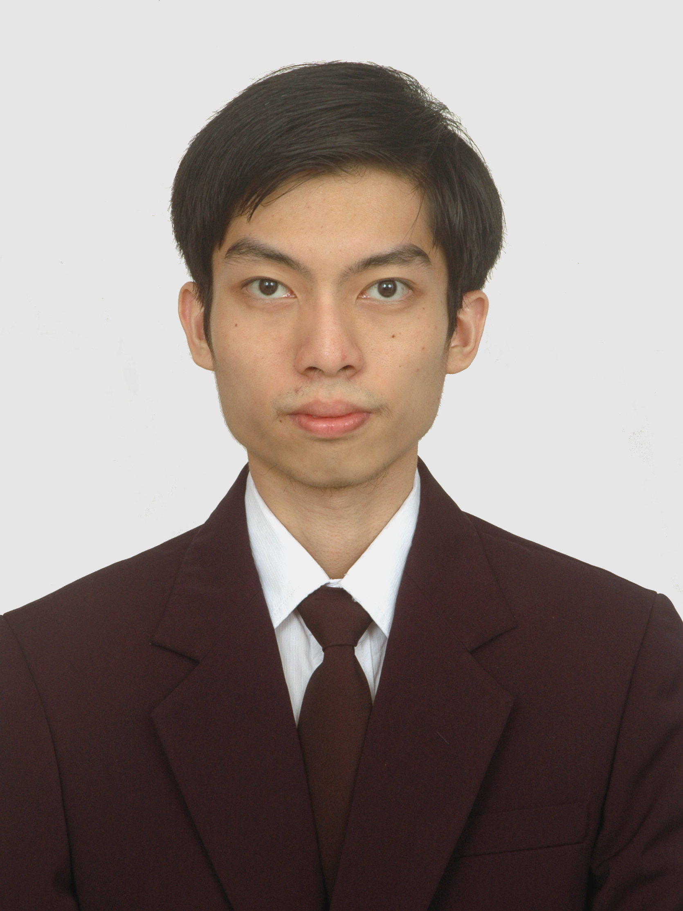
Lungprilyanto Budiman

Address : Sidoyoso Street Blok IX No. 27
Surabaya
Birthplace, Date : Surabaya, 11 April 1988
Telp. : 087750979708
E-mail : lungpril44@yahoo.co.id

Formal Education
2006 – 2011 : Bachelor Degree of Informatics Engineering Petra Christian University (GPA: 3,04)
2003 – 2006 : Saint Agnes Senior High School, Surabaya
2001 – 2003 : Saint Agnes Junior High School, Surabaya
1995 – 2001 : YPPI II Elementary School, Surabaya

Informal Education
2004 – 2008 : English course at English First Surabaya

Working Experience
April 2013 – Now : Independent Assurance Agent of PT. Prudential Life Assurance. Helping people to manage and prepare their retirement fund.
November 2011 – March 2012 : Computer Teacher and Staff of Maple Leaf Centre. Teaching computer and maintenance the school website, make a final computer project material for students.
September 2011 – October 2011 : ERP Programmer of PT. Sariguna Primatirta. Developing the company old system from Visual Foxpro to the new ERP application by using VB.NET & Developer Express.
March 2009 – March 2010 : Internship Student at Petra Career Center. Helping the PCC Staff to do career workshop, training, and seminar.
January 2009 – August 2010 : Part-time staff at English Language Teaching Center (ELTC). Prepare the online English material for students using Moodle; Maintenance the multimedia laboratory, such as make a network setting of client-server computer, repair the broken computer.

Computer Skills
- Microsoft Office
- Making website and blog
- Designing system & object
- Basic Networking

Other Skills
- Good English language
- Writing and listening
- Leadership
- Time and money management
- Organizational skill
- Mathematical and logical skill

Strength
- A good listener and writer
- Have a passion at book editor, writer, business, technology, and financial
- Always plan my monthly working schedule

Weakness
- Having small voice
- Lack of discipline

