CURRICULUM VITAE

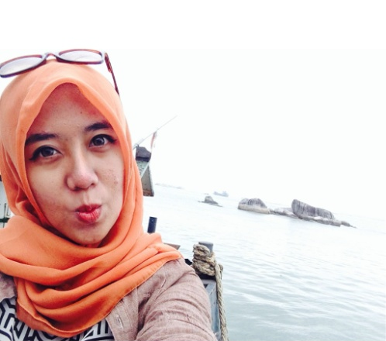

RIZKI AYu ACHYAR
Perum.Margahayu Raya Barat Jl. Uranus I blok B3 No. 43
RT/003 RW/004 Kelurahan Sekejati, Kecamatan Buah Batu
Bandung 40286
Phone : +6282112109797
Email: ayuachyar@gmail.com
Twitter: @_merayu , Facebook: Rizki Ayu Achyar
Ayuachyar.blogspot.com | LinkedIn : ayu achyar

PERSONAL INFORMATION
Name : Ayu
Date of birth : March, 03 1990
Place of birth : Bandung, Indonesia
Sex : Female
Religion : Islam
Blood type : O
Citizen : Indonesia
Status : Not married
Hobbies : Listening to music, Reading, Writing,etc
IPK : 3.48

FORMAL EDUCATIONAL BACKGROUND

2008 – 2012 Padjajaran University (S1) Bandung
(Faculty of Communication - Department of Public Relation)
2005 – 2008 25 SENIOR HIGH SCHOOL Bandung
2002 – 2005 22 JUNIOR HIGH SCHOOL Bandung
1996 – 2002 SABANG PRIMARY SCHOOL Bandung
1995 – 1996 AL QOLAM Bandung

INFORMAL EDUCATIONAL BACKGROUND

Bimbingan Belajar SSC Tahun Ajaran 2005 dan 2008
Les Private Bahasa Inggris Tahun Ajaran 2008
SKILL SETS

COMPUTER
Operating System :

● Microsoft DOS, XP Professional, Windows 8
Office Application:

● MS Word
● MS Excel
● MS Power Point

SPORTS
- Swimming
- Running
- Cycling

SPEAKING
- Broadcasting
- MC
- Marketing – Promotion

EXPERIENCES

Organizational Activities :
- Angklung team of SABANG Primary School, Bandung. 1998-2002
● Organisasi Tari SDPN Sabang Bandung Tahun 2000-2002
● Organisasi Angklung SDPN Sabang Bandung Tahun 2000-2002
● Komandan Regu Putri Organisasi PMR SMPN 22
● Organisasi Cheerleaders SMAN 25 Bandung 2007-2008

Work Experiences :

- Digital and Event Strategist at CreativeLand Corp
- OC Public Relation and Communication of ROAR Organizer
- Social Media Strategic Planner of Ridwan Kamil’s Campaign ( Mayor of BANDUNG )
- Marketing of Potluck Consulting
- Secretary of Sindikat Kuliner @SindikatKuliner
- Online Project Manager at Dixgital Online Marketing

