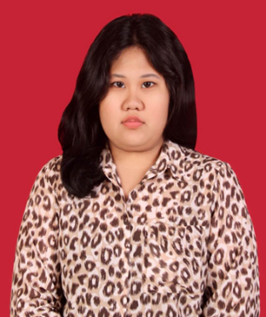

CURRICULUM VITAE

Raissa Janitra Gianti
Date of Birth : 19 April 1995
Place of Birth : Jakarta
Gender : Female
Religion : Islam
Civil Status : Single

Address (per ID) : Jalan Sederhana 7 no 165 Cijantung II
Kelurahan Gedong Kecamatan Pasar Rebo
Jakarta Timur 13760
Phone no : 021 8403711
Mobile no : 0813 8208 7068
Email : raissajanitra19@gmail.com

Educational Background

- Formal
2001-2006 : SD Kartika XI-I Cijantung
2006-2009 : SMPN 102 Jakarta
2009-2012 : SMAN 58 Jakarta
2012-Present : London School of Public Relations Jakarta
Major in Public Relations
Current GPA 3,22 out of 4,00
2015-2016 : European University Business School, Barcelona
For the 5th semester as an exchange student

- Non Formal
2010-2012 : English Course at English First Jakarta

SEMINAR / TRAINING / WORKSHOP

April 2015 : Seminar ¨Youth Innovation Summit¨
The Role of Indonesian Young Generation Business Innovation (Based on Local
Wisdom) in the Era of ASEAN Economic Community 2015
Organized by PPM School of Management
May 2015 : Seminar ¨Music in Digital Era¨
Organized by LSPR Radio
May 2015 : Seminar ¨Self Creative Employed¨
Organized by Center for Creative Entrepreneurs and Business Clinic LSPR
November 2015 : Career Workshop ¨The Art of Networking Online and Offline and How To Make
It Work For You¨
Organized by EU Business School Barcelona,Spain
December 2015 : Seminar ¨Inspiration for Technology-Minded Students¨ with guest speaker
Mr Sjaak Koole, Chief Support Officer at Prolin
Organized by EU Business School Barcelona,Spain
SKILLS

Computer : Microsoft Word, Microsoft Excel, Microsoft PowerPoint
Languages :
- Indonesia : Full professional proficiency
- English : Professional working proficiency
Other skills:
- Public and Media Relations
- Public Speaking
- Team Leadership
- Social Networking
- Strategies and Campaigns
- Event Planning
- Team Building
- Conflict Resolution
ACHIEVEMENT

- LSPR delegate for LSPR International Study Program, Student Exchange Program, to European University Business School, Barcelona, Spain

Accomplished Projects

- The 13th LSPR Theatre Festival, 2014
As cast
- LSPR PR Festival ¨Me and ASEAN¨ , 2016
As person in charge for talkshow
Other Experiences

- MC for Fanbase Gathering "Welcoming Demi Lovato Live in Jakarta March 24th" at Tea Box Cafe, Jakarta, 2014

- MC for Awarding Day Ceremony of LSPR PR Festival 2016 Video and Public Speaking Competition at Kuningan City, Jakarta

Jakarta, 15 Agustus 2016
Raissa Janitra Gianti

