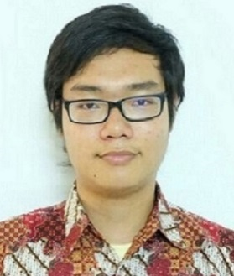 | elvan adiyan wijaya  Kos Putra Pondok Hijau Jalan Kober No. 32 Depok, Jawa Barat | elvanw1997@gmail.com | 085213813800  ENGLISH PROOFREADER, EDITOR, AND WRITER
STRENGTHS & WEAKNESSES | Strengths including traits such as perfectionist, dilligence, attention to details, and proactiveness (as opposed to procrastination). One notable weakness is occasional occurence of being demotivated.
Skills & Abilities | Responsibility, great work ethics, punctuality, and earnestness.
Education | sutomo 1 private school, medan, north sumatera (2011 - 2014)  senior high school  Graduated from one of the best private school in North Sumatera with satisfying results averaging 87.5 out of 100 in the last semester. Also managed to became the Chairman of School Council in sophomore year.  university of indonesia, depok, west java (2015 - present)  freshgraduate  Currently ongoing freshgraduate education in one of the best state university in Indonesia. Majoring in the law school, the latest GPA achieved was 3.7 out of 4 (first semester)
Achievements | Some notable achievements are as following (proof by certificate photos are available upon request):  SILVER MEDAL WINNER of National Science Olympiad at Surabaya (2007, 6th grader)  8th RANKED in Northern Sumatera Region (Aceh, North Sumatera, Riau, Riau Archipelago, West Sumatera) English Olympiad (2011, 9th grader)  DISTINCTION result of English Proficiency Test held by Sutomo 1 Senior High School (2014, Senior year)  PASSED AS COMPETENT in Advanced Level English Proficiency Test held by government-supported English institution (2014)  ACHIEVED 883/1000 SCORE ON CASEC TEST, classified into the highest grade AA, with rough equivalence to 955 TOEIC SCORE.

