Curiculum Vitae

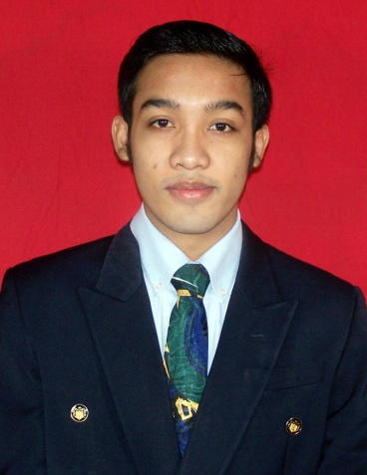

Personal Data

Name : Yudha Varian Wiratama

Place / Date of Birth : Jakarta, January 09th 1991

Religion : Moslem

Nationality : Indonesia

Marital Status : Single

Gender : Male

GPA : 3.35 (Scale 4)

Address : Jalan Talas II, Gg. H Maid No. 08 RT 006/001. Pondok Cabe Ilir,

Pamulang. Tangerang Selatan.

Phone : 087781807099

Email : yudhavarianwiratama@gmail.com

Personality : like a challenge, communicative, capable to work independent or

with team in any activities, want to learn from beginning.

.

Educational Background

Year |  | Institution | Location
2008 | – 2014 | Padjadjaran University (Faculty of | Jatinangor, Sumedang
 |  | Communication) with GPA 3.35
2005 | – 2008 | SMA N 29 | Jakarta Selatan
2002 | – 2005 | SMP N 87 | Jakarta Selatan
1996 | – 2002 | SDN Pisangan III | Tangerang Selatan

Workshop/Course and Skill

Year | Workshop/Course and Skill
2007 – 2008 | GAMA ‘88
 | Humanities
2004 – 2005 | Primagama
2004 – 2005 | English Course in LIA

Organization Experiences

Year Experiences
2002 – 2005 Dokter Cilik SDN Pisangan III
2005 – 2007 Arts and Sports Division of OSIS SMAN 29 Jakarta
2005 – 2008 Head of Rekara (Remaja Bhayangkara) Komp. Polisi Udara
2008 – 2010 Member of USBU (UKM sepakbola mahasiswa UNPAD)
2008 – 2013 Member of Cosmic (UKM sepakbola mahasiswa ilmu komunikasi)

2008 Public Relation Division on Gebrak Fikom UNPAD
2009 Pubication and Documentation Division on Galeri Kapur Tulis
UNPAD
2010 Logistic Division on Martabak Manis Mankom UNPAD
2012 Head of Mansion Cup 2012 Mankom UNPAD

Additional Qualification

Language:
- Good ability in Indonesian and English (reading-writing-speaking)

Skills:

- Computer Ability
  - Operating Systems Windows
  - Microsoft Office Word, Excel, Power Point
  - Familiar with internet and can typing fast
- Photography
  - Understanding of basic photography

