Protofolio
Apps Name | Screenshot | Description
Visit Kuningan | 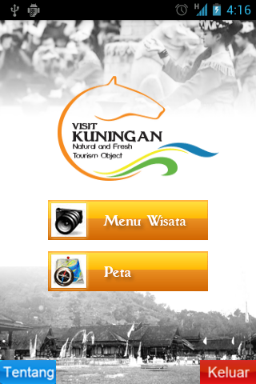  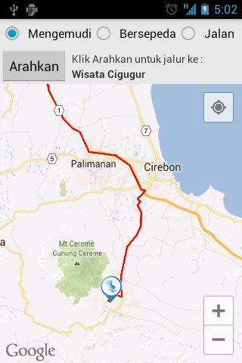 | Visit Kuningan is application that provide information about tourism places in Kabupaten Kuningan and provide route guidance to help people to find location about tourism places. There are many features in this application including addres of each tourism place, Map (using Google Maps API), information about Kuningan culture and information about accomodation for treaveling in Kabupaten Kuningan.  - Eclipse JUNO with ADT Bundle (Android)  - Google Maps API V2  - SQLite
Zona Kuningan | 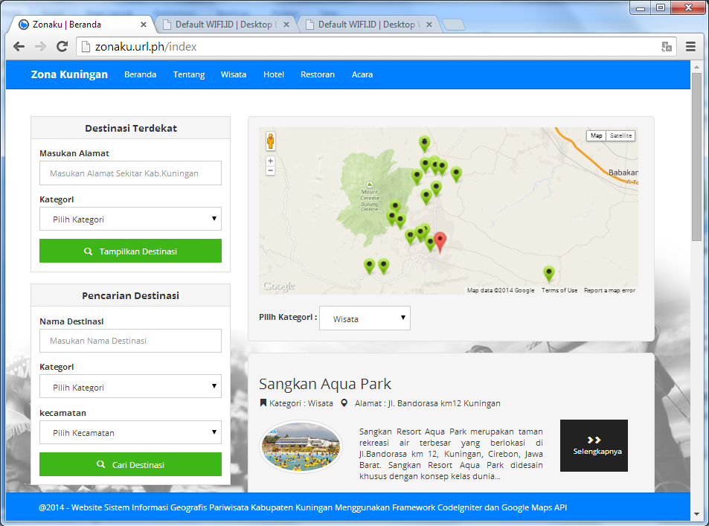  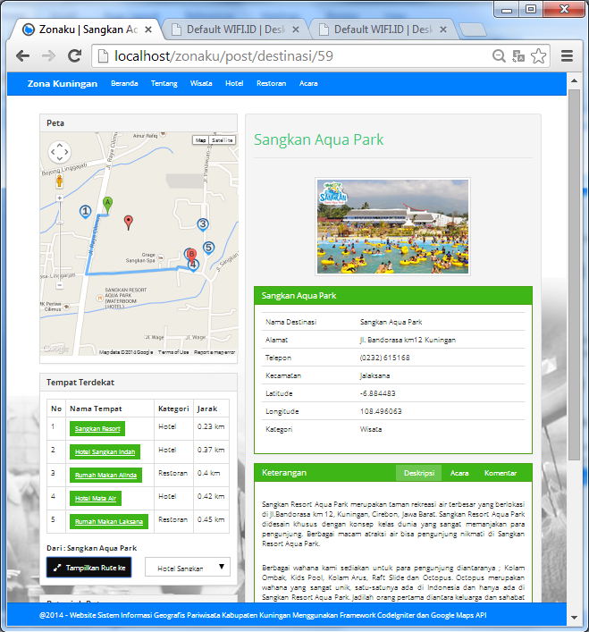 | Zona Kuningan is web-version application from visit kuningan. Zona Kuningan is website that provide all over information about tourism places in Kuningan, including addres of each tourism place, Photos, Map (using Google Maps API), providing calculation about distance about each tourism place.  - Using Framework PHP CodeIgniter  - Bootstrap for design layout  - Adobe Photoshop  - MySQL  - Google Maps API V 3
Wonebiunik |  | Wonebiunik is ecommerce website that i have ever made for a distro shop, this website sells many kinds of jersey.  - Using CMS Wordpress  - Woocommerce Plugin for Ecommerce functions
Kidsknow |  | KidsKnow is basic learning english application for kids, this aplication provides interisting learning method with showing many interisting pictures for kids with some catagory such as animals, transportations and music instruments, and including sound in each object.  - Using Eclipse Juno with ADT Bundle (Android)

