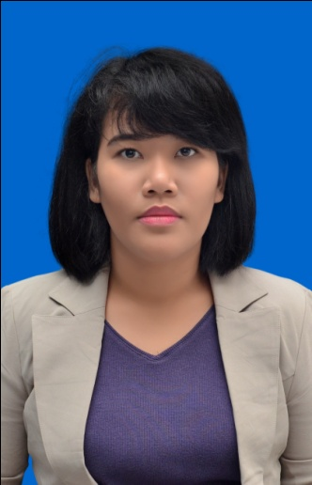

Microsoft Word



Microsoft Excel



Microsoft PowerPoint



Fast Typing



Write Editing



EYD



English



Bahasa Indonesia



**PERSONAL SKILLS**

* Member of Saman dance (2009-2011)
* Member of Opera Budaya (2012)
* Member of Opera Budaya (2013)
* Member of Gelanggang (2011-2015)
* Member of Volunteer PON XIX Jawa Barat 2016

**ORGANIZATION EXPERIENCES**

* 1999–2001 TK Maria Mediatrix (kindergarten)
* 2001–2007 SD Maria Mediatrix (elementary school)
* 2007 – 2010 SMP BKKK Tangerang (junior high school)
* 2010 – 2013 SMAN6 Tangerang (senior high school)
* 2011 – now UNPAD (Universitas Padjadjaran) Faculty of Literature

**FORMAL EDUCATION DETAILS**

**KEZIA FERONIKA SHINTA MORANA**

Jakarta

January, 27th 1993

163 cm / 55kg

Christian

Wisma Kalatea, Gang Caringin

Jatinangor, Jawa Barat

Indonesia

(+62) 813-2039-5607

Keziaferonika@gmail.com

Line: keskekes

ABOUT ME

Hello, my name is Kezia. I currently live in Bandung-Jatinangor. I take Linguistic Department (Bachelor Degree) at Padjadjaran University. Take your time to look at my resume. If you ready please give me a call.