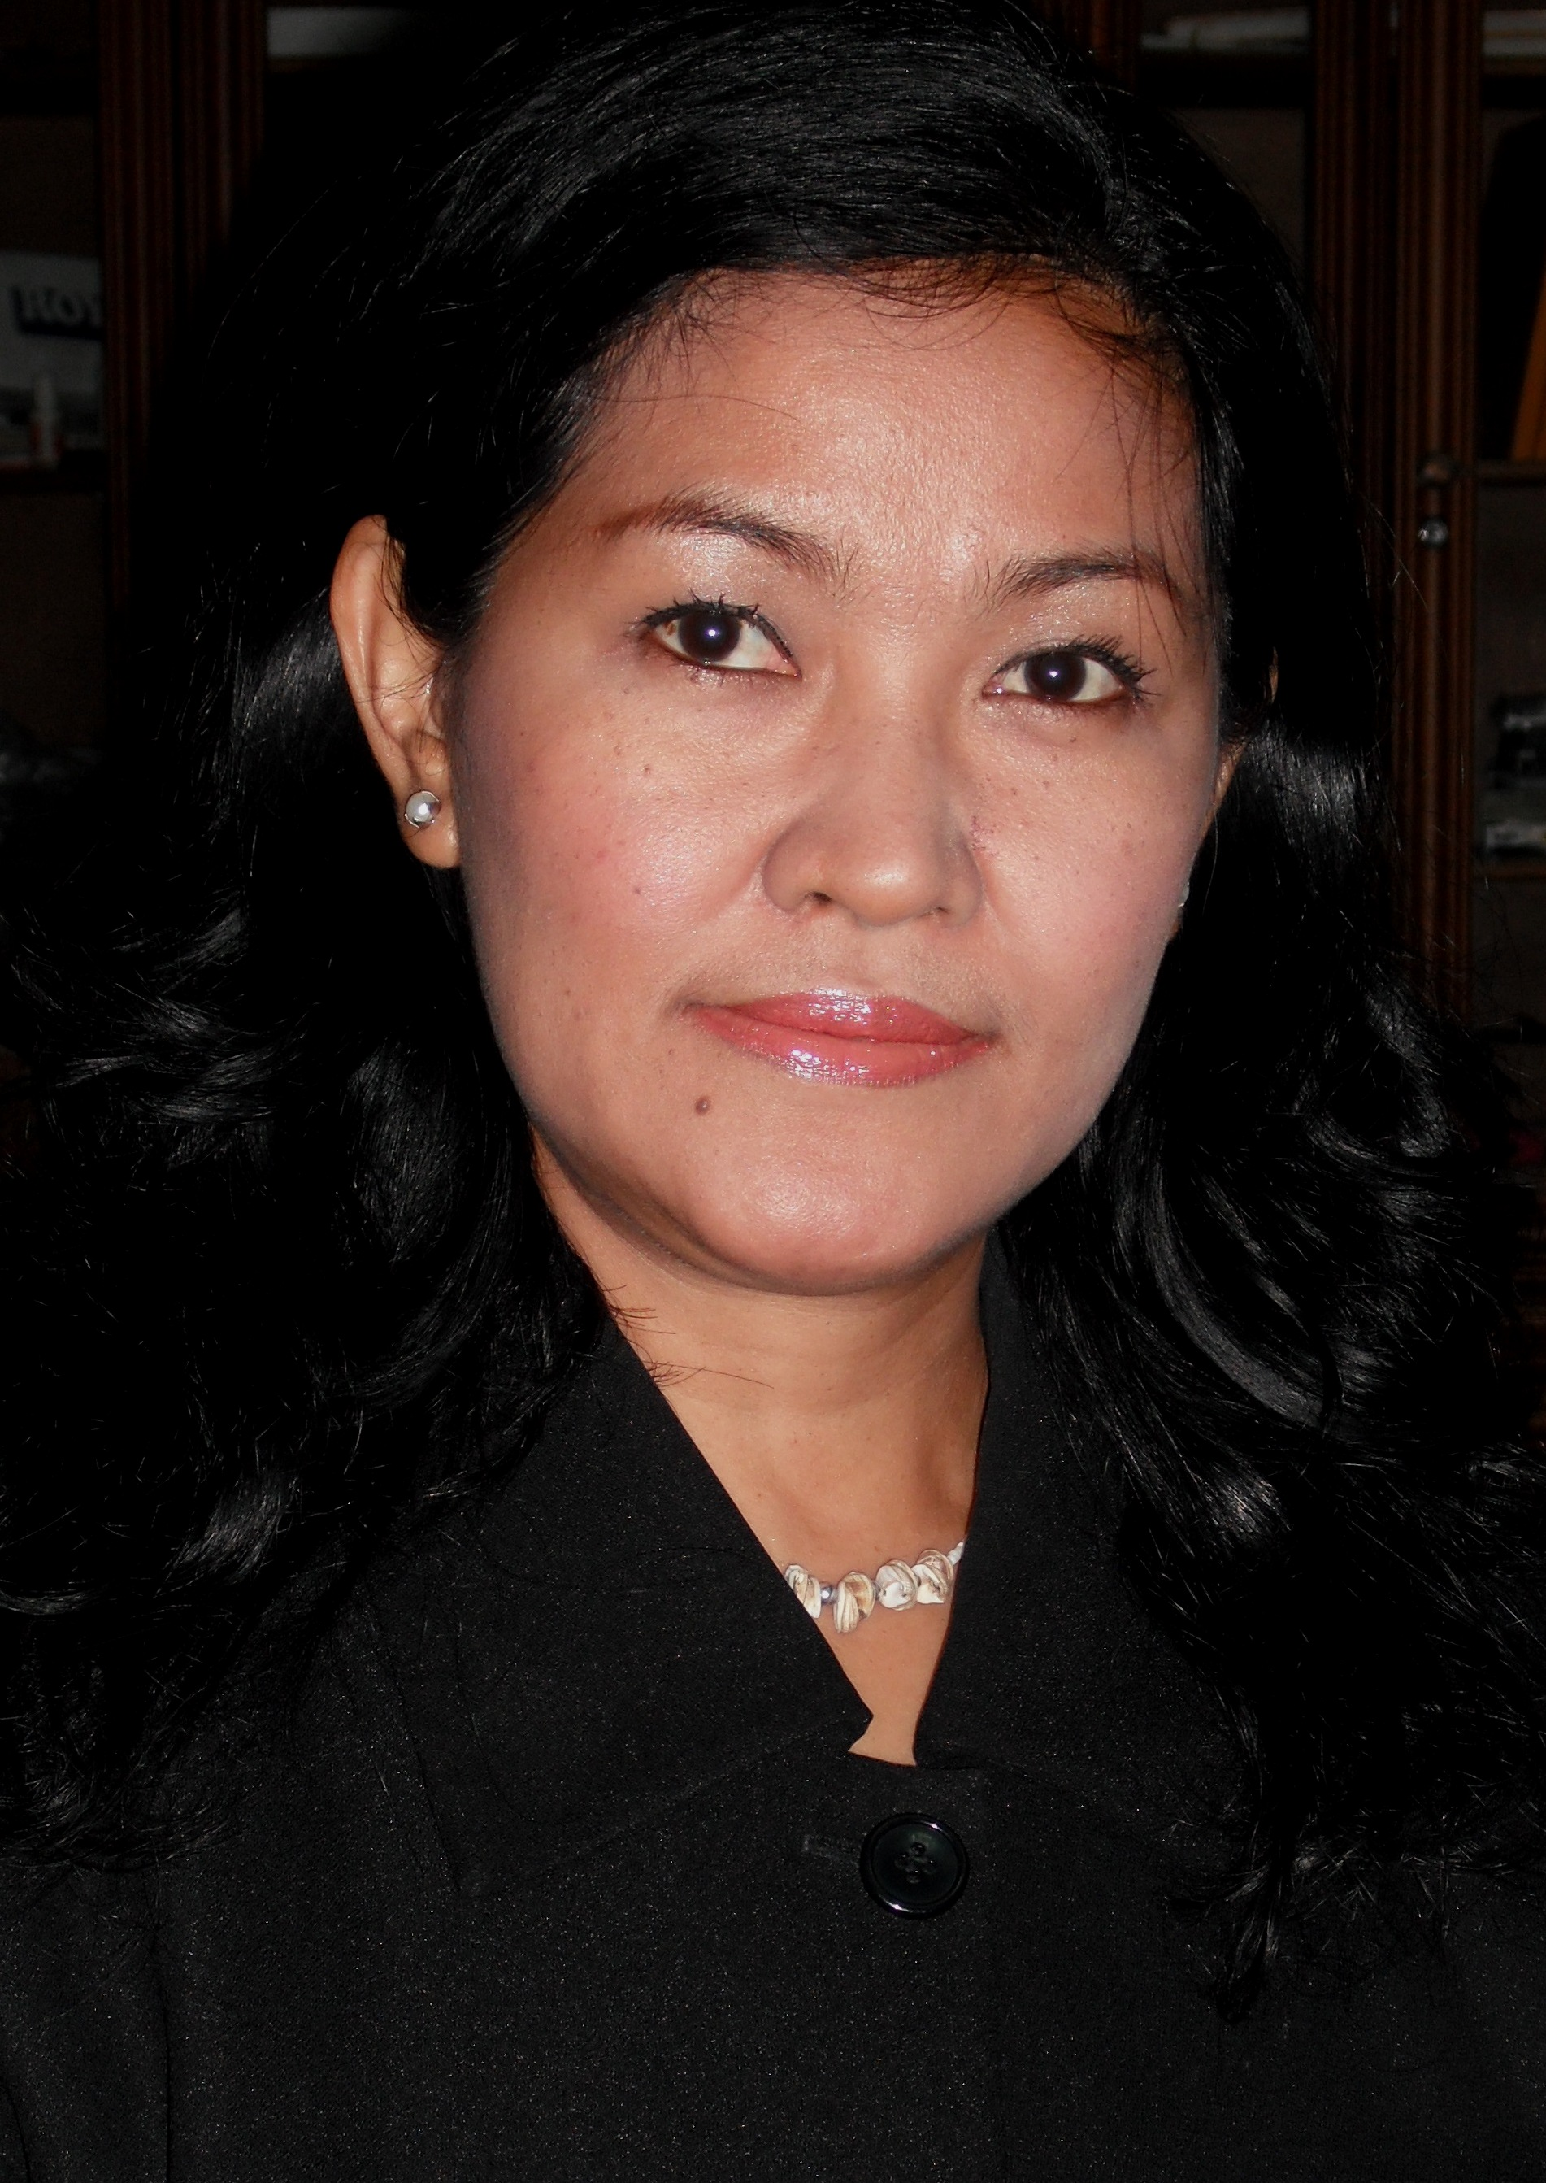
CURRICULUM VITAE

Nuzulla Wahyu Windharti (Yayu)
Jl. Bojana Tirta IX / No 2
Jakarta 13230, Indonesia
Mobile: 0812 1326 9141
Email to: yayuchoky@yahoo.com

CAREER & FUTURE OBJECTIVES

Senior Executive in hospitality industry and others service industry with multicultural environment. With exposure to educational aim and develop the skillful and knowledgeable resources, including managing and lead a group of people, monitor and control cost and revenue and all related technical aspect of the hospitality business area. Developing and giving a contribution interdependently within the working environment of the service industry.

SUMMARY

- Managing Director of Global Hospitality Coach. An Hospitality Management Training Company that established to answer the needs of professional in the service industry and to challenge the service industry in the globalization era to generate a skillful and knowledgeable Resources in the industry.

- Partner ICLC Inner City Learning Center with Agung Podomoro, PT. Joint cooperation training center for providing extra value added program for internal Staff and external staff. Responsibility for providing lecturer and module for the hospitality program.

- Trainer and speaker in the various programs of service industry, like Hotel, Restaurant Institution and other company related to the service Industry.

- Six Teen years experienced Senior Executive in Hotel industry, with proven strength in related technical skill in hospitality industry. Extensive experience in multicultural environments and clientele in five and four star hotels, enhanced by fluently in English, French (passive).

- Personal qualification includes achievement orientation, analysis/ problem assessment skill, planning and organizing and leading a group of people with delegation of authority and responsibility. Strong technical knowledge together with tendency to initiate ideas and solutions would be a strong contribution to both new set up and established organization in hospitality industry.

PERSONAL INFORMATION

Date of Birth Desember 20th, 1967
Age 47 years
Nationality Indonesian
Religion Moslem
Gender Female
Marital Status Single

Formal Education

1983 – 1986 Graduated from Senior High School

1986 – 1989 STIBA Malang

2010 – Current STIBA Jakarta

Non Formal Education

- Training Program ITT B43 Certificate III in Hospitality
TAFE UNIVERSITY, AUSTRALIA,
- Orientation Program ATI – ITT Sheraton Asia Project
- Train the Trainer, ACCOR ASIA PACIFIC,
- Keys to Communications, ACCOR ASIA PACIFIC

Professional Experiences:

1989 – 1992 GARDEN PALACE HOTEL SURABAYA
As Guest Relation Officer
Duties :
- Handle all the VIP treatments and ensure that all amenities and the arrangements are well organized.
- Make personal contact with all guests to ensure that all their requirements are fulfill properly.
- Handle complaint that may arise during the guest stay in the hotel and go through with follow up.

1992 – 1993 SAHID HOTEL SURABAYA
as Guest Relation Coordinator
Duties:
- Directly supervise the Guest Relation Officer to maintain the standard of the operational in the hotel.
- Responsible to manage the Executive floor, and its guest and providing personalized check – in and check – out of the guest.
- Handling all guest requirements and any complaint.

1993 – 1996 HYATT REGENCY HOTEL SURABAYA
as Team Leader of Regency Club
Duties:
- Directly supervise both GRO and Butler to maintain the operational of the Regency Club for Breakfast and evening cocktail that provide in the Regency Club.
- Responsible for the operational at the Club Floor, and oversee the GRO staff to handle Registration and Check out process, Handling VIP guest and it’s amenities.
- To coordinate with F&B Department for the facilities of F&B in the Regency Club Floor.

1996 – 1997 SHERATON BANDARA HOTEL JAKARTA
as Guest Service Manager – Pre Opening Team
Duties:
    - Oversee the daily operational of the Front Office Department and maintain good working environmental among the guests and the staff.
    - Responsible the daily operational of the Front Desk, Reservation, PABX, Concierge to ensure the quality and guest satisfaction.
    - Implement the SOP during Pre – Opening of the hotel.

1997 – 1997 THE ACACIA HOTEL JAKARTA
as Sr. Front Desk Manager
Duties:
- Responsible for daily operational at the Front Desk and maintain the standard of the operational of the hotel.

1997 – 1999 GRAN MAHAKAM HOTEL JAKARTA as Asst. Front Office Manager – Pre Opening Team
Duties:
- In-charged as Front Office Manager and directly responsible for the Front Office daily operations. Involve of the Pre – Opening team and assist the EAM to establish Standard & Operational Procedure.
- Directly supervises all Front Office Personnel and ensure the completion of all Front Office duties are well maintain.

2001 – 2004 IBIS ARCADIA HOTEL JAKARTA (Managed by Accor)
as Front Office Manager
Duties:
- Directly supervises all front office personnel and ensures proper completion of all front office duties. Directs and coordinates the activities of the front desk, reservation, guest services and telephone areas.
- Maintain working relationship and communicates with all departments.
- Assist the hotel in term of maintaining rate consistency and do yield management and revenue management.

2004 – 2006 GRANDKEMANG HOTEL JAKARTA
as Front Office Manager
Duties:
- Directly supervises all front office personnel and ensures proper completion of all front office duties.
- Directs and coordinates the activities of the front desk, reservation, guest services, business center and telephone areas.
- Maintain working relationship and communicates with all Departments.
- Assist the hotel in term of maintaining rate consistency and do yield management and revenue management.
- Assist the management to do rationalization program.

2006 – 2008 Hospitality World Asia
as Business Development Director
Duties:
- Developing the company to expand the business, plan and organize and lead some project that carry out the company goals.
- Setting up some project and follow through the result that has been confirmed and make some appointment to the customer and maintain the business regularly.
- Assist the Company to make a modules, syllabus, and respected training materials.

2008 – 2010 PT Budhidharma Dibya Raga
As General Manager & Business Development Director

- Oversee and responsible the whole operation of the company and set up new opening of the center, and also develop their product and other related matters of the development of the Company.
- Developing the company to achieve the target and make some relation with the respected industry in the field of Spa industry in the world.
- Supervise all the companies that under PT. Budhi Dharma, Spa Operation, Product, Consultation, Man Power supply, Spa Academy, to fulfill the needs of its operational.
- Together with Financial Controller to set the budget and implement it to achieve the company goals in term of revenue and its profit.
- Coordinates the preparation of budgets and the definitions of goals for all operating departments Coordinates with the heads of departments concerned the Sales & Marketing strategy and the Personnel & training policy.
- Sets standards of product and service in the spa Industry and its affiliation. And ensure that all policies are strictly adhered to Develops and enforce sets of procedures and rules & regulation to ensure effective control on revenues & expenses.

2010 – Current Run Hospitality Training Management Company, Global Hospitality Coach (GloHC) Jakarta.

References
- Trainer for Jakarta Tourisindo Group (Grand Cempaka Hotel, C’One Jakarta, Grand Jaya Raya Hotel & Resort, C’One Plaza, Cempaka Sunter Hotel & Apartement ). Training for Service Excellence, Supervisory Skill, Managerial Training, Basic Sales & Marketing, Motivation Training.
- Trainer for Rekayasa Engineering, for their Outsource Company, Housekeeping. Training Basic Housekeeping.
- Trainer for Medco, for their Outsource Company. Training Basic Hospitality and Service Excellence.
- Trainer for 21 Group. Training Managerial Skill, Service Excellence, and Wine Training.
- Trainer for PT Sierad Pangan Group ( Wendy’s, Hatrz Buffet, Warung Daun ) Managerial Skills n Service Excellence.
- Trainer for PT. Agung Podomoro Group. Managerial Training.
- Trainer of ICLC ( Inner City Learning Center ) Agung Podomoro Group.
- Trainer for Sport Art – Fitness Company. Training Service Excellence.
- Training partner of Abadi Funeral Homes, Jakarta.
- Trainer of Continent Indonesia Hotel.
- Trainer for Lorin Sentul Hotel, Supervisory and Managerial Training.

- Other related file available on request -

