CURRICULUM VITAE
PERSONAL DETAILS
Full Name : Boy Brian E.S.
Place/ Date of Birth : Kabanjahe/ April 30th,1993
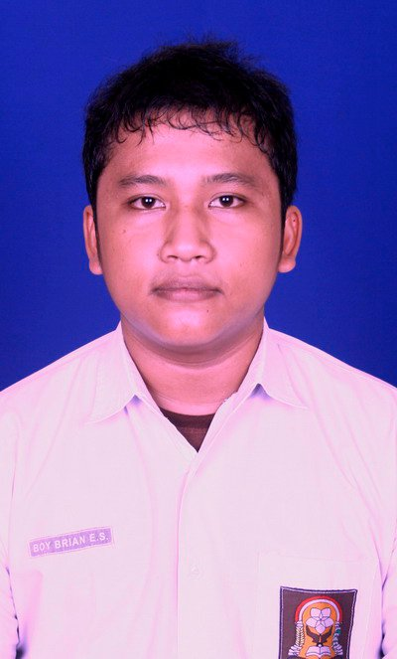
Gender : Male
Age : 21 years old
Religion : Christian Protestant
Marital Status : Single
Nationality : Indonesia
Address : Jl. Bagusrangin 2 No. 103 C RT 004 RW 007 Kel. Lebak Gede Kec. Coblong, Bandung, West Java 40132
Phone Number : 0889193324/ 085658555980
Email : boysukatendel@gmail.com

FORMAL EDUCATION DETAILS
1998 – 2004 : SD RK Budi Murni 2 Medan, Elementary School, North Sumatera
2004 – 2007 : Junior High School/ SMP RK Budi Murni 2 Medan, North Sumatera
2007 – 2010 : Senior High School/ SMAN 1 Medan, North Sumatera
2011 – Present : Faculty of Law, Padjadjaran University, Bandung, West Java

INFORMAL EDUCATION DETAILS
2013 – Present : English Course (Conversation in English) LBPP LIA Bandung, West Java
2013 : Legal Workshop (Contract Drafting) by Balai Studi Pelayanan Hukum Student Christian Movement of Indonesia Bandung, West Java
2013 : National Seminar of Cyber Law by Faculty of Law, Padjadjaran University Bandung, West Java
2014 : Club of Public Speaking Seminar by Faculty of Law, Padjadjaran University Bandung, West Java
2015 : ALSA Workshop in Cooperation with Hadiputranto, Hadinoto & Partners, Padjadjaran University Bandung, West Java
2015 : Moot Court Society Workshop in Cooperation with Kaltim Prima Coal (KPC), Padjadjaran University Bandung, West Java
ORGANIZATIONAL EXPERIENCE
2008 – 2009 : Organization of Bible Review Bukit Sion Senior High School/ SMAN 1 Medan, North Sumatera
2012 – 2013 : Staff of Creativity dept. of Student Christian Fellowship Faculty of Law, Padjadjaran University Bandung, West Java
2012 – 2014 : Research and Development Division of College Students Activity Unit of Journalism, Vonis Faculty of law, Padjadjaran University Bandung, West Java
2012 – 2013 : Treasurer of Student Christian Movement of Indonesia, Bandung Commissariat of Padjadjaran University Bandung, West Java

2013 – 2014 : Head of Information And Communication Dept. of Student Christian Fellowship Faculty of Law, Padjadjaran University Bandung, West Java
2013 – 2014 : Staff of Media Division of Moot Court Society Faculty of Law, Padjadjaran University Bandung, West Java
SKILLBASE
Computer Skills : Microsoft Word, Microsoft Excel, Microsoft PowerPoint, Email, Internet, Website, Blog, Adobe Photoshop
Languages : Indonesia, Japanese and English
Other Skills : Design, Public Relations, Creative, Training, Music

I here by declare that all information above is true and correct to the best of my knowledge. Thank you
Bandung, Mei 26th 2015

Boy Brian E.S.

