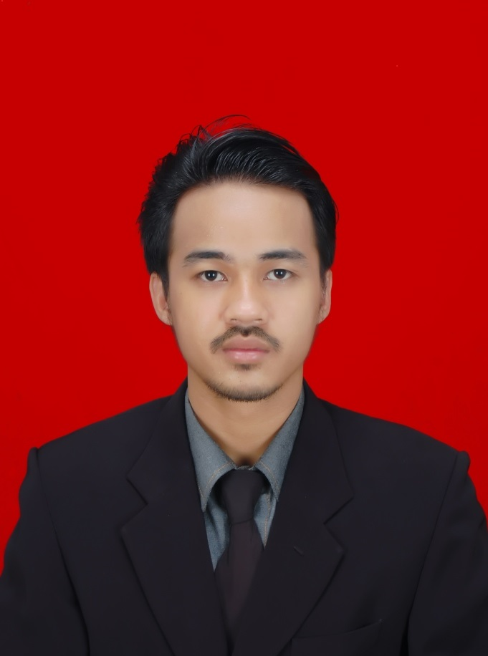 | Aji Irawan  Web Programmer at Freelance IT consultant
 | (+62) 08971015290 | aji.momo4@gmail.com | 23 years old | Jawa Barat
 | Experience | 2 years
 | Previous | Web Designer  CV.maryand Beauty & Care
 | Education | Universitas Darma Persada  Bachelor's, Computer/ Telecom Engineering (Sep 2014)
 | Nationality | Indonesia

Experience
Sep 2012 - Present  (2 years ) | Web Programmer  Freelance IT consultant | Jawa Barat, Indonesia
 | Random Salary | IDR 3.000.000
Iradvanced.com (company profile IT konsultan saya)
- satrianews.com (Portal news CMS custom)
- saungapung.com (Company profile resto)
- joso.co.id (Website application)
- puncakrayahotel.com (Company profile)
- slowphotograph.com (Company profile CMS custom)
- Aplikasi penyetaraan mata kuliah mahasiswa pindahan dan konversi kurikulum (Sistem user)
- Aplikasi sistem booking futsal (Sistem user)
- Aplikasi portal jadwal kegiatan universitas darma persada bagian HUMAS & BUP (Sistem user)
- Aplikasi faktur & nota penjualan mebel (Sistem user)
- Aplikasi Payroll sistem gaji (Sistem user)
- Aplikasi transaksi service bengkel CV.MEGATOP (Sistem user)
Jun 2013 - Jun 2014  (1 year ) | Web Designer & Design  CV.maryand Beauty & Care | Jawa Barat, Indonesia
 | Monthly Salary | IDR 1.500.000
Oct 2012 - Apr 2013  (6 months ) | Web Programmer  PT.JOSO INDONESIA | Jakarta Raya, Indonesia
 | Monthly Salary | IDR 3.000.000
-Membuat aplikasi web pendaftaran online karyawan baru.
-Membuat Aplikasi Payroll Berbasis php & Mysql
-Aplikasi Accounting Dengan cms custom front accounting.
Aug 2012 - Sep 2012  (1 month ) | Census tanker  PT.Nielsen | Jakarta Raya, Indonesia
 | Monthly Salary | IDR 1.300.000
Education
Sep 2014 | Universitas Darma Persada  Information Technology (S-1)
 | Major | Teknik informatika
 | CGPA | 2.83/3
Skills
Advanced | Database System, PHP, MySQL,
Intermediate | Web Design And Development
Languages
Language | Spoken Written Relevant Certificates
English (Primary) | 5 5 -
About Me
Address  Hobby  Date of birth  Religion  Status  Gender  Blood type | Villa nusa indah Blok H2/6 Jln.taman flamboyan RT 03 RW 14  Kel.bojong kulur, Kec gunung putri kab.bogor.  Playing football, listen music indie and enjoy tea with interface laptop.  04 august 1991  Moslem  Single  Male  O

