CURRICULUM VITAE

PERSONAL DATA

- Name : Thomas Adrian Soegiarto
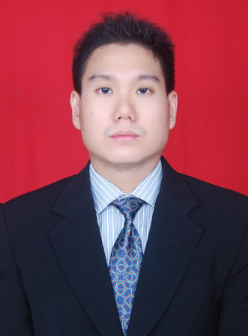
- Gender : Male
- Marital status : Married
- Place/date of birth : Semarang, 12 July 1984
- Address : Jl. Totem 7 Blok B8/3, Semarang
- Mobile phone : 081328290092
- E-mail : thomas.soegiarto@hotmail.com

FORMAL EDUCATION

- Soegijapranata Catholic University, Semarang (2007 - 2009)
Master Degree Program majoring in Science Management with concentration in Marketing; GPA: 3,63 (very satisfactory).
Academic Degree: Master of Science in Management (M.Si.)
Thesis: Analysis of the Influence of Brand Knowledge on Information Search and Purchase Intention with Perceived Risk as a Mediator (Empiris Study on LCD TV Sony in Semarang)
- Swiss German University, BSD, Tangerang (2002 - 2006)
Bachelor Degree Program majoring in Mechatronics Engineering; GPA: 3,12.
Double Academic Degree:
    - Academic Degree of Swiss German University: Mechatronics Engineering / Sarjana Teknik (S.T)
    - Academic Degree of Fachhochschule Südwesfalen, Germany: Diplom–Ingenieur (Dipl.-Ing)
Thesis: Designing and Constructing a Model of an Electropneumatic Bending Machine
- SMU Kolese Loyola, Semarang – Science Class (1999 - 2002).

INFORMAL EDUCATION

- English Course at English First, Semarang
- German Course at EURO, Jakarta
- Basic JAVA Programming at Wahana Komputer, Semarang
- MS Visual C++ at Informatika Nusantara, Semarang
- Computerized Business Operator at STEKOM, Semarang
- Computerized Accounting at STEKOM, Semarang

COMPUTER LITERATE

- MS Office (MS Word, MS Excel, MS Power Point, MS Access)
- Open Office (OpenOffice Writer, OpenOffice Calc, OpenOffice Impress)
- MATLAB
- Automation Studio
- Solidworks
- Visual Basic
- JAVA
- C/C++
- Python
- Pascal
- Assembly Language
- SPSS
- AMOS
- MYOB Accounting
- UBS Accounting System
- AutoCAD

LANGUAGE SKILL

- English, both oral and written.
- German, basic for daily conversation.
- Indonesian, native.

INTERNSHIP & WORKING EXPERIENCE

- PKKT PT. Siemens Indonesia, Cilegon (September 2003 – January 2004)
Description:
I took the internship training in the field of mechanical and electrical industries with the following programs:
- Technical drawing
- Benchwork and mechanical measurement
- Machining
- CNC-programming
- Welding
- Electrical basic training and Electrical wiring
- Electrical and power measurement
- Electrical basic component
- Electric protection
- Electrical installation and panel installation

      - Hella KGaA Hueck & Co, Werk 4, Bochum-Hövel, Germany
(March 2005 – July 2005)
Description:
I was placed within Production Technique Department and I was responsible for measuring and examining the quality of solder paste print out especially its height and position on Printed Circuit Board (PCB) then I made the quality control chart based on the measurement data I collected daily. I also learned about Surface Mounting Devices (SMD) technology during my internship at Hella.

- CV. Cipta Kencana, Semarang (January 2009 – June 2011)
Description:
I worked as accounting officer at CV. Cipta Kencana, one of the biggest distributors and wholesalers company in wheat, flour and sugar. I have worked here while I was continuing my study S-2 Science Management in Soegijapranata Catholic University, Semarang. I was responsible for data entry, checking and controlling stocks, making daily stock report, making daily journal, managing petty cash, etc.

- PT. Immanuel Dunamis, Semarang (July 2011 – January 2012)
Description:
I worked as administration & marketing officer at PT. Immanuel Dunamis, one of the biggest steel distributors in Semarang. I was responsible for taking order from customers directly and by phone, maintaining good relationship with existing customers, and looking for the new one, reminding customers that payment is almost due.
- CV. IT Pro Solution, Semarang ( February 2012 – July 2014 )
I worked as programmer at CV. IT Pro Solution. I was responsible for making, updating, and maintaining programs.

