CURRICULUM VITAE

I. PERSONAL ID
Full Name | Fitria Hardiyanti | 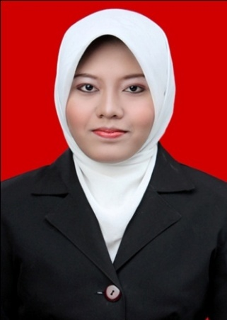
Address  Phone Number | Bulusari RT 3 RW III, Wonogiri, Central Java, 57651  085647480778/081225148225
Place and Date of Birth | Wonogiri, April 15th, 1991
Sex | Female
Blood Type | O
Nationality | Indonesian
Religion | Islam
Marital Status | Single
Email | rionasuharto@gmail.com

II. EDUCATIONAL BACKGROUND
Level | Institution | Major | Graduation Year | GPA
University (S-1) | Universitas Sebelas Maret Surakarta | English Education | 2014 | 3.48
Senior High School | SMA Negeri 1 Wonogiri | Science | 2009 | 7.28
Junior High School | SMP Negeri 1 Wonogiri |  | 2006
Elementary School | SD Negeri 1 Wonogiri |  | 2003

III. JOB EXPERIENCE
Position | Institution | Job Description | Year
Freelance Translator | Prime Translate | Translating any materials from English to Indonesian and vice versa | 2013-present
English Teacher | LPK Prima Utama | - Teaching English to students (Elementary-Senior High School)  - Providing material and test for exam preparation  - Making report of students’ achievement | 2013-2014
Instructor of Speech and Storytelling | SMP N 1 Matesih | - Preparing materials for the students (short stories, videos, etc.)  - Guiding students to practice in giving speech and telling story | 2014
English Teacher (Extracurricular) | SMA N 2 Surakarta  SMA N 1 Karanganyar | - Promoting new method developed by the owner of HE Global Institute  - Teaching students using the method | 2011  2012
English Teacher | Human Excellent Global Institute(English Course) | - Teaching English to students (Elementary- Senior High School)  - Teaching English for TOEFL Preparation  - Preparing learning materials (module, audio/video for listening and speaking practice)  - Giving test for exam preparation | 2010-2012

IV. NON FORMAL EDUCATION
Title | Institution | Year
English for Academic Purposes | Universitas Sebelas Maret Surakarta | 2009
PPL (Internship Teaching Program) | Universitas Sebelas Maret Surakarta | 2012
Training of Scientific Writing | Universitas Sebelas Maret Surakarta | 2011

V. SKILL
      - Ms.Office & Wordfast Classic (Translation Tools)
      - Internet access
      - English (Oral and written)
      - Translating, Editing and Proofreading

VI. PUBLICATION

Education Journal entitled “Using Talking Chips to Improve Students’ Participation in EFL Classroom”.

