CURRICULUM VITAE

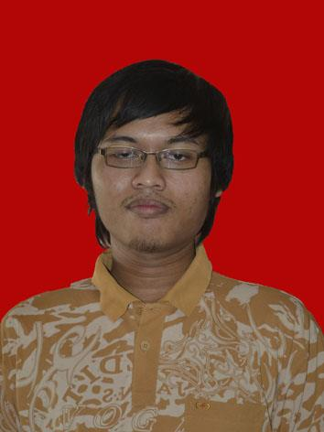

4x6

4x6

Biography

Name | Reza Destian Bayu Aji
Place and date of birth | Purbalingga, December 17, 1991
Age | 23 years old
Height, weight | 191 cm, 76 kg
Address | Kalimanah RT 02/ RW 02, Kalimanah district- Purbalingga Regency- Central java- Indonesia - Zip 53371
Status | Married
Phone | 6275726422657
Email | Rasacool0[at]gmail[dot]com
Skype | Reza.destian

Background of Education

No | School’s Name | Year | Status
1 | University of Muhammadiyah purwokerto | 2009-2013 | Pass
2 | Senior High Scool 1 Bukateja | 2006-2009 | Pass
3 | Junior High School 1 Kalimanah | 2003-2006 | Pass
4 | Elementary School 1 Kalimanah Kulon | 1997-2003 | Pass

Work Experience

No. | Job | Year
1. | Build web company profile for CV karya madiri | 2013
2. | Developing inventory system | 2012
3. | Web developer at Hypermedia | 2014
5. | Developing Erp System for PT.Transvia otomasi pratama | 2014
6. | Developing website www.balisa-auction.com | 2014
7. | Developing website r-moving.com | 2014
8. | Developing isnoke.co.id | 2014
9. | Developing www.cellphonecity.com | 2011
10. | Developing CRM Software for CV karya mandiri | 2013
11. | Developing www.fanos.co.id | 2012
12. | Developing website www.ocakesion.com | 2013

Skill Experience

No | Skill | Experience
1 | PHP | 5 years
2 | HTML5 and CSS3 | 5 years
3 | Java | 5 years
4 | Javascript | 5 years
5 | Angular js | 3 years
6 | Mysql | 5 years
7 | OOP Framework php | 4 years

