Curriculum Vitae
Personal Identity

Name : Apriliani Gita Fitria
Nickname : Gita
Birth Date : April 24, 1990
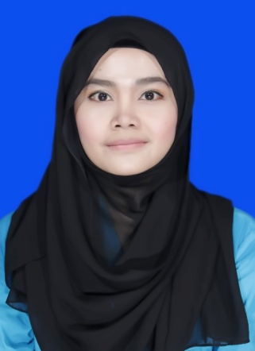
Address : Jl. Pulau Bintan No. 13, Komplek TNI AL Kodamar III, Kelapa Gading-North Jakarta 14240
Mobile Number : 085710425080
Email : aprilianigita@gmail.com
Hobbies : Reading, travelling, listening radio, and watching
Personality : Active, dynamic, sociable, ambitious and well organized
Formal Educations

2008-2012 International Relations Department, Faculty of Political and Social Science, University of Prof. Dr. Moestopo (Beragama), Jakarta, GPA 3.54 (Cum Laude)
Informal Educations

2010-2014 Kahfi BBC Motivator School, Bintaro. KAHFI is a high school equivalent of D3 that concentrates on Communication Science, Public Speaking, Media (Graphic Design, Photography, Radio, Film Production) and Hypnosis.
  - Lembaga Bahasa & Pendidikan Profesional LIA, Jakarta
2004-2007 Creative English Course (CEC), Tangerang
  - Excellent English Course, Tangerang

Honors and Awards

2010 Chief Delegation of University of Prof. Dr. Moestopo (Beragama) in National Congress of International Relations Students of Indonesia in Universitas Negeri Jember, Jember, East Java.
- 2nd Winner of English Speech Presentation Contest, Daar El-Qolam Islamic Boarding School

- 1st Winner of Presenter Contest, Daar El-Qolam Islamic Boarding School
2005 2nd Winner of English News Reading Contest, Daar El-Qolam Islamic Boarding School, 2005
Working Experiences

Period : May 2015-present
Position : Business Development
Company : PT Gratyo Practical Business Advisor
Main Job :
- Seeking new clients with formulated sales strategies
- Maintain relations with clients in sales funnel
- Connecting with clients by phone, email and face to face

Period : April 2013-July 2014
Position : Reporter
Company : PT Tempo Inti Media
Main Job :
- Reporting news
- Researching some issues to produce news
- Interviewing speakers related to cases

Period : October-December 2012
Position : Administration staff
Company : PT Amcor Flexibles Indonesia
Main Job :
- Managing in-out data
- Translating reports in Indonesia to English and English to Indonesia
- Correspondence with internal and external contacts
- Publishing bulletin (as reporter and layout designer)
- Controlling and monitoring projects of departement
Organizational Experiences
2011- 2012 Secretary General of Association of International Relations Students, University of Prof. Dr. Moestopo (Beragama)
2011- 2012 Head of Human Resource Department of Islamic Students Studies Center, University of Prof. Dr. Moestopo (Beragama)
  - Head of Communication Network Department of Association of International Relations Students, University of Prof. Dr. Moestopo (Beragama)
2010 Temporary President of Islamic Students Studies Center, University of Prof. Dr. Moestopo (Beragama)
  - Member of Human Resource Department of Association of International Relations Students, University of Prof. Dr. Moestopo (Beragama)

  - Member of Human Resource Departement of Islamic Students Studies Center, University of Prof. Dr. Moestopo (Beragama)

  - Head of Language Departement of ISA (Islamic Students Association), Daar El-Qolam Islamic Boarding School

  - Head of Creative English Community, Daar El-Qolam Islamic Boarding School
Skills
Computer : Microsoft Word, Excel, Power Point, Internet
Others : Writing, Selling and Public Speaking

