CURRICULUM VITAE

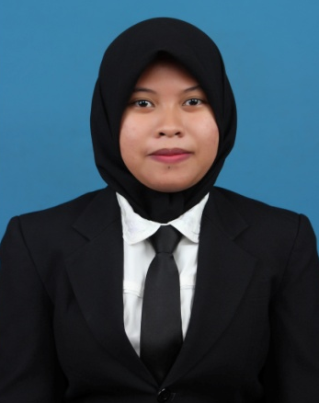
Name : Nurul Khoiriyah
Place, Date of Birth : Samboja, 6 Juli 1994
Gender : Female
Religion : Islam
Nationality : Indonesia
Marriage Status : Single
Address : Balikpapan Regency Sektor III Tampak Siring Blok CC1 No. 37 Balikpapan Selatan, 76114
Telephone : 085345510693
Email : n.khoiriah99@yahoo.co.id

EDUCATIONAL DETAIL
FORMAL :
- 2000 – 2006 SD Negeri 017, Samboja, Kutai Kartanegara

- 2006 – 2009 MTs Negeri, Samboja, Kutai Kartanegara

- 2009 – 2012 SMA Negeri 3 Unggulan Tenggarong, Tenggarong, Kutai Kartanegara

- 2012 – 2016 S1 TEKNIK PERMINYAKAN STT MIGAS Balikpapan, Balikpapan

SKILL
- Microsoft Office Word, Exel, Power Point and Outlook
- Bahasa Indonesia (Active), English (Passive)

EXPERIENCE
- 1 – 30 October PT. VICO Indonesia Job Training
2016

Balikpapan, 28 Oktober 2016

Nurul Khoiriyah, ST

