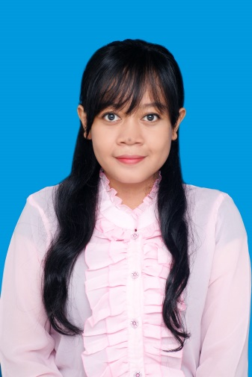

CURICULUM VITAE

Name : Silviani Sabita
Adress : Jln Sawo No 18 Margonda, Depok, West Java.
PERSONAL INFORMATION
Mobile Number : +6285645717121/ +6287856405293
Email : silviani.sabita@yahoo.com
Sex : Female
Date of birth : 18/01/1992

PERSONAL STATEMENT
a woman with strong communication, confident, and organizational skill. Know how to work on team and by myself and able to work under pressure.

2010 – 2014 : Majored Russian Literature in Universitas Indonesia with GPA 3.39
EDUCATIONAL BACKGROUND
2007 - 2010 : SMAN 2 Jombang
2004 - 2007 : SMPN 2 Jombang
1998 – 2004 : SDN Kepanjen 2 Jombang
1996 - 1998 : TK Pertiwi Jombang

2008 – 2009 : Prasmajo as main Komisaris in Senior High school
2011 : PSA MABIM FIB UI 2011 (Orientation in Faculty of FIB UI) 2010 as a staff event
2011 : BAKSOS (Charity) FIB UI 2011 as a staff event
2011 : IMUIJO (Group of Kinship of student who’s studying at University of Indonesia from Jombang, East Java) as a leader
ORGANIZATION EXPERIENCES
2011 – now : Member of UI Hangugo Dongari (Group of Indonesian and Korean students studied at University of Indonesia,who gathered and learning about each other language and culture)
2011 – now : IKASSLAV (Group of Kinship of Slavic Literature) as a member
2012 : Russian Festival as a Publication staff
2012 : DPM FIB UI - PSDM (Human Relation Development) as a staff
2013 : DPM FIB UI – PSDM (Human Relation Development) as a leader

LANGUAGE
Language | Understanding |  | Speaking |  | Writing
 | Listening | Reading | Interaction | Production
English | C2 | C2 | C2 | C2 | C2
Russian | B2 | C2 | B2 | B2 | B1
Korean | C1 | C1 | C1 | C1 | B2
Italian | A2 | B2 | A2 | A2 | A2
Levels: A1/2: Basic user - B1/2: Independent user - C1/2 Proficient user Common European Framework of Reference for Languages

COMMUNICATION SKILLS :
PERSONAL SKILLS
Good communication skills gained through my experiences as a part of some organization.
Excellent contact skill with new person gained through my experiences joined in some organizations.

JOB RELATED SKILLS :
• Excellent explanation skill (as a leader, I had to explain as clear as possible to my staffs)
• Confident (as a part of dance group and a former singer, I love to be a limelight)
• Good public speaker
• Good at learning new languages (I have studied more than 4 languages up until now)

Organisational / managerial skills:
• Leaderships : as I ever be a leader in some organizations
• Good-team leading skills
• Good organisational skills

Driving licence : C

