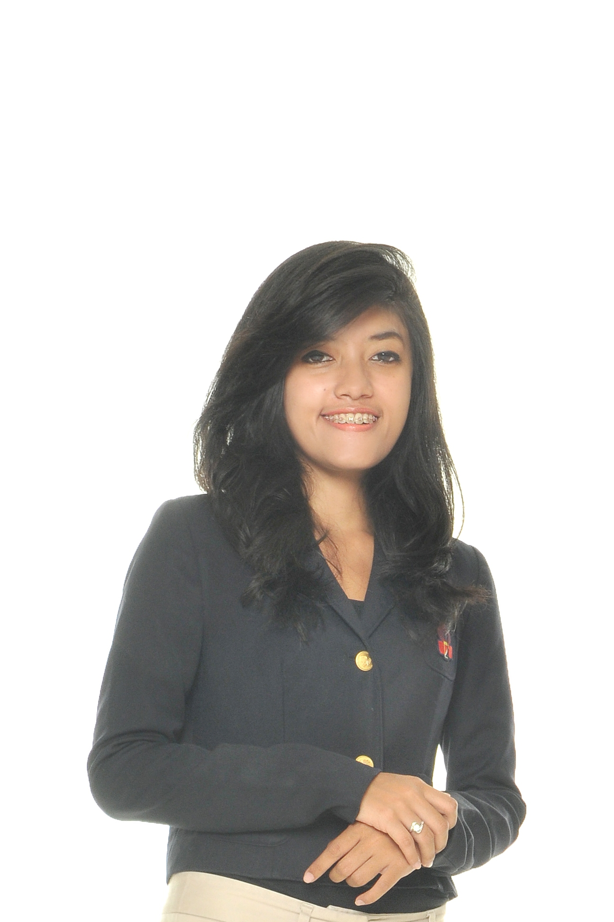

Summary of Qualifications

- Publications, media affairs, and public relations experience.
- Leadership skills; organizing workflows and people
- Diplomacy, communications, negotiation, and intrapersonal skills.
- Familiar with all MS Office Applications and Software.
- Web Design
- Self motivated; quick learner, ability to assume responsibility, and work well under pressure.
- Administrative and Secretary experience.

Personal Details
Name |  | AMANDA DESTIANI
Gender |  | Female
Marital Status |  | Single
Place & Date of Birth |  | Bandung, December 9th 1991
Age |  | 23
Nationality |  | Indonesia
Religion |  | Islam
Languages |  | Indonesian (mother tongue), English (Fluent)
Home Address |  | Jalan Bina Bakti No 16 Buciper Cimahi, West Java. Indonesia  Home: +62 22 6650590 ,  Mobile :+62 8812626625
E-Mail  Skype  Website |  | destiani.amanda@gmail.com  amanda.destiani  http://mendymanda.wix.com/mendys  Trainee atIndonesiaInvestmentCoordinatingBoard, PublicRelations  (Researching, writing and distributing press release to  targeted media.Collacting and analysing media coverage.  Organising events.)  Trainee at Indonesia Investment Coordinating Board, Promotion Development  (Cooperating with event organisers, embassies and companies  that want to join the exhibitions to establish event.)  Ambassador of West Java. Jakarta Fair 2013  (Promote culture, traditional foods, arts, music of West Java at Jakarta Fair Event.)  Secretary to Director, CV Masket  (Maintaining diaries, typing and word processing, filling, organising meeting, arranging appointment,preparing reports,answering telephone calls,managing budgets,and financial reporting)  International Business Development Executive, KW Group Malaysia.  (Make a business call, arranging business appointment with companies, selling company’s products, Market Research).
Work Experience
January 2013

February 2013

July 2013

August 2013- December 2014

January 2015– April 2015
Formal Education
Bachelor Degree  (2009 – 2013)  Senior High School  (2006 – 2009)  Junior High School  (2003 – 2006) |  | Padjadjaran University, West Java  Bachelor of International Relations Science  3 Senior High School, Cimahi, West Java  Science  6 Junior High School, West Java

Organization Experience
Staff  (2009)  Staff of Security Council Division  (2010)  Staff of Logistic Division  (2010)  Coordinator of Public Relations Division  (2011)  Coordinator of “Think Global Act Locally”  (2012)  Vice Coordinator of Publication and Media Affairs  (2012) |  | HIMA HI UNPAD  Reformist International Relations  Symphonesia  Enlightment  Environment in International Relations  Symphonesia
Achievement  Head Delegate of Malaysia on Reconstructive Simulation Open Thematic Debate of The United Nations Security Council Under The Presidency Of Indonesia |  | Asia Africa Conference Building. 2012

Courses/Training
2004 |  | - English Course. LBPP LIA, Bandung.
2004 |  | - Keyboard Course. Maestro, Bandung
2010  2011-2012  2012  September 2012 |  | - German Course, SastraUNPAD  - English Course. EF, Bandung  - Table Manner Course, Hotel Savoy Homan Bandung  - English Course, English Max, Bandung

IT Skills
Operating System |  | Windows and Macintosh
Professional Software  References |  | - Office: Microsoft Office (Word, Excel, Power Point,Note and Publisher).  - Social Media  - Web Design  Hadiyat Afandi (+62811230853 / hadiyatafandi@gmail.com)  Asep Djuhaerun (+62811224566/ asepdieje@gmail.com)
 | I certify that all the information contained in this Curriculum Vitae is true and accurate.

