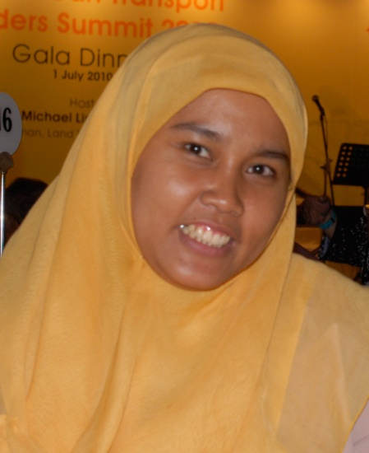

Curriculum Vitae

Dian Anggreini
Medan, 25 Juli 1978

Home
Perumnas Depok Timur
Jl. Jelutung VI No. 350 RT 09/ RW 16
Kota Depok, Jawa Barat
Telp ( 021) 77836198

+6281806269964
dian_just@yahoo.com

EDUCATION
- UNDERGRADUATE, 1996- 2002
Accounting, Economic Faculty University of Indonesia,
Thesis ; Environmental Accounting

- Master Program, 2002-2006
Financial Management, University of Indonesia

NON-FORMAL EDUCATION
- Tax Course : Brevet A dan B, LM Patra, Bogor 2000
- Strategic Public Decision Making Training, USAID 2004
- Financial Report for NGO Training, USAID 2005
- Performance Budget Training, USAID 2005
- Decentralization Course, University of Barcelona and UCLG ASPAC, December 2009- February 2010
- World Young Leader 2012, Singapore
- Symbiocity Workshop April-December 2013, Helsingborg, Sweden
- Vulnerability Assessment and Climate Resilient Strategy Workshop January-March 2013, Jakarta
- National Climate Leadership Program, February 2014-May 2014

Working experience
Apeksi
Urban Development & Environment Manager
- Responsible to the program design, preparation, execution, monitoring, evaluation, and reporting of Urban Development Program for local government officers and general public
- In practical, the responsibilities expect various roles in hand: preparing the curriculum and modules, writing modules, designing sessions for trainings/courses (allocating source persons), delivering the materials (speaker), creating attractive methods for effective campaign
- Building and maintain comunication and networking with national and International partners
- Research on climate change, infrastructure and urban issues
- Analizing and Evaluating capacity development and inter organization relation program

Capacity Development and Inter organization relation Manager, 2011-2013
- 1. Responsible to the program design, preparation, execution, monitoring, evaluation, and reporting of Capacity Building for local government officers and general public
- 2. In practical, the responsibilities expect various roles in hand: preparing the curriculum and modules, writing modules, designing sessions for trainings/courses (allocating source persons), delivering the materials (speaker), creating attractive methods for effective campaign
- 3. Building and maintain comunication and networking with national and International partners
- 4. Research on decentralization issues
- 5. Analizing and Evaluating capacity development and inter organization relation program

Local Finance Manager, 2008-2011
- 1. Developing annual work plan of Apeksi’s Local Finance Program;
- 2. Break downing annual work plan into monthly activities;
- 3. Building comunication and networking with national and International partners
- 4. Managing Apeksi’s Local Finance Program
- 5. Close communicating and networking with experts to improve local finance program of Apeksi
- 6. Research on local finance issues
- 7. Analizing and Evaluating local finance program
- 8. Preparing annual report of Apeksi’s Local Finance Program
Finance Manager, Apeksi, 2003-2007
- Coordinate resource allocation processes
- Provide clear guidelines to APEKSIs and supporting data.
- Review and analyze APEKSI submissions and resolve issues.
- Ensure that APEKSI submissions are entered into the resource allocation process.
- Negotiate required adjustments.
- Oversee liquid and fixed asset management
- Receive funds requests, review for reasonableness and process.
- Do and check monthly bank reconciliations.
- Ensure that accounts receivable are current.
- Ensure that annual fixed asset counts are done in each location and differences with fixed asset records are resolved.
- Financial reporting
- Ensure timely input of APEKSI financial information to general ledger
- Produce reports from Sun and other tools and provide to the APEKSIs on a timely basis.
- Monitor APEKSI compliance to APEKSI financial policies and procedures
- Complete monthly checklist to ensure that key tasks are done on time and in compliance to policy.
- Review financial registers.
- Visit at least two APEKSIs per year.
- Monitor financial risks and recommend appropriate mitigation measures.
- Provide head office support to regional colleagues
- Advice and fact finding on issues.
- Represent APEKSI perspective in Finance team meetings.
- Coordinate with other members of the Finance team to ensure seamless support to, and monitoring of, the APEKSIs Financial Report.
- Interface with other head office units to support the APEKSIs
- Assist APEKSI regional staff with development of financial policies and procedures.
- Coordinate training/orientation visits to head office of regionally based finance staff.
- Propose and implement measures to improve the efficiency and effectiveness of APEKSI financial operations.

Operation Manager, PT. Wirausaha Sahabat Serantau (WISATA) 2001-2003
- Assist the Executive Director in coordinating and managing financial, administration, and personnel matters of the WISATA, including assessment, development, and oversight of appropriate policies and procedures.
- Coordinate the preliminary financial appraisal of project proposals and the final financial recommendations to be submitted to the Executive Director and the Board of Trustees, and prepare correspondences and reports as well as provide suggestions and recommendations on the improvement of financial aspects of project management and possible impact assessment.
- Participate in the operational plan development of the WISATA and initiate/develop appropriate follow-up activities.
- Monitor and evaluate periodically the investment and management of the WISATA funds, assist in the fund-raising endeavours of the WISATA and the liaison with donours and partners.
- Prepare the annual budgets of the WISATA, monitor, and evaluate fund utilisation and compliance at periodic intervals and assist in the financial auditing process.
- Supervise the disbursement of salaries and other office payments as well as the required expenses for project implementation.
- Implement, monitor, and evaluate personnel policies including staff recruitment, appraisal, remuneration, and fringe benefits assessments and learning requirements.
- Assist in the preparation of working papers, correspondences, reports, and other required materials for the Share holders, and other relevant meetings as well as provides necessary supports during meetings.
- Assist in the preparation of work plans, annual reports, profiles, articles, statements, media releases, and other publications/materials for the promotion of the WISATA to various stakeholders and audiences.
- Represent the WISATA in meetings, ceremonies, and seminars as assigned.
- Assist the Executive Director on the technical, administrative, and financial aspects and preparation of materials and logistics for planning, execution, monitoring, and evaluation of special programs and social event, and other activities undertaken by the WISATA.
- Maintain and foster conducive working environment and high spirit of staff members for stronger team work, team building, and improved productivity within the Organisation.
- Assist in updating the WISATA website and relevant databases periodically.
- Perform any activities related to the functions of the WISATA that may be assigned by the Executive Director.
Accounting staff, IIFTIHAR, 2000-2001

Job Skills
- SPSS
- MYOB for Financial Report
- Accurate Systems
- Computer literate: Windows7, Windows XP, MS Office 2013, Internet Explorer.
- Leadership skill
- Vibrant Communication skills
- People skill
- Presentation skill

Papers and Books

- Best Practice Kota-Kota Volume 2, 4, 5, 6, 7 dan 8, 2007-2014
- Diskresi Keuangan Daerah Setengah Hati, Dian Anggreini, Newsletter Kota Kita, July 2009
- Barcelona Face-off, Dian Anggreini Newsletter Kota Kita, January 2010
- Akankah Pengalihan PBB dan BPHTB Tuntas Segera? Dian Anggreini, Newsletter Kota Kita, May 2010
- Dunia Batik Jultin, an an assistant editor, 2012
- Batalyon 330, as an assistant editor, 2015

Experience

Resource person for “Financial planing and reporting on Disaster Management Regional Training, GTZ, 2007

Team member for Modul of Indonesia’s Cooperative Ranking, 2007

Resource person for “Optimalization for Local Bond on Infrastructur program”, 2008

Research on Infrastructur Funding in Indonesia, DIE, 2008

Research Global Observatory on Local Democracy and Decentralization UCLG ASPAC 2009 section Indonesia

