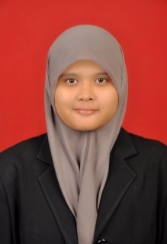
CURRICULUM VITAE (CV)
PERSONAL DATA

Name : Anita Widyastuti
Gender : Female
Place /Date of Birth : Bekasi, November 19th,1992
Address : Wisma Jaya, Jl Kusuma Timur 1C Blok E5 No.31, RT 007 RW 019, Aren Jaya,
Bekasi Timur
Handphone Number : 081519685176/ 082138999171
Email : a_nitha92@yahoo.com
Status/Religion : Single/Moslem
Nationality : Indonesian

EDUCATIONAL BACKGROUND

Name & Location | Major | Year | Remarks
Sahid University, Jakarta | Enviromental Engineering | 2015-currently
Polithecnic of Health Jakarta 2, Jakarta | Enviromental Health | 2010-2013 | 3,44
Senior High School at SMA PGRI 1 Bekasi |  | 2007-2010
Junior High School at SMPN 11 Bekasi |  | 2004-2007

ORGANIZATION EXPERIENCE
Experience | Year
Head of MPM Politehnic of Health Jakarta 2 | 2013
Secertary of MPM Politehnic of Health Jakarta 2 | 2012
Coord. Equipment Field of Healthty Seminar in Ministry of Healthty | 2012

Job Training and Working Experience

