**Name : Veranika Cahyani**

**Address : Jl. Cipinang Jaya II No.22**

**RT.010/RW.007, Cipinang**

**Besar Selatan, Jatinegara,**

**Jakarta Timur, 13410**

**Date of Birth : Jakarta, 30 March 1997**

**Email :** [**veranikac@gmail.com**](mailto:veranikac@gmail.com)

**Gender : Female**

**Marital Status: Single**

**Nationality : Indonesia**

**Hobby : Photography, Photo**

**Editing, Browsing,**

**Reading**

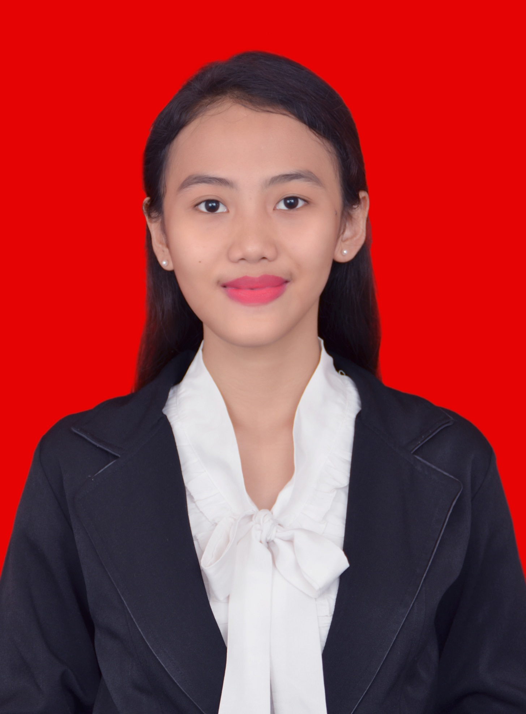

**089604329471**

* **April 2016. Surveyor at Cyrus Network**
* **Universitas Terbuka (Management)2015 – Present**
* **SMA Negeri 53 Jakarta 2012 – 2015**
* **SMP Negeri 148 Jakarta 2009 – 2012**
* **SDN CBS 03 Pagi 2005 – 2009**
* **SD Persatuan 2003 – 2005**
* **Yayasan Lembaga Pendidikan Indonesia – Amerika (LPIA) 2008 – 2009**
* **Peserta Pelatihan Mengembangkan Citra dan Persepsi Realitas Pemuda Dalam Bersosialisasi Bagi Pelajar/Pemuda 2014**

**WORKING EXPERIENCE**

**SKILLS**

**FORMAL EDUCATION**





**NON FORMAL EDUCATION**

**SOCIAL MEDIA**



**@veranikac**

 

**@veranikac**

**Veranika Cahyani**