ARGIA ADHIDHANENDRA
August 13 1997
Jakarta

Address: Villa Jatipadang 3A Jatipadang Poncol, Jakarta Selatan, 14520
Phone: +628111333585
E-mail: Argia.adhi@gmail.com

Undergraduate economic student with a passion for writing, able to work as a team, and a good communicator. Fluent in both English and Indonesian with 3 years of solid writing about music and cultural views. Handled a number of shows focusing on music. Also founded noisewhore.com in 2013, a webzine that focuses on music
and other views on everyday life.

ACADEMIC BACKGROUND

Elementary School
2003-2009

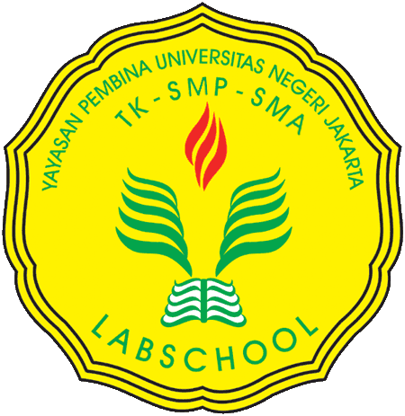Junior High School
2009-2012
Al-Azhar Syifabudi Jakarta

Jl. Kemang Raya No.7, Mampang Prpt., Kota Jakarta Selatan, Daerah Khusus Ibukota Jakarta 12730

Labschool Kebayoran

Jl. K.H. Ahmad Dahlan No.14, Kebayoran Baru, Jakarta
Selatan, DKI Jakarta 12130

Senior High School
2012-2015
Al-Izhar Pondok Labu

Jl. RS Fatmawati Kav.49, Pondok Labu, Daerah Khusus
Ibukota Jakarta 12450

University
(Undergraduate)
2015-
Universitas Indonesia
Faculty of Economics and Business

Depok, West Java 16424
ACTIVITY HIGHLIGHT

noisewhore.com

A webzine focusing on music and cultural views. Bringing recommendations of recently released music, as well as classics in a wide array of genre and writing recaps of gigs around Jakarta. Also entertaining the readers with a selection of contemporary cultural views.

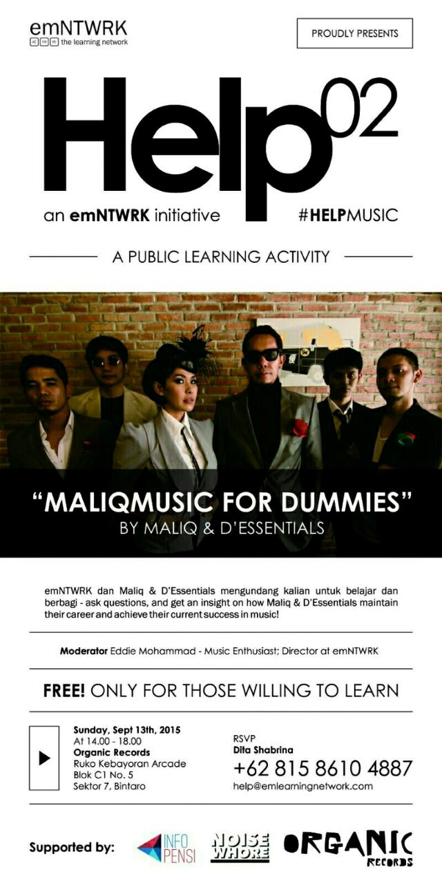

Help 02: Maliq Music for Dummies
Project Manager

Help is a public learning activity intiated by emNTWRK,
a network focusing on the creative development of human capital through the platform of language learning. Help itself is a music discussion platform, a collaboration between emNTWRK and Maliq and D’Essentials, where participants discussed the steps to achieve success with Maliq and D’Essentials with the help of Organic Records.

Help 03: Maliq Music for Dummies
Project Manager

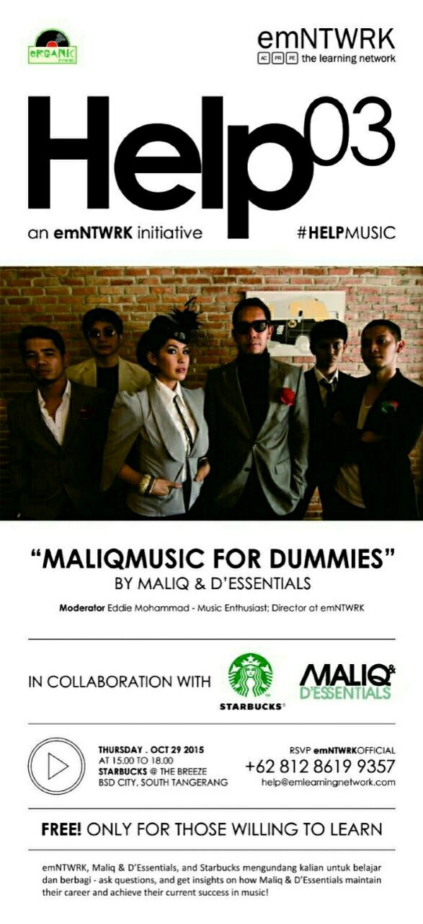With the same goals and source, Help, working together with Starbucks Indoesia and Organic Records held a bigger scale of music discussion with the hope of raising more public consciousness of learning and music itself.

