Curriculum Vitae
Last updated 2016

JENNIFER LINARTA

Personal Information
Address | Jalan Kramat Lontar J3A | 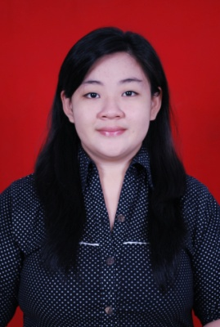  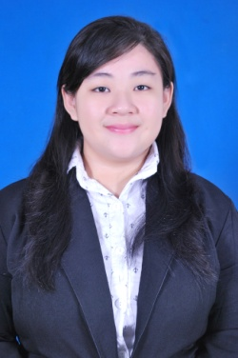
 | Jakarta 10450, DKI Jakarta, Indonesia
Phone number | (+62) (21) 3909715
Mobile phone no. | (+62) 82123233428
Email | jenniferlinarta@yahoo.co.id
Nationality | Indonesian
Gender | Female
Marital status | Single
Place/date of birth Religion  Current GPA  Degree | Jakarta/ November 16th 1992  Buddhist  2.99 (max 4.00)  Bachelor of Economic Accounting (S.E)

Formal Education
2010 – 2014 | Accounting Department, Faculty of Economic, Atma Jaya Catholic University of Indonesia, Jakarta
2007 – 2010 | Cahaya Sakti Senior High School, Jakarta
2004 – 2007 | Budhaya 1 St. Agustinus Junior High School, Jakarta
1998 – 2004 | Marsudirini Elementary School, Jakarta

Informal Education
2014 | Training of SAP Fundamentals at Atma Jaya Catholic University of Indonesia, Jakarta

Language
Indonesia | Both spoken and written active, native language
English | Spoken-good, written-good

Committee Participation Experience
2011  2012 | “Pengenalan Mahasiswa baru Universitas katolik ATMA JAYA”  Staff Of Consumption  “PUSS THE DOOR- Public Speaking Hours for The Dream of Your Life”  Staff Of Registration

Working Experience
July 2014-October 2014  November 2014- February 2015  February 2015 – November 2015  November 2015 - Now | LF Consulting, Jakarta  Internship as Tax Compliance Division  LF Consulting, Jakarta  Junior as Tax Compliance Division  PT Valbury Asia Futures , Jakarta  Tax Staff  PT Citra Sawit Harum , Jakarta  Harum Agro Group  Accounting and Tax Staff

Research Experience
2014 | The Effect Analysis Of Probability, Firm Age, Firm Size and Type of Industry to Disclosure of Corporate Social Responsibility (CSR) in Manufactures Company (Empirical Study on Listed Company on the Indonesia Stock Exchange in 2009-2013)  Accounting Department, Faculty of Economic, Atma Jaya Catholic University of Indonesia, Jakarta

Special Skill, Soft Skill, and Interests
Computer Skills  Soft Skill | - Familiar to operate Personal Computer (PC), Microsoft Office (Ms. Word, Ms. Excel, Ms. Power Point, etc) and Basic Statistics.  - Familiar to operate E-SPT Program.  - Familiar to operate MySAP3 Accounting Program.  - Good communication skill and personality.  - Good analytical thinking.  - Easy to adapt in new workplace and trustworthy.  - Fast learning.  - Able to lead and working in a team.

