CURRICULUM VITAE
Social Media Networker

Personal Information
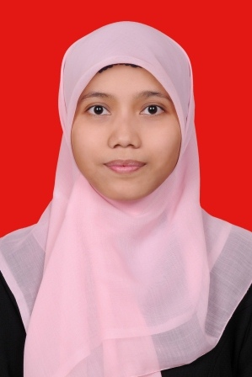 | Name | Anita
 | Place and Date of Birth | Jakarta, September 24, 1991
 | Address | Jl. Kp. Utan Jaya RT 005 RW 003  No. 76 Kel. Pondok Jaya,  Kec. Cipayung, Citayam-Depok
 | Sex | Female
 | Status | Single
 | Nationality | Indonesian
 | Mobile | 087809332314
 | Email | 1. anitaaulia@hotmail.com  2. auliaanita88@gmail.com

Educational Background
September 2009-April 2014 | State Islamic University Syarif Hidayatullah Jakarta  S.S. with GPA: 3.12/4.00 Major: English Language and Literature
2006-2009 | MAN 7 Jakarta
2003-2006 | MTs Al-Karimiyah Sawangan Depok
1997-2003 | SDN Pondok Terong II Citayam Depok

Language Skills
Language | Written | Spoken | Related Certificate
English | Advance | Intermediate | TOEFL 510
Arabic | Intermediate | Beginner | TOAFL 376

Computer Skills
Microsoft Office Tools | Ms Word, Ms Excel, Ms Power Point | Intermediate
Internet Applications | Social Media (Facebook , Twitter, Instagram: ID Anita Takeko Futaa) | Advance

Other Skill
Writing Skill | Active in a writing forum  (Kompasiana: anitatakekofutaa) | Intermediate

Seminar and Training Experiences
Year | Position | Explanation
2011 | Participant | Fethullah Gullen Chair Seminar  “Coexistence of Civilizations and the Role of ‘Hizmet’ between East and West” in UIN Syarif Hidayatullah Jakarta
2010 | Participant | Anti-Coruption Training Road to Campus 2010  Corruption Preventing Aliance (CPA) in UIN Syarif Hidayatullah Jakarta
2008 | Medical Recorder | Pendidikan Sistem Ganda (PSG) at Zahirah Hospital

Hobbies and Interests
Writing articles and poetry, Learning New Language and Cultures and Being Active in Social Media

