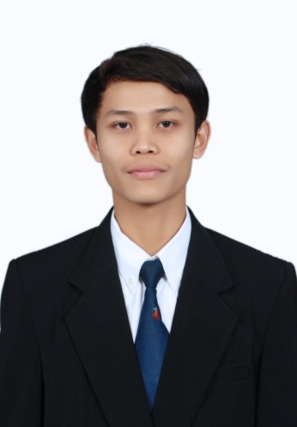
Curriculum Vitae

ALEK, S.ST
Ampel Lonceng 31 RT 001 RW 004 Ampel Semampir Surabaya Indonesia
Mobile Phone : +62857 3118 2043 (Primary)
Email : alek_it07@yahoo.com
alekkuningan@gmail.com

Personal Details
Full Name : Alek, S.ST
Age & Date of Birth : 26 years, 2 Nopember 1988
Religion : Islam
Height/weigth body : 163 cm/54 kg
Marital Status : Married
Sex : Male
Nationality : Indonesia
Permanent : Ampel Lonceng 31 RT 001 RW 004 Ampel Semampir Surabaya Indonesia
Temporary : Jalan Manggis No.29 Wage Waru West Java Indonesia
Contact Number : +6285731182043
Languages Known : Sundanese, Javanese, Indonesian, English
GPA : 3.66 Scale 4.00
Toefl : 464 Held By EEPIS

Education

2007 - 2011 : Politeknik Elektronika Negeri Surabaya - Majoring Information Technology (IT)
2004 – 2007 : SMA Negeri 2 Kuningan
2001 – 2004 : SMP Negeri 1 Kuningan
1995 – 2001 : SD Negeri 1 Bojong

Non Formal Education

Training of Database Oracle held by TC PENS-ITS
Training of Computer Build held by HIMIT PENS-ITS
Training of Manajemen Pra TD held by BEM PENS-ITS

Organization Experience

Head of Badan Sosial Unit Kegiatan Kerohanian Islam PENS-ITS
Staff of Badan Pelaksana Mentoring Unit Kegiatan Kerohaniaan Islam PENS-ITS
Head of OSIS SMA Negeri 2 Kuningan

Working Experince

- Intenership PT.Juara Persada Nusantara August 2009 – Sept 2009
Jobdesc : Development News Portal

- EDP RS.Al Irsyad Surabaya July 2011 – August 2012
Jobdesc : Responsible Maintance Local Area Network, Technical Support Both Software and Hardware

- EDP PT.Daya Anugerah Semesta August 2012 – April 2013
Jobdesc : Responsible Maintance Local Area Network, Technical Support Both Software and Hardware, Create Back End Website Using PHP Programming
- SIRS RS.Bedah Surabaya April 2013 – Present
Jobdesk : Database Administrator, Network Administrator, Programmer

Technical Ability and Experience

Database MySQL ,SQL Server,Oracle ( Intermediate)
PHP (Intermediate)
HMTL (Advanced)
CSS(Intermediate)
Microsoft Windows All Edision (Advance)
Networking ( Mikrotik ) (Basic)
.Net Programming (Basic)
Microsoft Visaul Foxpro Programming (Intermediate)
Java Programming ( Basic )

Hobbies

Mountainering
Travelling
Listening Music
Net Surfing

