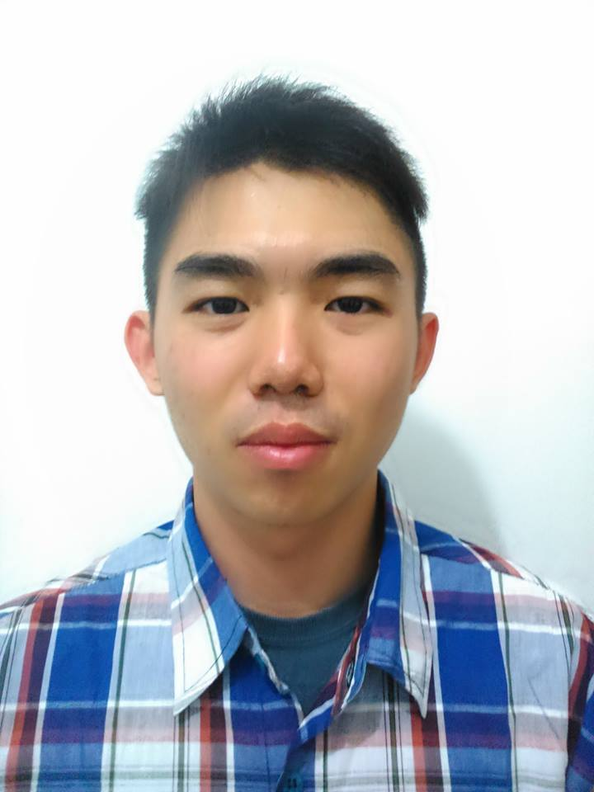
Eddyanto Salim
Eddyanto.lim94@live.com
Temporary: Jl. Ciumbuleuit Gg. U Sukandi no. 29/155C
Permanent: Jl. Berlian Sari no 69E, Titi Kuning, Medan
Bandung, Indonesia
087821579099
- Education Background
July 2012-Now | Pursuing Bachelor Degree at Civil Engineering, Institut Teknologi Bandung
2012 | High School diploma from Methodist-3, Medan , Sumatra Utara
Current GPA: 3.51
- Organization Experience
August 2013-February 2015 | HMS (Himpunan Mahasiswa Sipil)  An organization run by civil engineering students of ITB since 1954. This organization is a part of ITB’s Student Body  Current Position: Competitions  Organizing the needs of ITB’s Civil Engineering students for competition and exhibitions to improve student’s knowledge of the world of Civil Engineering
Oktober 2012-Oktober 2013 | UKT (Unit Kebudayaan Tionghoa)  A culutural organization in ITB that learned about Chinese cultural such as Chinese Traditional Dance, Chinese Painting, Mandarin language, and etc.  Position: Head of UKT  Organizing the main events for the whole year (duration of the position)
- Comitee Experience
2014 | HMS October Graduation Ceremony  To appreciate the graduates for finishing their studies in ITB particularly in civil engineering, HMS hold a closed annual party  Position: Staff of the Fund Raising Division  - Provides funds for provisions in the event
2014 | Mini Concert UKT ITB  A concert UKT held in ITB that shows Chinese Traditional Dance, chinese songs, a bit of explanation about Chinese New Year.  Position: Head of Mini Concert’s event  - Coordinating the divisions to work together.
2013 | PPAB 2012  An initiation of KMB for new recruits, held in a full month  Position: Publicity and Documentation  - Making and organizing the structure of events held during the initiation

- Training Attended
2012 | The “ 7 Habits of Highly Effective People by Stephen Covey” Training in Institut Teknologi Bandung.

- Skills
Language | Moderate in English, Native in Bahasa Indonesia, moderate in Chinese, Moderate in Hokkien
Computer | Able to use general Windows Software such as Microsoft office, able to use structural engineers apps such as Etabs.

I hereby state this information to be true and complete
Eddyanto Salim
(CV made on February 21st,2015)

