Jakarta -
To : HRD Manager

Dear Sir / Madam
Here with I would like to acknowledge my deep interest in working for your company as Editor video as I know the information from internet

My name is Erdo Pamungkas as resume show I’m 31 years old and graduated from STT
Cahaya Yobel Jakarta in 2008. I still working as senior animator and segment producer at HMM Production ( Harmony TV ). I have experience in making program soap ( sinetron ) tv program and kids program animation ( cartoon and 3d ) for Bali ,tvc , Australia and Brunei Darussalam as design graphics ( also as creative ), cameraman ( also as switcher and Program Director ) , editor ( also as chef editor ), motion graphics ( also as senior ), Script Writer, Director and Segment Producer ( News and program ). I have interpersonal skill and be able work under pressure.
I enclose my show real video and to see on line u can open at http://lithosmedia.blogspot.com/
Or http://www.youtube.com/watch?v=KzBEJl2CREU. If an ability to learn, self motivation and high degree of initiative are important to you than I believe I would be a good candidate.
I would be very much appreciating the chance to meet you and to get your opinion
on whether my background would be suitable for the job.
Your Faithfully
Erdo Pamungkas
CURRICULUM VITAE
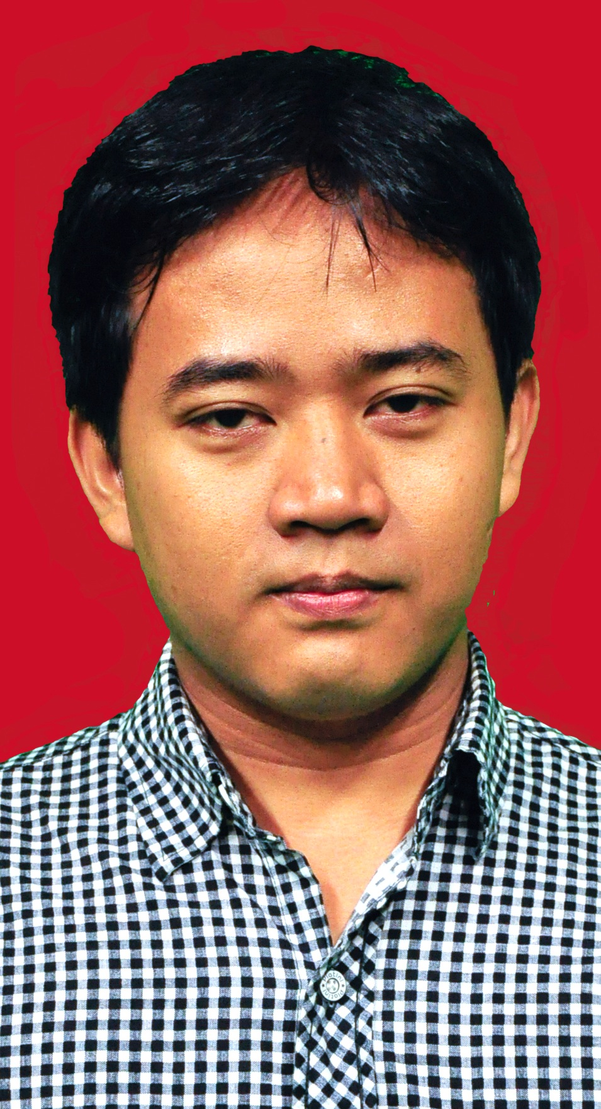
PERSONAL DATA
Name : Erdo Pamungkas S. Th
Sex : Male
Religion : Christian
Place date of birth : Jakarta September 29 1981
Nationality : Indonesia ( Java )
Address : Tridharma v road No.6 Pondok labu South Jakarta
Phone Number : 083866315322,083866315323
Marital Status : Married
Hobby : Music and Computer
Email : erdo_ornan@yahoo.com
Pasport No : U 163644
EDUCATION
2004 – 2008 : STT Cahaya Yobel Majoring Universal Theology ( S1 )
2002 – 2004 : AMIK Bina Sarana Informatics as Management
Informatics ( D1 )
OTHER QUALIFICATION
2001 : English Conversations for basic at Dana Private
2002 : Multimedia ( Editing, Animation ) at Informa Computer
2005 : Management Business at IEI Jakarta
WORKING EXPERIENCE
2002 – 2004 : video city as ass cameraman, editor, design graphics
2004 – 2008 : Kreasi Selatan Production as Motion Graphics and Editor
2008 ( 6 month ) : Supervisor editor and head studio at Art Vision Bali
2008 – 2010 : Supervisor Editor and Motion Graphics at Megabond SDN
BHD ( Brunei Darussalam and Malaysia )
2011 – present : Motion graphics | animator ( 2d, 3d ), PIC ( director, script writer ) for kids tv program at SICC ( Harmoni Media Production) Segment Produser Animation Program
SOFTWARE PROCESS CAPABILITY
- Microsoft Office
- Design Graphics
Adobe Photosop | Corel Draw | Adobe Ilustrator
- Editing Video
Final Cut | Adobe Premiere | Edius
- Motion Graphics | Visual Effect
Adobe After effect | Mac Motion | Particle Ilusion
- 2D
Toon Boom | Adobe Flash | After Effect ( bone tools ) | Crazy talk
- 3D
3ds max | Maya | Iclone | Faceshift | Daz 3D

EXPERIENCE AS
- Design graphics
- Editor
- Motion Graphics
- Animator 2D and 3D
- Cameraman
- Photographer
- Program Director | Switcher
- Script Writer
- Director
- DOP
- Segment Producer
- Producer

