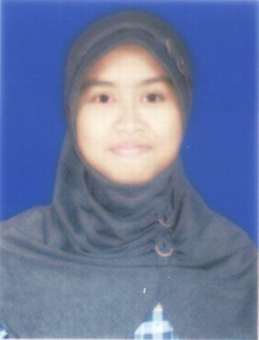Photo

Human Resources Department
Dear Sir/Madam,
On this opportunity, I would like to apply as Telemarketing Officer in your company, my name is Dewi Hapsari Anderlina,Iam 27 years old, Female, single. I am a senior high school and graduated from SMU MTA Surakarta on 2005 and I would like to have career to expand my experience.
My personality as a hard worker and fast learner type of person would bring benefit to your company. I will be very appreciated if you could give in opportunity to work in your company.
Here with I enclose my curriculum vitae,copy of ID card, copy of Final Certificate, Transcript Academic, Photo, which will give detail of my qualification.
I hope my qualification and experience merit your consideration and look forward to your reply.
Sincerely yours,

DewiHapsariAnderlina

CURRICULUM VITAE
PERSONAL DETAILS
Name : DewiHapsariAnderlina
Date of Birth : Sragen, 30 December 1986
Religion : Moslem
Height : 160 cm
Weight : 48 kg
Healthy : Good
Address : JL Raya MawarMerahRt 002/Rw 001 No 1
Jakarta Timur 13460
Phone : 083890501627/081382053889
Email : girl.generation1986 @gmail.com

PERSONAL EDUCATION
1993 – 1999 : SDN 14 PETANG JAKARTA
1999 – 2002 : SLTPN 139 JAKARTA
2002 – 2005 : SMU MTA SURAKARTA, SOLO
WORK EXPERIENCES
1.PTJoharAgung : June 2009 to Nov 2010 as Desk Collection
2.PT KAO Indonesia : Nov 2010 to Mei 2011 as SPG
3.PT AXA Mandiri :Juli 2011 to Desember 2012 as Sales Counter
4.PT Telkom Indonesia : Januari 2013 to Nov 2013 as Tele Marketing
5.Bank Mandiri TBK : Nov 2013 to Mei 2014 as Sales executive

