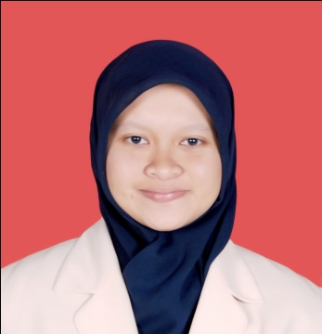
RIZQA TSANIA, S.Si
Graduated of Statistics, Universitas Padjadjaran

SUMMARY
My name is Rizqa Tsania. I am graduated from Statistics, Faculty of Mathematics and Natural Sciences, Universitas Padjadjaran. I have ability to process, analyze, interpret and present data into information. I have worked as Statistician at Education Hospital, Faculty of Medicine, Universitas Padjadjaran

SKILLS
- Computasional Skills :
Ms. Office (Ms. Excel, Ms.Word, Ms. Power Point), SPSS, Minitab, R, Lisrel, and Smart PLS.
- Hard Skills :
Statistics Analysis (Descriptive and Inferential)
- Soft Skills :
Leadership, Management of Organization
- Languages :
Indonesian (active)
English (passive)

CONTACT ME
0813-2258-3568
rizqa.tsania@gmail.com
Taman Kopo Indah Blok O-61, RT 03, RW 18, Kelurahan Margahayu Selatan, Kecamatan Margahayu, Kabupaten Bandung 40226

PERSONAL DETAILS
Nickname : Rizqa
Place of Birth : Bandung
Date of Birth : January, 6th 1993
Sex : Female
EDUCATIONAL HISTORY
- (2011-2015) - Universitas Padjadjaran with GPA 3,08 (scale 4,00)
- (2008-2011) - SMA Negeri 11 Bandung
- (2005-2008) - SMP Negeri 13 Bandung
- (1999-2005) - SD Negeri Mochammad Toha I Bandung
- (1996-1999) - TK Bunda Asuh Nanda

SEMINAR, COURSE, TRAINING
- English Course in Lingua Franca 2015
- Participant of Leadership Training “School of Leader VI” by PSDMO BEM Kema Unpad 2013
- National Seminar of Statistics “Risk Management in the Insurance Sector” by Statistics, Universitas Padjadjaran 2011

ACHIEVEMENTS
- One of 60 Semifinalist in Data Analysis Competition by Statistics ITS Surabaya, East Java, Indonesia 2013 (group)
- 1st winner of Sainstrepreneur by BEM Kema FMIPA Unpad 2013 (group)
- 2nd winner of MTQ Competition by Universitas Padjadjaran 2012 (group)

WORK EXPERIENCES
- Assistant of Regression Analysis Laboratory in Statistics, Faculty of Mathematics and Natural Sciences, Universitas Padjadjaran 2013
- Statistician of Academic Leadership Grant Research Team, Education Hospital, Faculty of Medicine, Universitas Padjadjaran 2015.

RESEARCH EXPERIENCES
- Zahra Syahida Sabila and Rizqa Tsania. “Student Awareness of Enviromental Issues in Jatinangor” . Poster published in Indonesian Environmental Summit 2015 by BEM Kema Unpad 2015, Universitas Padjadjaran.

ORGANIZATION EXPERIENCES
- General Secretary of Ecosystem Guard, Environmental and Disaster Organization 2015 - now
- Vice President of BEM Kema FMIPA Unpad 2014
- Head of PSDMO Division in BE Himasta FMIPA Unpad 2013
- Member of FUSI “Statistics Moeslem Association” FMIPA Unpad 2013
- Staff of HRD Departement in BE Himasta FMIPA Unpad 2012
- Staff of HRD Departement in BEM Kema FMIPA Unpad 2012
- “Juru Adat” of Student Scouting Organization in SMAN 11 Bandung 2009-2011

INTERESTS
Research, Data Analyst, Organization Management, Business Management

