CURRICULUM VITAE
Fellicia Arini
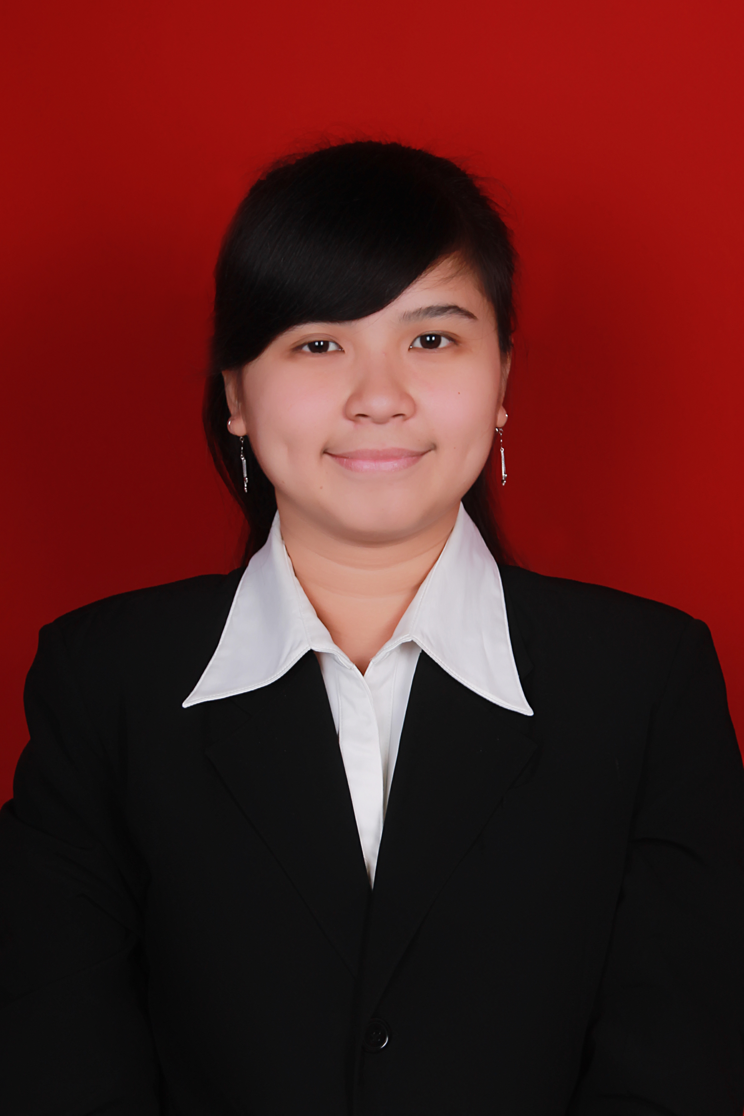
Jl. Alpukat 2 No. 12, Jakarta Barat
0857-5845-4308
fellicia.arini08@gmail.com

Personal Info
Place / Date of Birth : Lubuklinggau / 8th of April 1993
Religion : Buddhist
Sex : Female
Nationality : Indonesia
Marital Status : Single
IPK : 3.70

Education
- 2000 – 2005 : Xaverius Elementary School, Lubuklinggau
- 2005 – 2008 : Xaverius Junior High School, Lubuklinggau
- 2008 – 2011 : Xaverius Senior High School, Lubuklinggau
- 2011 – 2015 : Faculty of Economic Management Tarumanagara University, Jakarta

Language
Indonesia & English

Organizational Experiences & Activities
- 2011 - 2012 :
  - Member of Bakti Division, Badan Pengurus Harian KMB Dharyamana 2011/2012
  - Member of Fund Division, Kathina dan Pindapata 2011, KMB Dharmayana
  - Member of Fund Division, Metta Day XVII 2012, KMB Dharmayana
  - Secretary of HUT Dharmayana 2012, KMB Dharmayana
  - Member of Event Division, Vesakh Day 2012, KMB Dharmayana

- 2012 - 2013 :
  - Member of Bakti Division, Badan Pengurus Harian KMB Dharyamana 2012/2013
  - Member of Consumption Division, P3MB “EURO” 2012, KMB Dharmayana
  - Coordinator of Consumption Division Darmadhista 2012, KMB Dharmayana
  - Member of Event Division, Kathina dan Pindapata 2012, KMB Dharmayana
  - Treasurer of Metta Day XVIII 2013, KMB Dharmayana
  - Coordinator of Event Division, Dharmayana Buddhist Festival 2013, KMB Dharmayana
- 2013 - 2014 :
  - Treasurer Badan Pengurus Harian KMB Dharmayana 2013/2014
  - Member of Decoration Division, P3MB “D’FAME” 2013, KMB Dharmayana
  - Member of Event Division, Darmadhista 2013, KMB Dharmayana
  - Coordinator of Sorting Division, Kathina dan Pindapata 2013, KMB Dharmayana
  - Member of Event Division, Metta Day XIX 2014, KMB Dharmayana
  - Member of Event Division, Dharmayana Buddhist Festival 2014, KMB Dharmayana
- 2014 - 2015 :
  - Coordinator of Event Division, Darmadhista 2014, KMB Dharmayana
  - Member of Event Division, Tarumanagara Festival, BEM Universitas Tarumanagara
  - Chairman of Kathina dan Pindapata 2014, KMB Dharmayana
  - Comittee of Leadership Training Badan Pengurus Harian Dharmayana 2014/2015

I certify that all information and data in this application are true and correct and was made in good health and with my best knowledge.

Warm Regards,

Fellicia Arini

